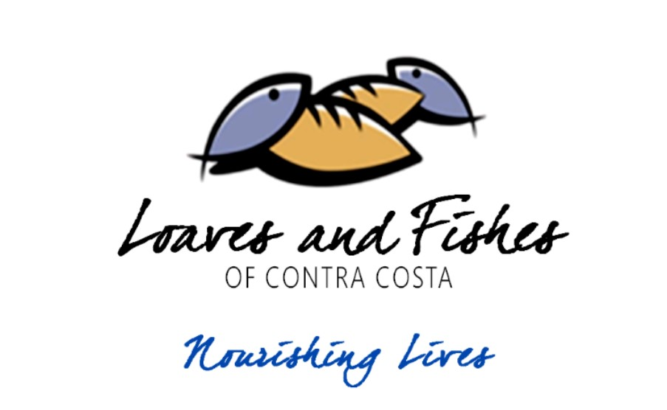
May 15, 2017

Donor Name
Donor Company
Donor Address
City, State Zip

Dear Donor,

On October 14, 2017 , Loaves & Fishes of Contra Costa and St. Vincent de Paul of Contra Costa County will hold our 5th Annual Bocce Ball Tournament, “The Big LaBocce 2017” at Martinez Bocce Federation, whose facilities boast 15 bocce courts and years of bocce ball experience. The event will include dinner, beverages, a silent auction, and a raffle. Over 150 attendees will participate, individuals with significant buying power and loyal to our organizations, and those businesses that support us.
St. Vincent de Paul and Loaves & Fishes are committed to serving those most in need in our neighborhoods. In Contra Costa County, thousands of citizens each day go without basic life necessities like food, shelter, and clothing. With 5 dining rooms throughout the county, Loaves & Fishes provides over 800 free hot meals daily. St. Vincent de Paul provides help to over 145,000 individuals in Contra Costa County annually through programs including 21 food pantries, medical and dental care for the uninsured, rental and housing assistance, thrift stores that provide free clothing and furniture, job training and employment for those with barriers, and much more. Loaves & Fishes 501(c) (3) Tax ID is: 68-0018077 and St. Vincent de Paul’s 501 (c) (3) Tax ID is: 94-1448577.

We're currently soliciting merchandise or services for our SILENT AUCTION and we are asking for your support. By making a donation to support this event, you'd be making a tax-deductible contribution that will help bring aid and comfort to the needy of Contra Costa and you'd gain valuable exposure.
Thank you for your consideration.

Sincerely,

Lynne Castagnola
Volunteer Auction Coordinator
St. Vincent de Paul
2210 Gladstone Drive
Pittsburg, CA 94565
Lynne5879@comcast.net

Joleen Lafayette
Development Director
Loaves and Fishes
835 Ferry Street
Martinez CA 94553
(925)293-4792
joleen@loavesfishescc.org
Barb Hunt
Development Director
St. Vincent de Paul
2210 Gladstone Drive
Pittsburg, CA 94565
(925) 330-6732
b.hunt@svdp-cc.org

2210 Gladstone Drive ● Pittsburg, CA 94565 ● Phone (925) 439-5060 ● Fax (925) 439-7863

