Please print this form, complete it and return to St. Vincent de Paul with your donation
Donor First Name: _____________________________________________
Donor Last Name: _____________________________________________
Donor Address: _______________________________________________
City/State/Zip: __________________________________________
Home Phone: ______________________________Cell Phone: __________________
Email: _______________________________________________________________
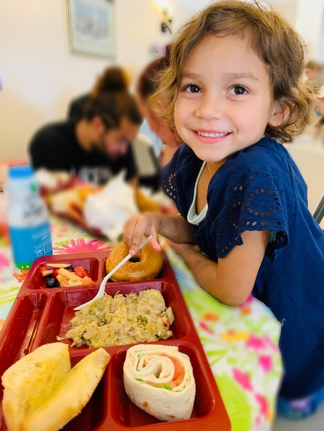
Enclosed is my tax-deductible gift of $_____________________________________
I would like my donation applied toward:
Where Most Needed

Other Program: (Please Specify) ______________________

Mail Check to: St. Vincent de Paul of Contra Costa County
2210 Gladstone Dr.
Pittsburg, CA 94565

Please Charge My Credit Card or enclose check
Account No. ________________________________________Exp Date_____
Signature: _________________________________________
My gift is given in Honor/Memory of (please circle): __________________________
Please send acknowledgement to: Name: __________________________________
Street: ___________________________City:__________State:____Zip:__________
Please consider requesting a Matching Gift from your employer.
Questions? Contact Barb Hunt at 925-439-5060 or b.hunt@svdp-cc.org
TAX ID#: 944-1448577 Legal Name: District Council Contra Costa County, Society of St. Vincent de Paul

