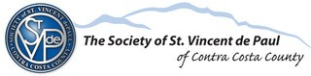

**Upgrade Your Skills to Land a Better Job!**

**Have You Encountered Barriers to Employment or are Returning to the Workforce and Need Help?**

**Join St. Vincent de Paul’s PAID Part-Time Employment & Training Program to Gain**

**Valuable Employment Experience and Master Job Search Skills!**

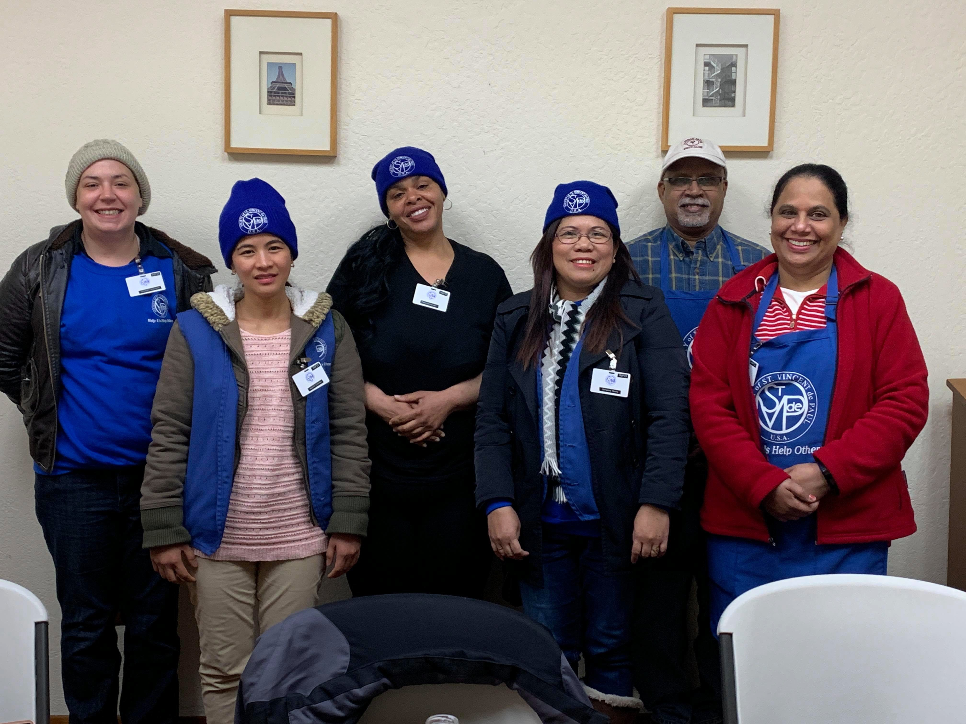

**Information & Workshop Sessions**

|  |  |
| --- | --- |
| **Dates and Location** | **Workshop Content** |
| **Wednesday 4/21 – 2 PM to 5 PM**  **1415 Simpson Ct. Pittsburg** | **Part 1. Job Search, Vision, Goal Setting, Overcoming Obstacles and Action Planning** |
| **Wednesday 4/21 – 2 PM to 5 PM**  **1415 Simpson Ct. Pittsburg** | **Part 2. Job targeting, Networking, Applications, Resume Objectives & Accomplishments** |
| **Wednesday 4/28 – 2 PM to 5 PM**  **8890 Brentwood Blvd. Brentwood** | **Part 1. Job Search, Vision, Goal Setting, Overcoming Obstacles and Action Planning** |
| **Saturday 5/1 – 2 PM to 5 PM**  **8890 Brentwood Blvd. Brentwood** | **Part 2. Job targeting, Networking, Applications, Resume Objectives & Accomplishments** |

Workforce Development Program at St. Vincent de Paul provides PAID training, part-time work experience and mentors over a 24-week period. Participants must attend both Part 1 and Part 2 to be eligible to apply for the paid employment & training program. Qualified applicants may start work before the official program begins.

St. Vincent de Paul’s Workforce Development Program is generously funded by: East Bay Community Foundation and Contra Costa County Employment & Human Services.

**To attend, please RSVP by contacting SVdP at (925) 439-5060 or email info@svdp-cc.org**

**Please leave your contact info**

Workforce Development Program

Cycle 17