CHAPTER 11
ACCOUNTING

INTRODUCTION

You are the steward of the funds which the conference accepts from members and contributors for the care of the poor. Very few conferences have enough funds to assist everyone who asks for help. We say "yes" to some and "no" to others. Further, the IRS has given the Society an exemption from paying income taxes and permits your contributors to take a tax deduction for their donations. In return, it requires an annual accounting.

RESPONSIBILITIES - Treasurer

The Treasurer is responsible for the conference funds, for keeping accurate and appropriate records of all the receipts and expenditures, and, with the President, for preparing the budget of the conference. The Treasurer keeps accounts which should be audited at least once a year by two members delegated by the conference or by a qualified person or organization.

The Treasurer keeps up-to-date the financial report, reflected in the Society's Official Minute Book. In this way, the true financial condition of the conference is known at all times. Funds belonging to the Society have always been, and must always be, kept separate from the Treasurer's personal assets. Conference funds should be deposited regularly and promptly in a bank account in the conference's name.

A bank balance should be reported at every conference meeting (see Page 11-19), submitted with your Quarterly Report, and verified annually by the President or an audit committee of two members. For auditing purposes, invoices and statements are obtained before disbursement is made or receipts should be collected and retained for all disbursements. Whenever possible, all payments should be made by check. The credit of the conference must be safeguarded at all times and, therefore, all just accounts should be paid as they become due.

DECEMBER 2008 PAGE 11-1

SETTING UP A BANK ACCOUNT

Conference funds should be deposited regularly and promptly in a bank checking account in the conference's name, specifically "Society of St. Vincent de Paul at St. Whatever". Do NOT use the words "church" or "parish" or start with "St. Whatever". The account typically referred to is a "business" checking account. The account may have service charges, be service charge free, earn interest, etc. Some banks offer monthly service fee-free accounts to charitable organizations. Service charges should be avoided if possible, but not at a cost of making part of the conference funds unusable. The account may be set up in a bank, savings and loan, credit union, investment brokerage house, etc.

The primary consideration is that the funds should be liquid. You are not in the business of financial investment; you are in the business of charitable helping, so there should be no restrictions on the immediate availability of all of the funds.

It is common practice for each of the four conference officers (president, vice president, secretary and treasurer) to be signers on the account. It is not uncommon to require two signatures on each check written. Because of the nature of the non-profit sector, accounting firms recommend that the checking account be the type where the canceled checks are actually returned with the monthly statement. Typically, the Treasurer is the holder of the checkbook, issuing checks as they are needed.

JOURNAL / LEDGER

It is recommended that SVdP Treasurers maintain a journal for recording the fiscal receipts and expenditures for the conference. The Receipts and Expenditures Journal, available from Vincentian Support Services, records all cash and check receipts and expenditures in the date order of their occurrence. The conference relies on the Treasurer for verifying any bills presented for payment. All expenditures should be transacted by check and cash avoided.

The Treasurer's Journal follows the same basic classification for income and expense items that are recorded in the Secretary's minute book. The definition of terms employed in the Treasurer's Journal is therefore identical to that used in the Secretary's Record. The various receipt items are defined later in this Chapter.

MONTHLY STATEMENTS

Each month, the Treasurer receives an account statement from the bank or financial

DECEMBER 2008 PAGE 11-2

institution with which the conference does business. The Treasurer must then balance the account to the statement and reconcile any differences. In addition, the
checks which are returned with the statement should be filed with previously returned checks in numerical sequence for easy search, if necessary.

At least annually, the Treasurer submits bank account reconciliation to the President of the conference.

AUDITS

A bank report and balance should be submitted at least annually and verified by the President or an audit committee. This audit is considered to be an internal audit and may be accomplished by a conference committee of two or more members. As with other committees, this one is appointed by the conference president.

STORAGE OF RECORDS

Generally, the IRS requires all conference records be kept at least seven years. There is a list in the U.S. Manual which defines each type of record and how long it must be maintained. Often there will be more than one Treasurer during any seven year period; so, at the appropriate time, all records must be transferred to the new Treasurer. (see Confidentiality and Records Retention, later in this Chapter.)

RESPONSIBILITIES - Others

PROTECTING VALUABLE FORMS

You keep close tabs on your cash, credit cards and checks. This should hold true for a conference as well. The practice of giving signed, blank checks to home visit teams are unwise and should be discouraged. Keep in mind that vouchers and Care-Cards™ are as good as money and should be just as well protected. There have been instances in which guests have gotten their hands on one or more blank vouchers, forged them for their own benefit, or sold them for ready cash.

Some guests have altered vouchers or checks. Do not give checks to guests! Avoid problems with vouchers by properly and completely filling in the amounts (see page 11-35) using both numbers ("1") and longhand ("one") on the form. Bank personnel are pretty good about not cashing what looks like an obviously altered check, but, unless you fill out every blank on a voucher, you leave it open to alteration. Thrift store personnel are less likely to notice or they may refuse to accept an

DECEMBER 2008 PAGE 11-3

altered voucher. In order to be good stewards of the funds entrusted to us, you must take proper precautions and follow reasonable procedures. (see "clothing" voucher procedures, Chapter 13)

LEGAL REQUIREMENTS

State and federal laws govern the activities of non-profit organizations. The District Council for the Society of St. Vincent de Paul, in Contra Costa County is the corporate entity under which conference operations are tax-exempt, and has the role of seeing that proper reporting of all funds is done. Conferences are dependent upon volunteers to achieve compliance with these increasingly burdensome government regulations, but that does not relieve them of these responsibilities.

As a non-profit tax-exempt organization, donations to the Society are deductible for state and Federal income tax purposes. The Society has been awarded a 501(c) (3) status by virtue of being listed in the Official Catholic Directory of the Catholic Church. The IRS has determined that the Society is not an "integrated auxiliary" of the Catholic Church because its activities are not exclusively religious, and therefore an annual tax report (Form 990) is required.

Each conference is associated with the Society of St. Vincent de Paul only at the pleasure of the District Council of Contra Costa County and the National Council of the United States. Each conference is sheltered by the tax exemption granted to the District Council for the Society of St. Vincent de Paul of Contra Costa County. The Society's tax exemption cannot be maintained unless all conferences comply with record-keeping and other requirements imposed by the government. Individual conferences who fail to follow these standards and file proper forms, place the entire Society at risk of losing its tax status.

DISTRICT COUNCIL STANDARDS FOR ACCOUNTING

⬥ Conferences must prepare and submit to the District Council of Contra Costa, an annual report by November 15th of each year, for the twelve month period ending September 30th of that year.
⬥ Conferences must maintain records on all the people that have been assisted.
⬥ Conferences must maintain receipt and expense ledgers and journals. Generally, such records must be kept for a period of seven (7) years.

DECEMBER 2008 PAGE 11-4

⬥ In accordance with IRS regulations, conferences must acknowledge in writing each donation of $250.00 or more, given at one time. $5,000 in donations given $200 at a time does NOT legally have to be acknowledged (but it's smart to!).
⬥ A conference may not accept donations "earmarked" for a particular person. This would enable someone to give money, through the Society, to another person and take a tax deduction for their "donation." This is clearly against the law.
⬥ A conference must deposit all funds into the conference checking account. With rare exceptions, all expenditures by the conference should be paid by check, with proper supporting documentation.
⬥ Assistance from a conference must not be self-serving. If a member of the conference or a person related to a conference member should request assistance, that person or relative of that person must not take part in the conference decision concerning assistance. To avoid embarrassment or hard feelings, that member should absent themselves from that portion of the conference meeting where the decision is decided. The conference shall make its decision with no special treatment or favoritism.
⬥ Guest information shared with the conference members must be kept in the strictest confidence.
⬥ Records of meetings, conference actions, guest files, checkbooks and minutes must be kept in a secure location and their use be maintained in confidence. If you share an office with another parish ministry, for example, these records must be kept in a locked file cabinet where no non-Vincentian will have access.
⬥ While individual expenditures must remain confidential, conferences should share information from the annual report of its activities with its contributors and the parish community.
⬥ Although no work of charity is foreign to the Society, money donated to the Society can only be used for works in which the Society's members are personally involved in a conference-supported activity. Giving money donated to a conference to another organization not in the Vincentian family, however worthwhile, violates the intentions of the donor and must be avoided. Donors would have made their donations directly to such organizations instead of SVdP if that had been their intention.
⬥ Surplus funds should be twinned to other, poorer conferences or forwarded to projects and programs of upper councils. Conferences should not hoard money, or keep more on hand than they expect to use within the following two or three months. Conversely, conferences needing funds should not hesitate to contact their District Council. Conferences who do have an excess of funds should consider twinning either domestically or internationally with one or more conferences.

DECEMBER 2008 PAGE 11-5

CONFIDENTIALITY

Confidentiality has always been an important value in the Society of St. Vincent de Paul. For many decades, we were known as "The Secret Society" in the Catholic Church because we so assiduously guarded the personal problems and finances of our guests (in those days, often our own fellow parishioners). Confidentiality does not prevent telling the SVdP story to the parish or the public. Confidentiality does prohibit information shared with your conference by those you help from "leaking" outside of the Society.

Outsiders. With less resources and more people in need, SVdP conferences may find that their resources are frequently not enough, and that they need to collaborate with other community groups, agencies or churches in their area to effectively help people. Such situations may range from a simple indication that a family is participating in a program like Adopt-a-Family to telling another church that Mary Doe can't pay her rent this month because her husband took off on her. As we network with other groups, we must have the written permission of the guest first.

When sharing with other agencies, do not give more information than what they need to help the family or individual. It may be good to ask up-front what their policy is on how this information will be used and with whom they may share it. With the development of national databases, what you share locally may quickly get into a national database and perhaps hurt the family or individual in some way by denying them benefits, etc. It is for this reason, among many others, that you should NOT collect Social Security numbers from your guests.

Computers allow the sharing of information on a wider basis than ever before. Once your database is shared, the information on your guests can easily be exchanged with other groups not initially involved or intended to be included.

Privacy laws and litigation. More laws regarding privacy have been enacted and people are more aware of legal issues. As a result, guests are more apt to resort to legal measures where there is a possible breach of confidentiality.

The requirements of others. New policies are being developed by some agencies that belong to national databanks, including utility companies. These often require conferences to have written permission from those they are helping before the guest's situation can even be discussed with the utility or agency. It is for this reason that the Contra Costa District Council recommends every guest we serve be asked to sign a statement (at the bottom of the new Guest Intake Card), giving us permission to share what we know with others in order to secure help for the guest.

DECEMBER 2008 PAGE 11-6

Definition of “confidentiality”

“The concept of confidentiality is based on the individual's right to privacy, expressed or implied, and has both legal and ethical implications. It means
that disclosures which the individual or family makes to the Vincentian and
the SVdP conference will not be revealed to others except under certain circumstances and then only for the purpose of helping them.”

Confidentiality is more than legally important. In Vincentian work, confidentiality is a basic, lasting concept -- essential to helping people help themselves. Trusting relationships develop between persons who need help and the conference. For those relationships to be productive there must be mutual trust. Confidentiality is one of the "building blocks" that help a good relationship to develop. It is so important that "confidentiality" is a prerequisite for membership in the Society and its breach by a member may be grounds for requesting a member's resignation from the conference.

In a home visit, guests tend to share more personal information than they would in a more formal setting (e.g. welfare or Social Security office, etc.) because the conference member is from a church. The guest also feels safer because s/he is in her/his own home. As a result, Vincentians have an added responsibility to be careful about what they ask and how they share it.

It is the Vincentian's responsibility to only ask questions that relate to the issue at hand and the help requested. Please read the "Brick" on the Guest Intake Card.
Only write down what is absolutely needed to serve the individual or family. Side comments, personal notes, and written records of the conference can be subpoenaed. Conference written records should be kept to a minimum because of this.

A Need To Know

Need is determined and help given only as a result of the guest sharing factual and often very personal information. It is in the "handling" of this information by the conference that questions about confidentiality arise. To help insure confidentiality, the only appropriate place to share this type of information is at the conference meeting. It is not wise to share such information with conference members in the parking lot, parish hall, in an elevator, etc. You do not know who may be listening.

Outside of a conference meeting, members should not share names or specifics with their friends or neighbors unless they are active Vincentians and involved in the case. Members should also not share names or specifics with their own family members. Finally, remember that cell phones, e-mail, the Internet and computers are not as secure as you might like.

DECEMBER 2008 PAGE 11-7

Write Articles with Care

Special caution must be exercised when including names, specifics, photographs or even general information in any communication or publication where someone could recognize an individual or family from the case description. Stories done with newsletters or local media must be done sensitively and only after securing the written permission of the person(s) being helped

Release of information

It is often helpful if home visit teams talk about "confidentiality" in one of the first interviews with the person being helped to explain how the information sought might be used or shared. The recommended Guest Intake Card has a "release" at the bottom, giving the conference permission to share the information it is given for the purpose of trying to secure assistance for the guest. The person you help should never be surprised by what you shared or with whom. If the guest says, "I didn't know you would contact them" or "I didn't know you would share that!" it usually means the conference home visit team did not properly explain what signing that release means.

We sometimes forget to have the guest sign the Guest Intake Card and end up asking if verbal permission is enough. Written Permission from the guest is highly advisable when working with those who have very personal, complicated problems (e.g. AIDS/HIV, emotional or legal problems, counseling situations, etc.)Vincentian Support Services and Conference Concerns will be able to provide general forms for this.

Possible Exceptions to Confidentiality

There are a few exceptions when information may be released without the informed consent of the family or individual. One such exception is when there appears to be a real danger that a person will injure him/her or others or endanger the larger community. If there is time, the conference should check with the Vincentian Support Services before acting.

A Conference Record Retention Policy

When a conference begins operation, paperwork is generated. This includes files on guests, bank statements, invoices, receipts, etc. which begin to take up space. There is an accounting need to keep information for a short while on the people served, what was done, payment of bills, statistics for local parish and District Council uses, etc. Initially this is not a problem, but, after a few years, a loose-leaf binder

DECEMBER 2008 PAGE 11-8

expands and older records have to be put into storage in the church offices or in a conference officer's home to make room for current records.

Confidentiality demands that all records on individuals and families served by the conference must be kept in a safe, private place and always remain secure. There are also remote but possible legal issues and potential liabilities that vary from state to state.

Therefore, it is wise for a conference to have a "record retention policy" because "confidentiality" involves not only how information is shared but also how old records are properly and confidentially stored and eventually destroyed.

Your conference record retention policy should include the following:

⬥ How records should be kept secure and confidential.

⬥ How long records should be kept.

⬥ How records should be disposed of confidentially, when no longer needed.

Never just throw records into the trash. You must shred old records. If you have neither the equipment to do this, nor the funds to acquire the required equipment, you can send your records to the Vincentian Support Services for this to be done.

SUGGESTED RECORD RETENTION SCHEDULE:

PERMANENT
Annual Conference Report
(Include statistics and membership lists with anything historically important.)
Articles of Aggregation

THREE (3) YEARS
Bank Deposits (Checking/Savings)
General Correspondence

SEVEN (7) YEARS
Bank Statements
Invoices and Receipts Received
Treasurer Statements (Month/Year)
Minute Books
Case Records/Cards

Computer records follow the same time frame.

DECEMBER 2008 PAGE 11-9

(Note that the time of the record retention period begins not from the actual date of the document, but, at the end of the fiscal year in which the document was created. That is, a three-year record created in April 2004 cannot be discarded in April 2007, but not until DECEMBER 2007 which is the end of that fiscal year.)


✪ 
✪ LAW ENFORCEMENT, LEGAL REQUESTS 
✪ 


The Contra Costa District Council has a policy which includes guidelines and procedures in case a conference receives a request from a law enforcement officer, lawyer or prosecutor for confidential information on those you serve. While this may come to you as an "emergency" request that "must be addressed immediately," does not panic into complying until you have received legal counsel? There is time to legally respond because normally a subpoena is needed before you can be forced to share this type of information. Legal counsel should immediately be contacted for help by calling Vincentian Support Services or the Executive Director of the Contra Costa District Council.

LIABILITY CLAIMS

There are situations that may cause claims or lawsuits to be made against the Society of St. Vincent de Paul and/or individual Vincentians. The District Council has a liability policy that generally covers all conferences and members.

However, some of the claims may not be covered by terms of the insurance policy. In addition, some of the claims may be directly against individuals for their actions and not fall under the insurance coverage of the Society. For example, intentional acts that injure people or property are excluded in most policies.

Also, anyone operating outside the rules and guidelines of the Society may not be protected. It may be determined that the person was acting on their own behalf outside the protection of the Society's insurance.

DECEMBER 2008 PAGE 11-10

All Vincentians using a vehicle on volunteer Vincentian business must have their own insurance. The District Council insurance policy will protect the Society in case you have an accident in your own vehicle, but it will not protect you.

Common Sense Rules To Avoid Potential Problems:

⬥ Always operate within the rules and guidelines of the Society as spelled out in the U.S. Manual and in the published Contra Costa District Council Policies and Guidelines. This includes all written communications from District Council officers, district presidents, and conference presidents where not in conflict with the U.S. Manual or District Council policies.
⬥ NEVER HOME VISIT OR MEET A GUEST ALONE. This especially includes giving anyone a ride anywhere without another Vincentian present. If a family's desperate need requires you to deliver food alone, take it to the apartment Manager's Office and ask the manager to call the guest to the office.
⬥ Use common sense when making physical contact with guests (hugging, for example), especially with children and those of the opposite sex. "Called to Protect" (successor to the Safe Environment Training) of the Oakland Catholic Diocese is quite specific about which actions are appropriate and which are not.
⬥ Do not discuss guests' personal problems except with them or with other Vincentians. If counseling for a guest is appropriate, your conference may want to offer to pay for an initial session with a professional. Vincentians are not trained marriage counselors, for example, so we do a couple a grave disservices if we try to be one.
⬥ If an incident occurs that you feel may result in a claim or if anyone threatens to sue or make a claim, contact the District Council immediately. Late reported claims can be denied by the insurance company if the delay causes a loss of their ability to conduct an investigation.
⬥ DO NOT TRY TO NEGOTIATE A SETTLEMENT WITH A CLAIMANT. This action may prejudice the claim and void our insurance coverage.
⬥ Call the police to all traffic accidents, period.
⬥ Do not discuss any incident with anyone except the police, the Society's insurance carrier's representative or your own lawyer. Do not talk or even accept a phone call from the attorney for or insurance company of any guest who is now or who may in the future sue or make a claim against you or the Society.

DECEMBER 2008 PAGE 11-11

ACCOUNTING REQUIRED BY SVdP

#1 -- WHAT

Four Quarterly conference Reports

The Secretary's Minute Book should contain copies of the Quarterly Report form. A sample of this form is shown in the upcoming section. If minutes of meetings have been carefully kept by the Secretary, the compilation of the Quarterly Report is relatively uncomplicated. The Quarterly Report is simply a compilation of the statistics which have been reported at each conference meeting during the quarter.

An Annual conference Report

The Secretary's Minute Book should also contain a copy of the Annual Report form. A sample of this form is shown in the upcoming section. If the Quarterly Reports have been prepared faithfully, the compilation of the Annual Report is simple. The next section explains in detail how to prepare for and complete your Quarterly and Annual Reports.

A PLAGUE OF PAPERWORK

#2 -- HOW
Hey, This Stuff Isn’t So Tough!

There is a certain amount of joy and satisfaction that comes from knowing what the heck you’re doing. The opposite is just as true. Fear and frustration fill the air when you try to do something new or something you are unsure of. Well, folks, that’s what this section is all about. In typical Vincentian spirit, we will attempt to turn your fear and frustration into joy and satisfaction. There is hope, yet!

If you haven’t figured it out yet, our topic is paperwork. With every job, whether paid or volunteer, there comes a certain amount of paperwork that must be completed. This is all part of accountability. Some jobs require more paperwork than others. And, yes, there are a few jobs in this world that don’t require any paperwork at all. But, this isn’t one of them. So, let us be the first to assure you that the paperwork requirements of your Conference are minimal. No bull, it’s true!

DECEMBER 2008 PAGE 11-12

SIX SIMPLE FORMS. Let’s look briefly at what is required. We’re a non-profit organization and one of our primary purposes is to assist people. We must be good stewards of the funds committed to our use. And, in order to be able to solicit tax deductible donations, our friendly government watchdog says we have to show in writing that we are doing what we said we would. This can only be shown through six Conference records. #1: Guest Intake Card (case record) must be kept to prove that we actually assisted real people. They also help us qualify people for special programs such as Adopt-A-Family and Youth Clothes Closet. Along with this comes #2: Secretary’s Minutes of our meetings and #3: Treasurer’s Report. So, if you look at those pieces and consider that we have had over 173 years to refine this process, and consider that Vincentians are volunteers who have other important things to do with their time, you will understand that every effort has been made
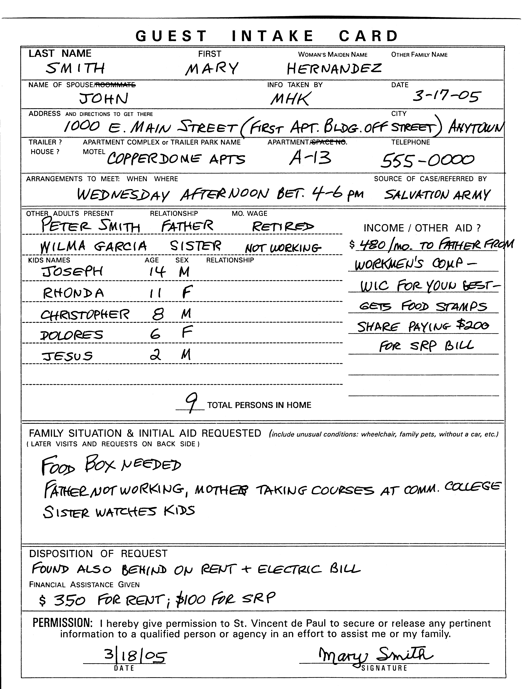
to make this
process as easy as possible.

Along with the three records that are described above, there is #4: the Quarterly Report and #5: the Annual Report that is sent to District Councils and forwarded to National. The amazing thing about these is that they are designed so that you can simply transfer the information from your other conference records directly with-out having to interpret a lot of odd
numbers.

DECEMBER 2008 PAGE 11-13

In giving assistance to those in need, it is sometimes necessary to fill out #6: a Request for Service (a “voucher”) so that service may be provided by someone else and then paid for by your conference. Filling this out properly is important. If all the blanks are not filled, the t’s dotted, and the t’s crossed, the service may not be provided.

Sounds like a lot?! No, not really. With the voucher (or Request for Service), we’re referring to just six reports or forms to be filled out. And, these are spread out among multiple people. Read on; you will see how easy paperwork can be.

Maintaining Guest Records

An individual record -- the Guest Intake Card -- is maintained for every person or family that comes to the attention of the conference. This record consists of two parts: 1) essential identifying information about the person or family, and 2) a log of contacts the conference has with the person or family under care.

As soon as the Conference enters into contact with someone in need, that person or family becomes a “guest”, hence the Guest Intake Card or Form. The Secretary is responsible for keeping all such records in a safe and protected place. Confidentiality is an important aspect of working with those in need.

It is the responsibility of the home visit team to review the guest record of the person they will be visiting. It is then their responsibility, prior to each conference meeting, to update the guest records of the persons they visited. They report on their visits during the meeting and return guest files to the secretary after use.

The Guest Intake Card makes provision for identifying information. The form in use actually covers a wide range of factors about the person or family. Remember that the Guest Intake Card constitutes a tool for getting to know and to help the family. Limit yourself to those elements which are necessary and useful to your being an effective helper. Only in those cases where the conference becomes rather deeply involved will home visitors want or need a fuller picture.

The information identified on the form is self-explanatory. There is nothing listed that needs special explanation. However, a second reminder is necessary that we should request only that information that we need to be a good helper. We should avoid the red tape look. If the person or family is visited more than once, additional information will be gathered on each visit.

The home visitors are responsible for documenting the guest's progress by recording their ongoing contacts. Be brief. Be factual; but remember that not all facts must be recorded. Opinions, particularly negative and judgmental analyses, seldom have

DECEMBER 2008 PAGE 11-14

a place in any SVdP report. Even if, for prudent reasons, some reservations about the people we are serving are inserted, be sure that such opinions are clearly labeled as personal impressions.

Case records that are more than a year old rarely have any meaningful value for most cases except as history. A person’s life may turn completely around in less than a year. Old guest records (although maintained for 7 years) should not be accessed on any guests except those who have been receiving ongoing assistance for a long time, as the Conference deems necessary.

Completing Meeting Minutes

The format which is set forth in this document for the recording of Minutes (Conference Meeting Report) has been officially approved by the District Council of Contra Costa Conference Resources & Concerns Committee, and its use by all parish conferences is strongly recommended. This standardization establishes uniformity of data and facilitates the collection and analysis of annual statistics and Annual Reports.

The “mock” Minute entries shown on the next page and explanation can serve as a guide for Conference secretaries. The first few lines need no specific explanation.

Near the top of the first page, statistics are requested about membership. This is a good place to restate what is meant by each type of member in the Society.

MEMBERSHIP CATEGORIES

Full members are those who fully participate in the life of the Society, which means (1) attends most conference meetings, promote the ideals of the Society, and (2) participates in the conference's basic works of charity. They are your members who make home visits, prepare food boxes, counsel those in need, visit the infirm, answer the phone, volunteer at the food reclamation center, a thrift store or dining room, and otherwise contribute their time to help those in need on a regular basis.

- According to the Rule of the U.S. Council, they must also be Catholic.

- According to the Policy adopted by the General Membership of the Contra Costa District Council on March 22, 2008, they must either (1) have completed the training (known as the Ozanam Formation Experience or "OFE") set by the Formation & Training Committee, or (2) been "grandfathered" as an existing Full member of the Society on March 22, 2003.

- Only Full members can hold office or vote on matters before a conference.

DECEMBER 2008 PAGE 11-15

Associate members are those who participate in the works of charity but do not regularly attend meetings. They may include members unable to participate actively in the charitable works due to age, health, work or other situations but who attend meetings. They pray for the Full and Contributing members of the Society, and for those in need served by the Society. As personal and job situations change, members move into and out of the Full and Associate categories.

Contributing members are those who contribute resources to the Society on a regular or substantial basis, providing the funds to make your conference's work possible. These individuals might give you twelve monthly checks of $10 each, a one-time check for $1,000, or a 3½ ton air-conditioner for your pantry. SVdP is a
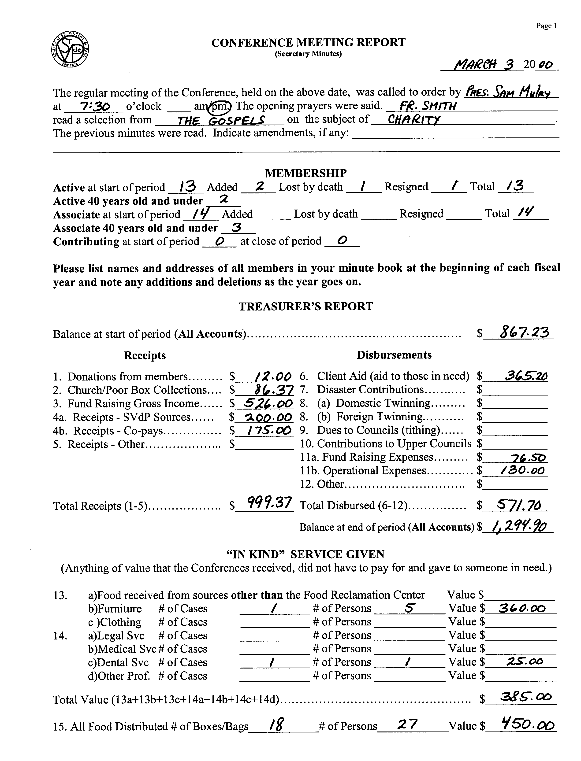
union of caring hearts, willing hands, and generous checkbooks.

Associate and Contributing members does not have been Catholic, but they cannot vote or hold office in the Society.

MEMBERSHIP. - This is a simple statistical record of change in conference membership. The numbers requested
are the number of members as of the
prior meeting; the number of new members, the number of members that have died or resigned, and the number of members as of the date of the current meeting. In addition, our National
Office considers
The Conference Meeting Report, page 1

DECEMBER 2008 PAGE 11-16

"youth" to be anyone who is 40 years old or under and they ask us to record the number of members currently in the conference who fit that age bracket.

TREASURER’S REPORT.

This portion covers information from the Treasurer about all conference funds: checking, saving, CDs, etc. Emphasis must be placed here on the words all conference funds. The Treasurer is obligated to report the status of all funds at every meeting -- not just the checking account.

Six categories of RECEIPTS are used. A full explanation of each is given.

1. Donations From Members - The Rule defines three types of members: Full, Associate, Contributing. This amount includes specific contributions from all three types of members. Include what is obvious. Do not try to pick out member donations from full church collections or the poor box...

2. Church/Poor Box Collections - This includes: (a) Church second or fifth Sunday, monthly or special (Ash Wednesday, Thanksgiving, etc.) collections; (b) Poor box collections; and (c) All other church related income. Also for those conferences that receive a fixed monthly stipend from their parish or a check from the parish council.

3. Fund Raising Gross Income - This includes gross income from special appeals and collection efforts not exclusively church centered (raffles, bingos, poor man suppers, sales of merchandise, etc.). The distinction here is that, if you have to work and ask for the funds, it is fund raising; if you didn’t ask for the funds, it is a donation and is probably better in 2. or 5.

4a. Receipts — SVdP Sources - This includes monies received from other SVdP units, twinning from other conferences or districts. No tithing is required on these funds since it is assumed that the SVdP sending entity already tithed on the funds.

4b. Receipts — Co-Pays – This includes monies received from individuals or organizations which are used to partially pay the bill of a specific guest. Other examples might be another charity, church or food bank contributing funds on behalf of a client both they and your conference are serving. These funds are considered to be a pass-through and no tithing is required.

5. Receipts — Other - Embraces all other types of income from sources not associated with the church, such as interest, bank adjustments, legacies, government subsidies or foundation grants, contributions from individuals and organizations.

DECEMBER 2008 PAGE 11-17

Conference EXPENSES are defined as follows:
6. Client Aid (Aid to Those in Need) - This is to include all monies expended for goods and services provided to people we serve. This entails all direct money grants; value of vouchers for food or merchandise; payment of bills, such as utilities, rent, medical, etc.
7. Disaster Contributions - This includes all monies sent to our National Office in response to a request for relief for victims of a disaster anywhere in the world.
8a. Domestic Twinning - This is financial assistance (a sharing of resources) by the conference to another conference(s) or council locally or somewhere in the U.S.
8b. Foreign Twinning - This is financial assistance (a sharing of resources) by the conference to another conference(s) or council in other countries. Foreign Twinning is arranged and coordinated through our National Office.
9. Dues to Councils (Tithing) - A 10% tithe of all income except that from other SVdP sources (4a) and co-pays (4b) is required of all conferences to be given to their district council.
10. Contributions to Upper Councils - This includes any other funds that are given by the conference to some upper (National, e.g.) Council of the Society.
11a. Fund Raising Expenses - This item includes all expenses associated with fund raising efforts (raffles, bingos, poor man suppers, merchandise sales, etc.). The distinction here is that, if you had to work to get the funds, it was fund raising; if you didn’t have to ask for the funds, it was a donation and shouldn't have expenses associated with it.
11b. Operational Expenses - This item includes ordinary and extraordinary expenses incurred by the conference in carrying on its work. Examples: postage, stationary, printing, meeting expenses, rent or utilities paid to the parish for the use of a room for a pantry or office, paying for the conference's telephone, whether wired or wireless. The purchase of religious materials that are distributed to the people we serve is also considered an operating expense. The conference is also permitted if not encouraged to vote to help a conference leader or leaders attend regional meetings for education and training purposes by underwriting reasonable costs of travel and/or registration and/or accommodations.
12. Other - This includes all other expenses, such as Mass stipends and bank adjustments (anything that doesn’t fit another specific category).

DECEMBER 2008 PAGE 11-18
The Conference Meeting Treasurer’s Report

Members of Vincentian Support Services regularly attend Conference and District Council meetings and they observe how the meetings take place, and how reports are given. The Treasurer’s Report is often commented on since it is presented in a variety of ways (and sometimes not at all).

What is expected from the Treasurer? First of all, the Treasurer is expected to give a formal report to the Conference at every meeting – not once a month, not occasionally. The purpose for this is to ensure that the Conference members know what funds they have available to them. A reminder here is that, in our Society, the disposition of the funds are the decision of the Conference as a whole – not just one or two people. No individual has a right to define how funds are to be spent and no individual has a right to veto an expenditure (assuming the money is in the account and that the Conference guidelines are being followed).

Secondly, the Treasurer must report the status of all accounts. Some Conferences are fortunate to have more than just a checking account. They may have a savings, CD, money market, or other type of account. The Treasurer must report the status of all of these during each meeting – for the same reasons as stated above.

Third, the Treasurer must then give an accurate summary of all income and expenditures. It is not necessary to list each individual donation or each individual check written – summary by category is appropriate. Below is a list of the categories that should be reported at each Conference meeting. The reason for these categories is that this is the way it should be reported on the quarterly and annual reports. Later in this Chapter, a Glossary describes what should be in each category. Follow the instructions – do not make up your own categories or rules for content.

TREASURER’S REPORT

Balance at start of period (All Accounts)……. $____________

Receipts Disbursements

1. Donations from members……… $__________ 6. Client aid (aid to those in need) $___________
2. Church/Poor Box Collections…. $__________ 7. Disaster Contributions…….…. $___________
3. Fund Raising Gross Income…… $__________ 8a. Domestic Twinning……… $___________
4a. Receipts - SVdP Sources…. . . . $__________ 8b. Foreign Twinning.……….. $___________
4b. Receipts - Co-Pays……………. $__________ 9. Dues to Councils (tithing)….. $___________
5. Receipts - Other……………….. $__________ 10. Contributions to Upper Councils $___________
11a. Fund Raising Expenses…….. $___________
11b. Operational Expenses………. $___________
1. + 2. + 3. + 5. minus 11a. times 10% equals 9. (tithing)
12. Other………………………….. $___________

Total Receipts (1-5)……………. $__________ Total Disbursed (6-12)…………$___________

Ending Balance (All Accounts) $____________

We really shouldn’t have to say this, but will. The report should add up. Many times the reports we are given do not add up. There is no reason for this. Balance at start of period plus Total Receipts minus Total Disbursed should equal Ending Balance.

Last, the Treasurer should welcome and be prepared to answer any question that members have about the report or details of it. This does not show a lack of confidence – it is their right. We are all stewards of the funds of the Society. We cannot manage them if we don’t accurately know what we are dealing with.

DECEMBER 2008 PAGE 11-19

“IN KIND” SERVICE GIVEN

This section of the Minutes reflects anything of value that the Conference gave to someone in need but did not have to pay for. According to tax laws, in-kind donations have value just like money donations and must be reported by non-profit organizations.

Food, Furniture, Clothing
13a. Food received from sources other than the Food Reclamation Center: All Conferences receive a monthly allocation of food from our SVdP Food Reclamation Center. What is requested here is the estimated value of food received from any other source: the parish food drive, donations from other churches, individuals or organizations, etc. Don't worry about detail here; just make your best guess.
13b. and 13c. Furniture and Clothing: Three numbers are requested for this in-kind donation: the number of cases in which in-kind furniture/clothing was given, the number of persons served by this donation, and the estimated (carport or flea market) value of the donation. This does not include items given guests via vouchers or CareCards® for our thrift stores.
14 a/b/c/d. In-Kind Professional Services - This includes legal, medical, dental and other professional services that are given without charge to those we serve. Just as with furniture and clothing, three amounts are requested: number of cases, number of persons served and value of the service.
15. Food Boxes Distributed - For ease of record keeping, this refers to all the bags or boxes of food distributed to the people we serve, regardless of the food’s origin. We realize that the value of a box or bag varies with size and the person filling it. It also varies with the size of the family being served. It is fairly easy to keep track of the number of boxes. Get a Vincentian who still shops for her own large family and she will undoubtedly have no difficulty in coming up with an average value for later accounting. Three amounts are requested: number of food boxes/bags, number of persons served and the estimated value of the food given. The value is normally a result of multiplying the number of boxes/bags by an estimated average value of a box/bag. Again, your best guess will work here; don't get hung up on precision.

SERVICES TO PEOPLE STATISTICS

At every conference meeting, members report on the cases contacted since the group’s last meeting. Members relate their activities, findings, and recommendations. The conference as a whole then discusses what future action is to be taken.

DECEMBER 2008 PAGE 11-20

The Secretary’s minutes report on families served is essentially a statistical report of conference casework. The following describes the statistical entries to be made:

Guest Name
Team - Enter the initials of the members handling the case(s).
No. Persons Served - This is the number of people assisted by the services described here.
Contact Hours - This is the number of hours spent is service on the case(s) described.
Jobs Obtained - This covers help in obtaining employment. If a job was obtained for a member of the family being served, complete the appropriate block.
Referrals Given - If specific referrals to other agencies are made, whether public or private, enter the number of agencies to which referrals were given.
Spiritual Aid - If there was a referral to a priest or minister for spiritual guidance, religious materials given, prayer shared or if a direct spiritual discussion took place, indicate the number of times.
Travel Aid - This is the number of times travel assistance was given to persons or families, not a dollar amount. Gas vouchers issued and car repairs are also included.
Home Visits - This is the number of visits made to the home(s) of those we served.
Other Contacts - This is the number of contacts made with the guests somewhere other than in their homes (i.e. parish office, SVdP pantry, local restaurant, etc.).
Rent - If rent assistance, either full or partial, fill in the appropriate box.
Utilities - Payments are sometimes made toward utility bills: gas, electric, water. Sometimes these are made for the complete amount due, sometimes partially. Enter the number of payments made.
Lodge - Lodging refers to temporary housing (primarily motel rooms, but also includes shelters). Enter the number of times this person or family was placed in temporary lodging, not number of nights. If 3 nights in a room was provided, this is one occurrence. If the member arranged on three different occasions for a one night stay, this is three occurrences.
Food - This is the number of times since the last meeting that food was distributed to this person or family either directly out of a food pantry or through purchase via cash or food vouchers.

DECEMBER 2008 PAGE 11-21

INSTITUTIONAL VISITATION REPORT
Four types of institutional visits are reported: prisons, hospitals or nursing homes, other institutional visits and young Vincentian projects.

G. Prison Visits - This refers to the number of times members called at a jail or prison to visit inmates; the number of inmates visited is entered; and the number of hours spent by the visitors.

H. Hospital/ Nursing Homes- This refers to the number of times members called at a hospital, overnight medical facility or nursing home to visit patients; the number of
patients visited is entered; and the number of hours spent by the visitors.

I. Other Institutional Visits. This refers to the number of times members called at some other type of institution; the number of persons visited is entered; and the number of hours spent by the visitors.

Young Vincentian Projects. This refers to the number of times our young Vincentian members executed a special service project of behalf of those in need; the

DECEMBER 2008 PAGE 11-22

number of persons served; and the number of hours spent by the young Vincentians.

OTHER CONFERENCE ACTIVITIES includes specific items explained below.

J. Twinning Letters Sent - The secretary reports on any letters sent in connection with twinning to other conferences or councils.

K. Twinning Letters Received - The secretary reports on any letters received in connection with twinning from other conferences or councils.

L. Religious Items Distributed - This refers to the number of items that are religious in nature (bibles, rosaries, prayer books, etc.) that were given to those served.

M. Blood Donations - This refers to the number of times members (or those we specifically solicited) had donated blood to hospitals or blood banks.

N. Total Hours (Conference) - Each member states hours given by him/her to SVdP charitable and organizational work since he/she last reported this to the conference. This includes all time spent as a Vincentian: meetings, home visits, pantry or office service, workshops, retreats, etc. and includes all travel time to and from these activities. This also includes number of hours in G, H, I above.

O. Total Hours (SVdP Special) - Each member states hours given by him/her to a SVdP facility or project (thrift store, dining room, food reclamation, etc.) where the hours are recorded separately.

P. Total Persons Served - For every case reported, the number of people served or visited is identified. This is the total number of people served since the last meeting. This also includes number of persons in G, H, I above.

Total Cases - One request or call from one person or family responded to by the conference counts as one case. Each call for help is a separate case.

Special Works - These differ from the items specified earlier in the minutes; some conference members are involved in special works such as volunteering at the food reclamation center, dining rooms, shelter, medical-dental clinic, etc. This also refers to special works operated by SVdP but not necessarily by the conference.

The Remaining Items covered in the Minutes form are self-explanatory. For purposes of illustration, mock entries are provided.

At the bottom of page 3 are the closing entries to be made by the secretary. Attendance must be recorded. The Secret Collection is then recorded. The secret

DECEMBER 2008 PAGE 11-23

collection is normally taken by passing a bag around to each member who then makes a personal, sacrificial contribution based on what that member can afford. Sometimes the collection is added to the normal conference funds. Sometimes it is recorded separately and used for special conference expenses such as Masses for deceased members, flowers for hospitalized members, etc. The secretary then signs the Minutes.

The Treasurer’s Record

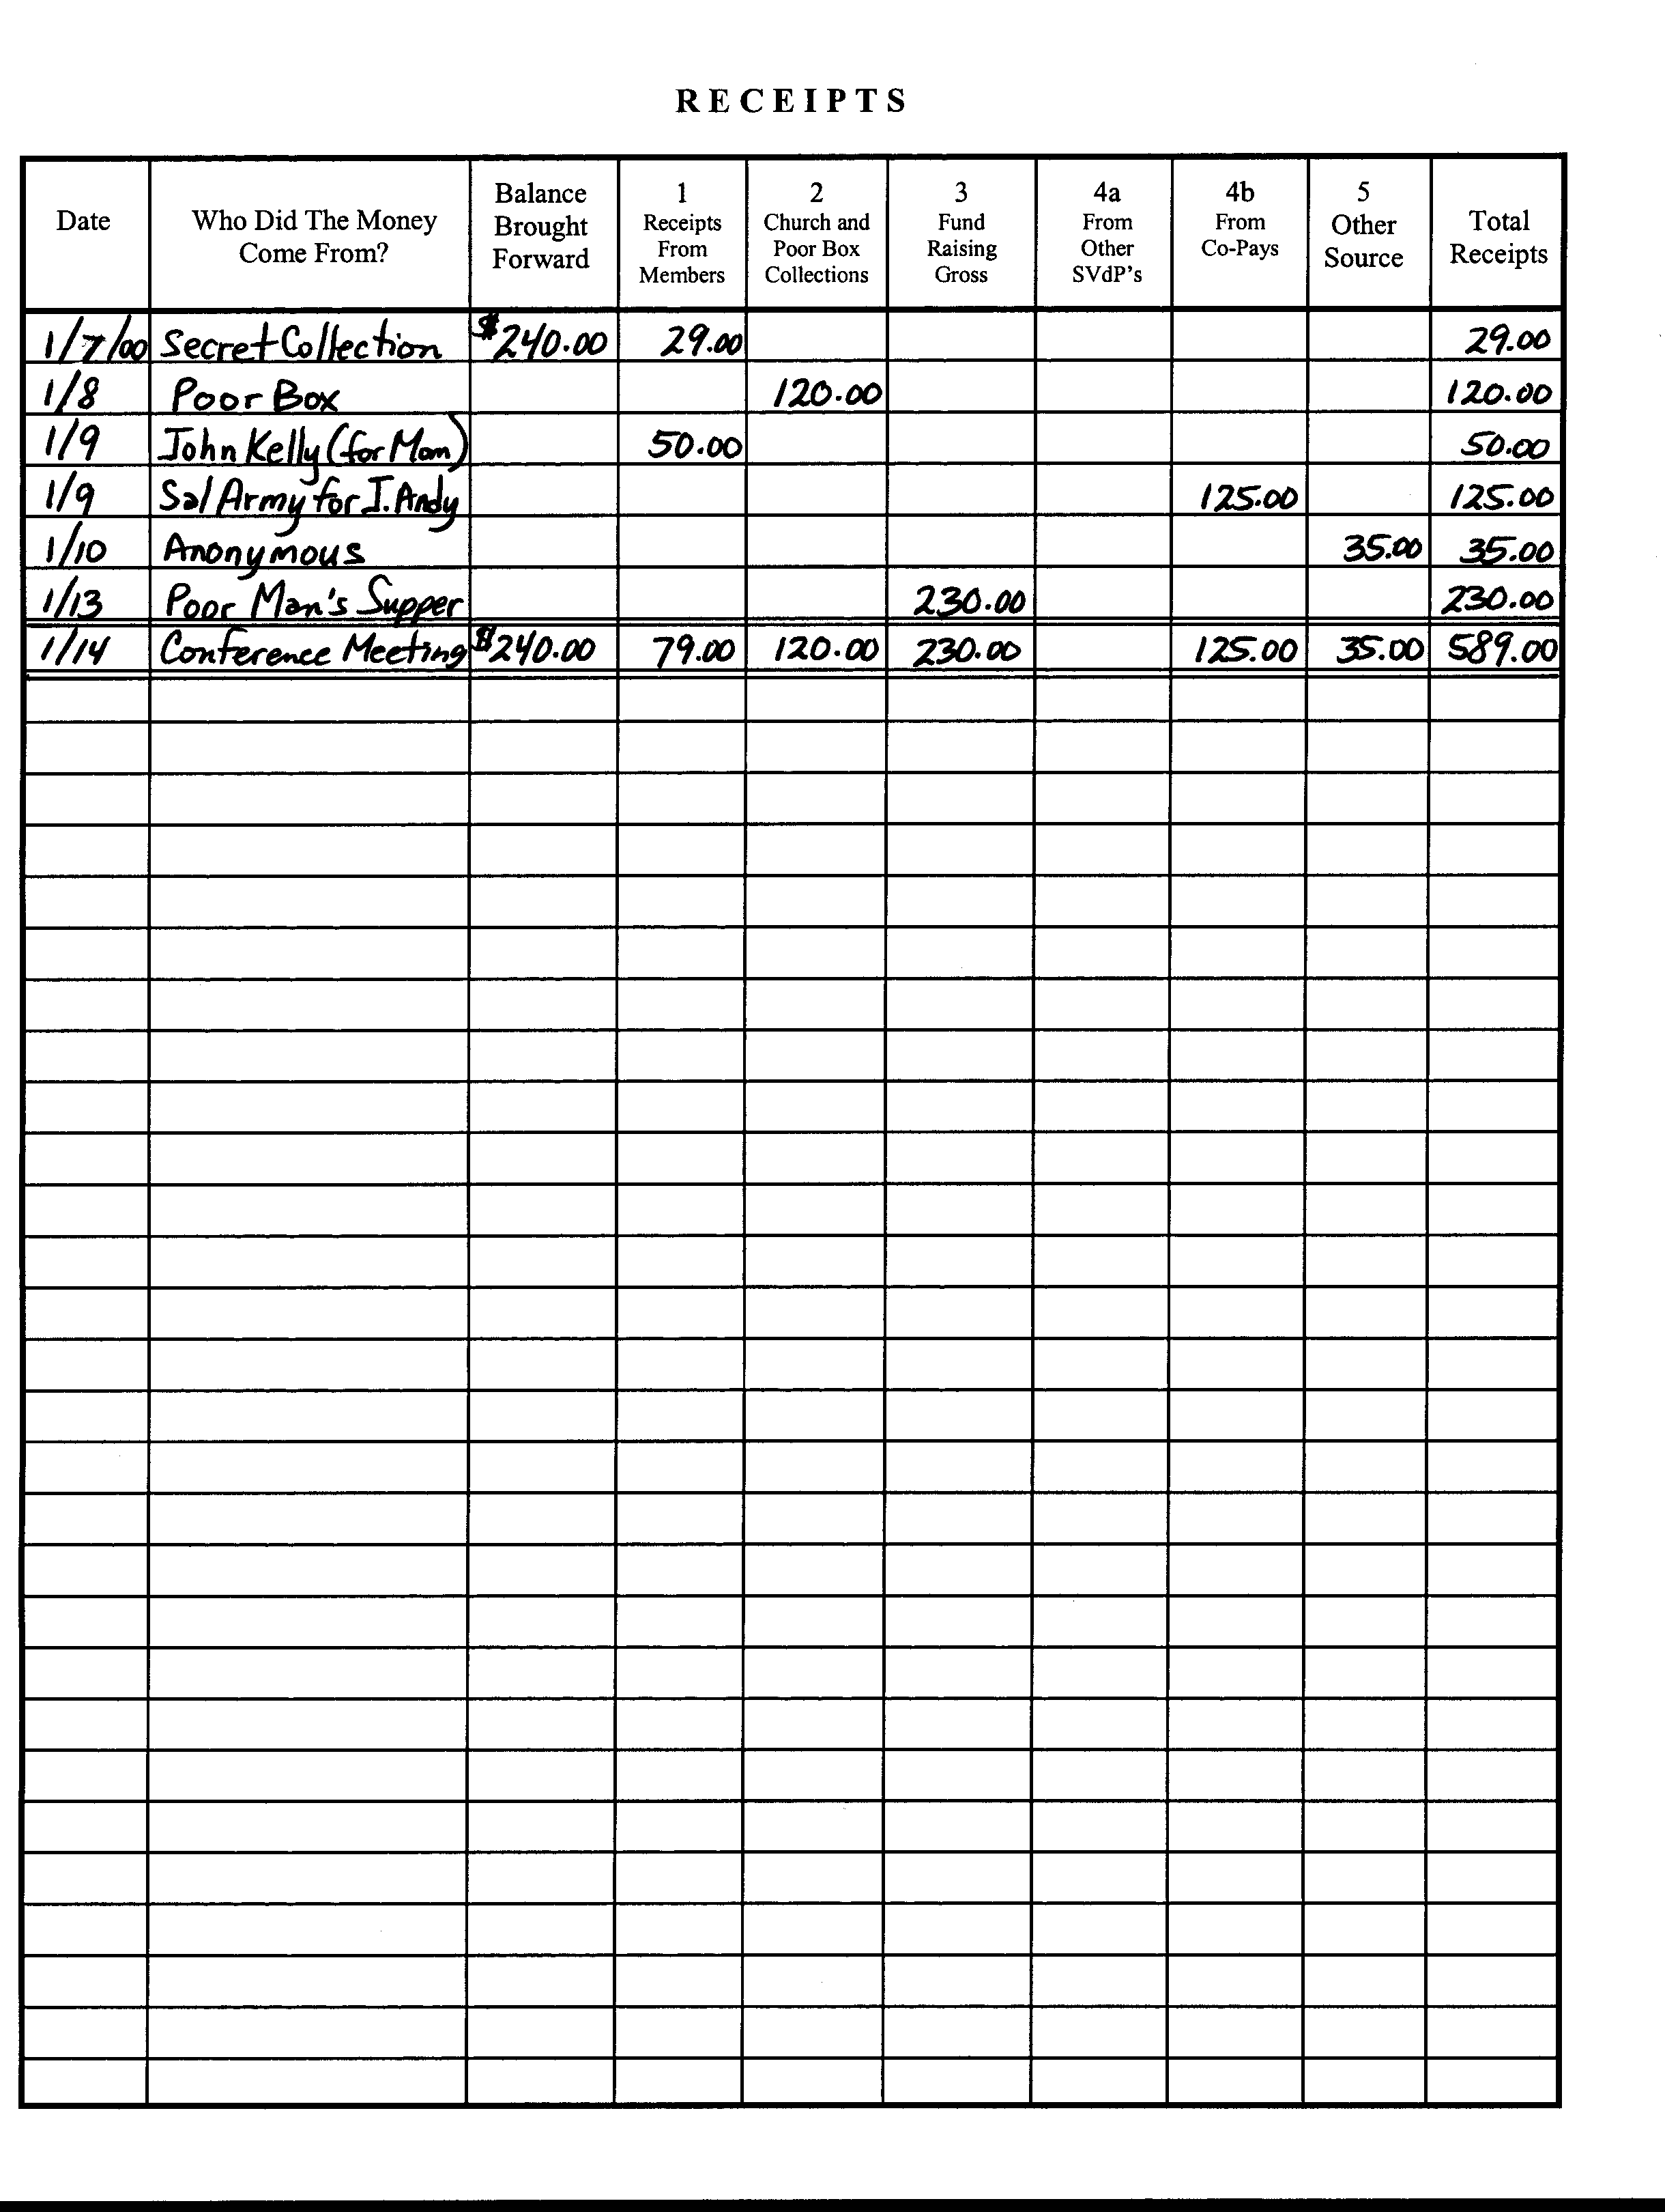

the “RECEIPTS” page of the Treasurer’s Journal

It has been highly recommended that SVdP Treasurers maintain a journal for recording the fiscal receipts and expenditures for the conference. To promote standardization, we designed and published the Conference Treasurer’s Journal, in which the treasurer would record all cash and check receipts and expenditures in date order of their occurrence.

The conference relies on the treasurer for verifying any bills presented for payment. All expenditures should be transacted by check. Cash transactions should be avoided as much as possible; but, if made, should be recorded in the journal as well.

The Treasurer’s Journal is not a checking account checkbook. It is a record of all transactions of all funds for which the conference is responsible. This includes checking, savings, CDs, money market accounts, etc. Special care should be taken in the way transactions are reflected. For example, if money is transferred from a checking to a savings account or vice-versa, there is no income or expenditure; the conference has not gained or spent anything. The funds were just moved from one pocket to another. Entries would be reflected in the checkbook and the savings account record but not in the journal since there was no change in funds.

DECEMBER 2008 PAGE 11-24

The Treasurer’s journal follows the same classification for income and expense items that are recorded in the Secretary’s minute book. The definition of terms employed in the Treasurer’s Journal is therefore identical to that used in the Secretary’s Minute Book.

The various conference receipt items are defined below.

Receipts From Members, Church and Poor Box Collections, Fund Raising Gross, Receipts - Other SVdPs, Receipts – Co-Pays and Receipts — Other Sources correspond directly to items 1 through 5 in the Secretary Minutes. The definition does not have to be repeated here. The definition also appears in the Glossary at the end of this document.

The various conference expenditures are defined as follows:

Client Aid: Shelter - This is the amount being expended for housing, permanent or temporary.

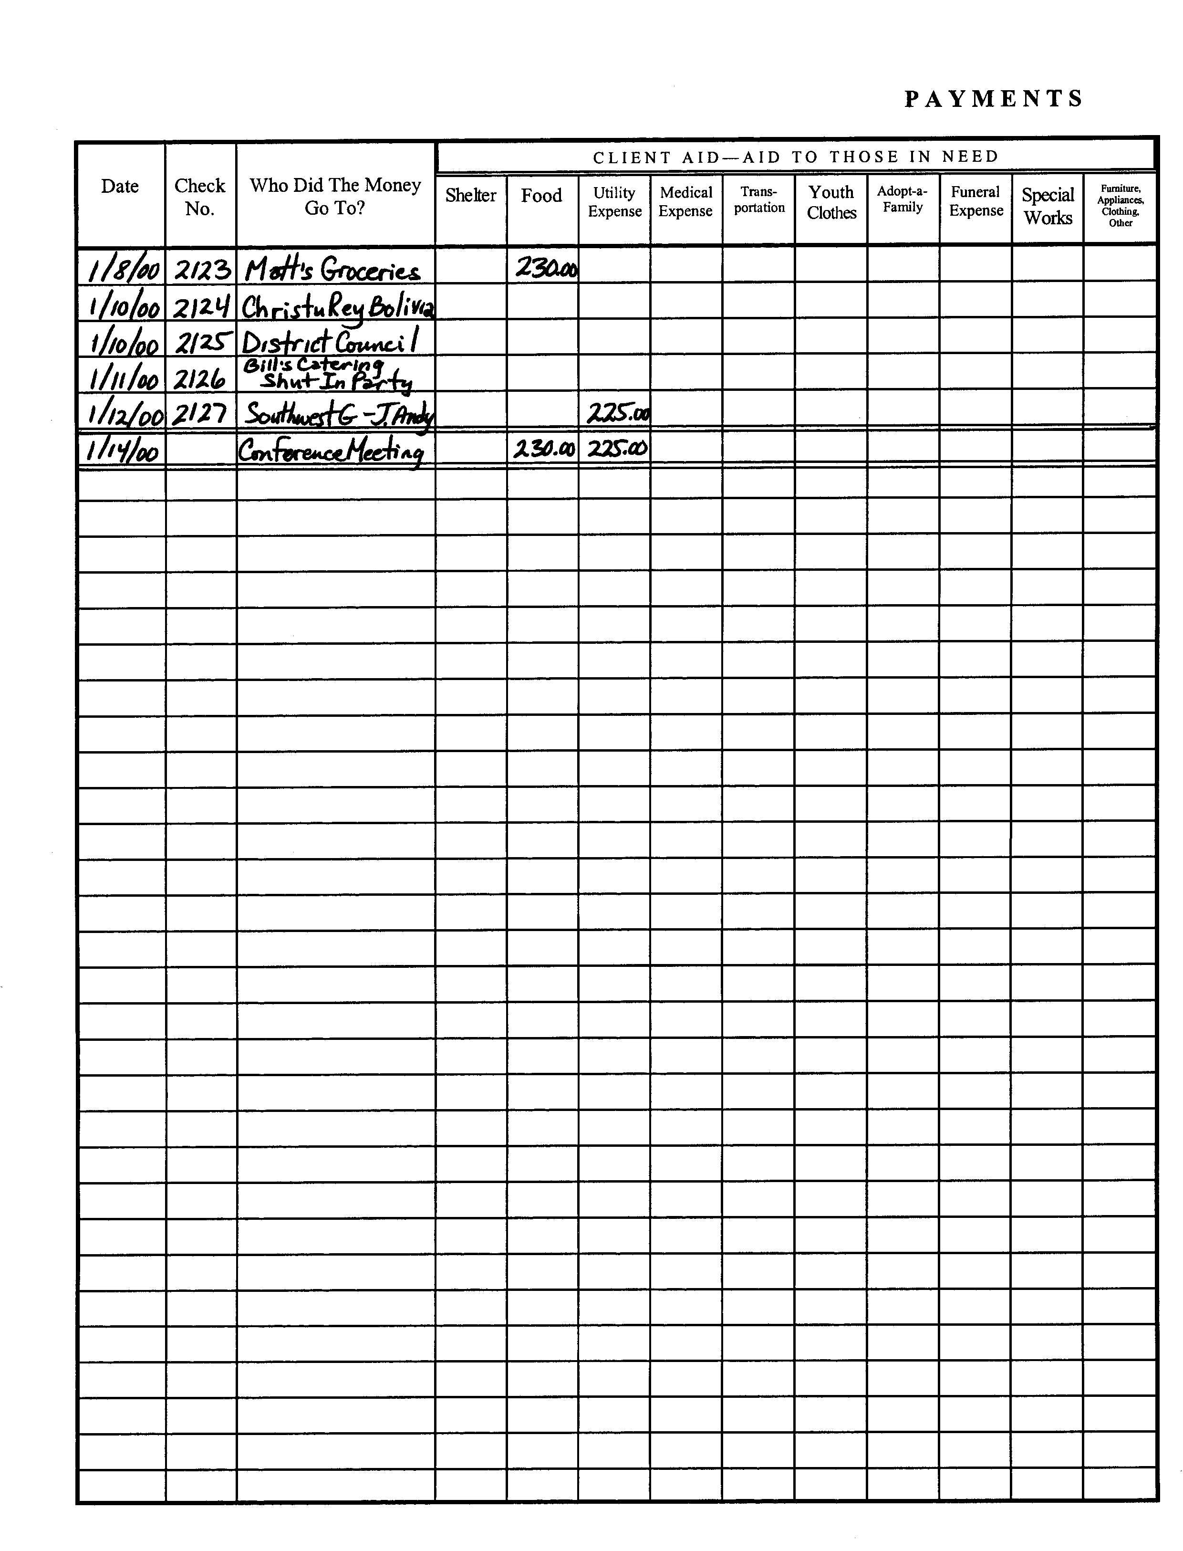
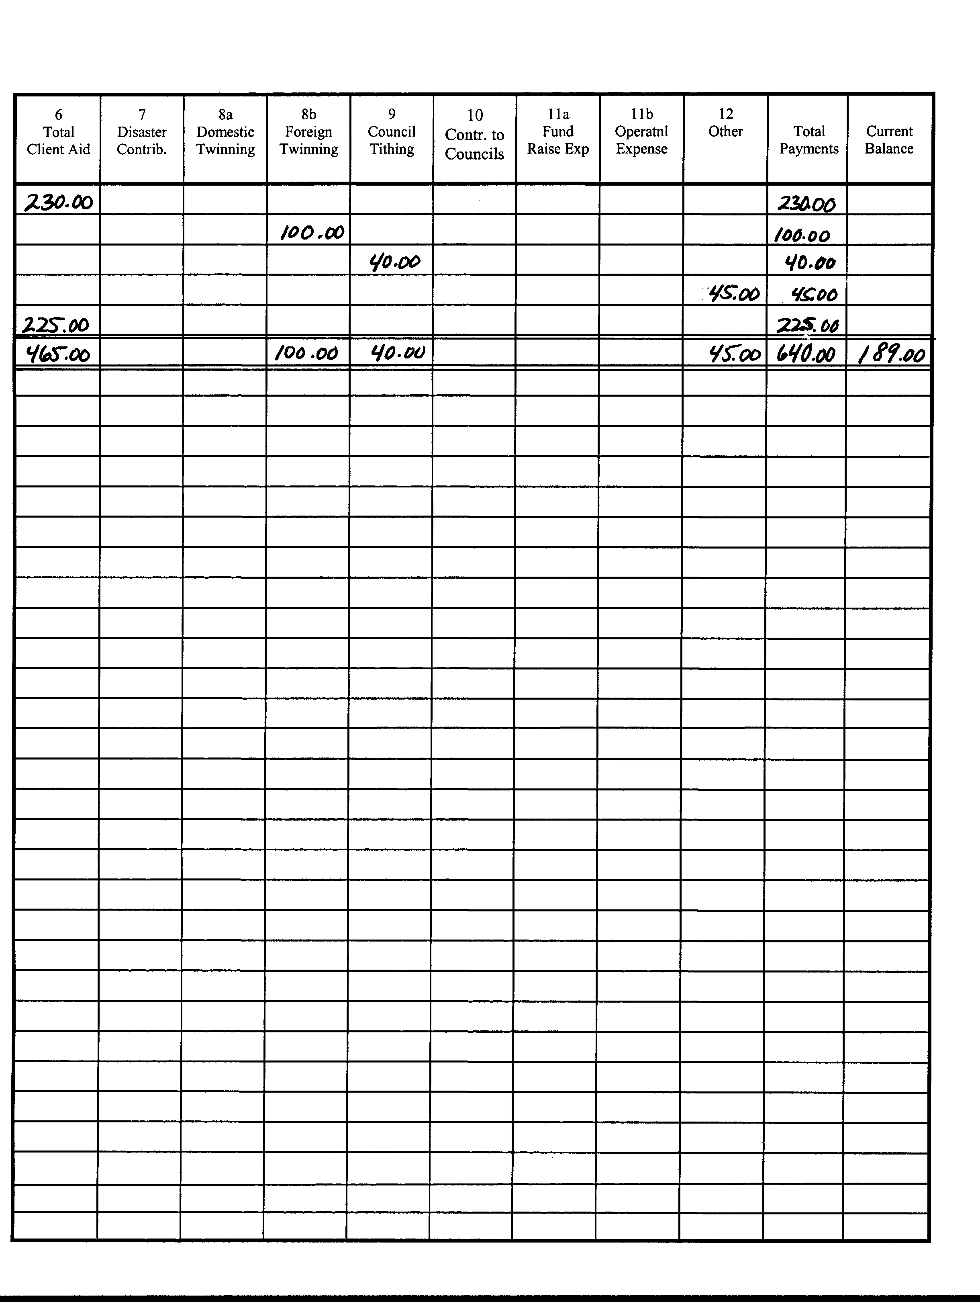
The “payments” pages of the Treasurer’s Journal

DECEMBER 2008 PAGE 11-25

Client Aid: Food - This includes funds spent for all food-related expenses -- groceries, prepared meals, grocery store vouchers or certificates, charges for food delivery, etc.

Client Aid: Utility Expense - The amount spent for gas, electric, and water utility payments is indicated here.

Client Aid: Medical Expense - This would be anything spent directly for medical purposes: doctor bills, hospital charges, prescriptions, dental work, etc.

Client Aid: Transportation - The amount being expended for travel (bus tickets or monthly passes, train or even airline tickets); includes car repairs and gas vouchers.

Client Aid: Youth Clothes - Any return to school clothing and supplies program is reflected in this column operated by the conference or its district.

Client Aid: Adopt-a-Family - Expenditures for Christmas food baskets/presents are included here: Adopt-a-Family program or local conference sponsorship.

Client Aid: Funeral Expense - This would include any payments made toward a funeral, funeral arrangements or funeral reception.

Client Aid: Special Works - Some conference members are involved in special works such as volunteering at non-conference food pantries, free dining rooms, rehab facilities, etc. This also refers to special works operated by SVdP but not by the conference.

Client Aid: Furniture, Appliances, Clothing, Other - This will include furniture, appliances, household items, clothing and anything else which is spent on behalf of the people we serve that is not designated in one of the other Client Aid categories.

6. Total Client Aid - This is a total of everything included on the line in the first ten columns (Client Aid). This also corresponds directly to item 6 of the secretary’s Minutes.

7. Disaster Contributions, 8a. Domestic Twinning, 8b. Foreign Twinning, 9. Council Tithing, 10. Contributions to Councils, 11a. Fund Raising Expenses, 11b. Operational Expenses, and 12. Other corresponds directly to items 7 through 12 of the Secretary’s Minutes. Their definition need not be repeated here. The definition is also included in the glossary at the end of this document.

As shown in the examples, totals are reflected on both the income and expense side

DECEMBER 2008 PAGE 11-26

of the journal corresponding to meeting dates. This keeps the Treasurer’s Report in line with that reflected in the Secretary’s Minute book. Also, the same type of totaling is done at the end of a quarter and at the end of the fiscal year to reflect the amounts that are shown on the Quarterly Report and the Annual Report.

The Quarterly Report

The Secretary’s Minute Book should contain copies of the Quarterly Report form. Page 1 of this form is shown on the following page, 11-28. If minutes of meetings have been carefully kept by the secretary, the compilation of the Quarterly Report is relatively uncomplicated. The quarterly tabulations are simply compilations of statistics which are reported at conference meetings during the quarter.

If you will take a moment to compare the recommended Secretary Minute format to the format of the Quarterly Report, you will see that they are very similar. Items 1 through 15 from the Minute book correspond directly to items 1 through 15 on the Quarterly Report. Items A through P from the Minute book correspond directly to items A through P on Page 2 of the Quarterly Report (below). It is simply a matter of accumulating the statistics from the Conference minutes and inserting them in the appropriate slots on the Quarterly Report.

DECEMBER 2008 PAGE 11-27

DECEMBER 2008 PAGE 11-28

Schedule “A” -- also on page 2 of the Quarterly Report

On the inside of the four-page Quarterly Report form, there are two supplementary schedules which must be filled out by the Treasurer. Schedule A (above), on page 2, is effectively a breakdown of Client Aid (#6. on the Quarterly Report). This will take a little research by the Treasurer, but everything should be easily identified under the ten column breakdown of Client Aid in the Treasurer’s Journal. Schedule A should need no explanation since all items are clearly identified. And, the total at the bottom of the page should equal the amount shown in #6. (Client Aid) on the Quarterly Report.

DECEMBER 2008 PAGE 11-29

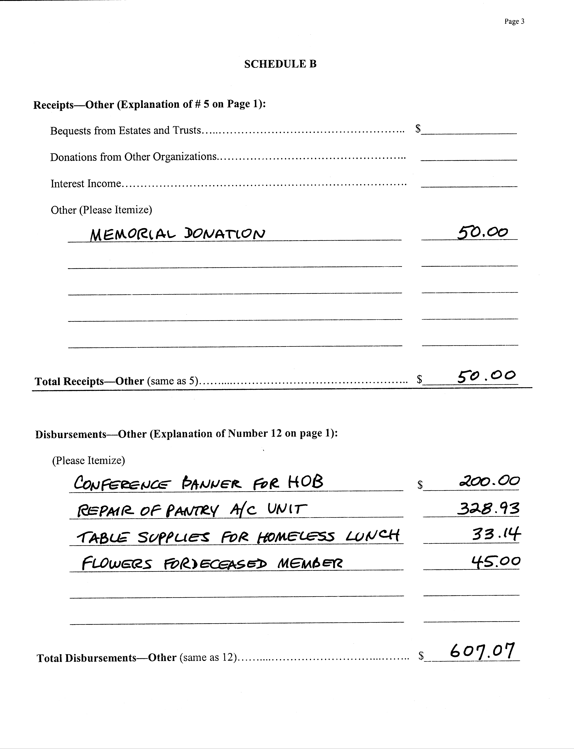

Schedule B (above), on page 3, is necessary only if entries were made on the Quarterly Report under “#5. Receipts—Other” or “#12. Other Disbursements.” It has become necessary to ask for this breakdown because of IRS regulations.

DECEMBER 2008 PAGE 11-30

page 4 of the Quarterly Report

DECEMBER 2008 PAGE 11-31

TWINNING INFORMATION

The back page of the Quarterly Report form has three sections. The first requests identifying information about conferences and/or councils with whom you twin. Please indicate three things for each: #1: whether you are receiving or giving twinning; #2: the amount given or received during the quarter; and #3: if that amount was every month, every quarter, or a one-time gift.

MEMBERS / OFFICERS

The second portion on the back requests information regarding officers and members of the conference. Full address (including zip code) and telephone information is requested because this is entered into a computer data base and used for conference statistics and for mailings which go out to officers and members.

The membership list is sent to the National office on occasion to insure that each member receives a copy of the Ozanam News which is published several times each year by the National office. It is expected that each conference has a full slate of officers which includes president, at least one vice-president, secretary and treasurer. It is also required that each conference have an active Spiritual Advisor.

ACKNOWLEDGMENT (Signature)

The final portion of the Quarterly Report form is the acknowledgment of the president of the conference. This report is normally prepared by a joint effort of the officers, but must be reviewed and approved by the president.

WHO GETS A COPY ?

This Manual originally advised that, once all forms had been completed, a copy was (1) retained by the conference Secretary, (2) a second copy sent to Vincentian Support Services and (3) the original of each form sent to the District President within 30 days after the end of the quarter. These instructions, in fact, appeared at the bottom of every Quarterly and Annual Report form.

It was discovered that the Contra Costa Council's District By-Laws (unfamiliar to most Vincentians) had a different procedure, and that a third procedure resulted when some district presidents asked to receive all copies before any were sent to VSS. Until these conflicts are resolved by the committee currently working on revising the Council By-Laws, the conference Secretary should retain the original Report and send three copies to the District President.

DECEMBER 2008 PAGE 11-32

Remember that tithing is to be done with each quarterly report. Tithing is 10% of Conference income. This is calculated as 10% of total income minus income from SVdP sources/co-pays and fund raising expenses. The calculation is specifically shown on page 1 of the Quarterly Report under the “Receipts” column.

This brings us to the piece d' resistance, the Annual Report.

Life can be full of pleasant surprises at times. And this happens to be one of them. The Annual Conference Report is almost identical to the Quarterly Conference Report. All forms are filled out and submitted as with the Quarterly Report. No sample forms will be shown here since they are like the others.

Basically, you take all four Quarterly Reports, add them up, and transfer the totals to the Annual Report form. Sound simple? It is!

There is one difference. The Annual Report's last page requests a complete list of your conference members. The Quarterly Report's last page requests only the changes since the prior Quarterly Report (new members added, old members lost).

One of the main purposes for the Annual Reports is to provide our National Office with a consolidated look at what has been done overall by all the conferences within our Diocese. This consolidation is done by Vincentian Support Services. Your Annual Report is combined with reports from all the other conferences and then the numbers are forwarded to National.

For now, the original of each Report form should be kept at your conference and three copies sent to your district council president by the first week in November. Your September Bank Statement is also needed. It is only needed for the Annual Report -- not for the Quarterly.

DECEMBER 2008 PAGE 11-33

note
Tithing
instruct-ions

DECEMBER 2008 PAGE 11-34

Filling out the Request for Service (the Conference Order form or “Voucher”)
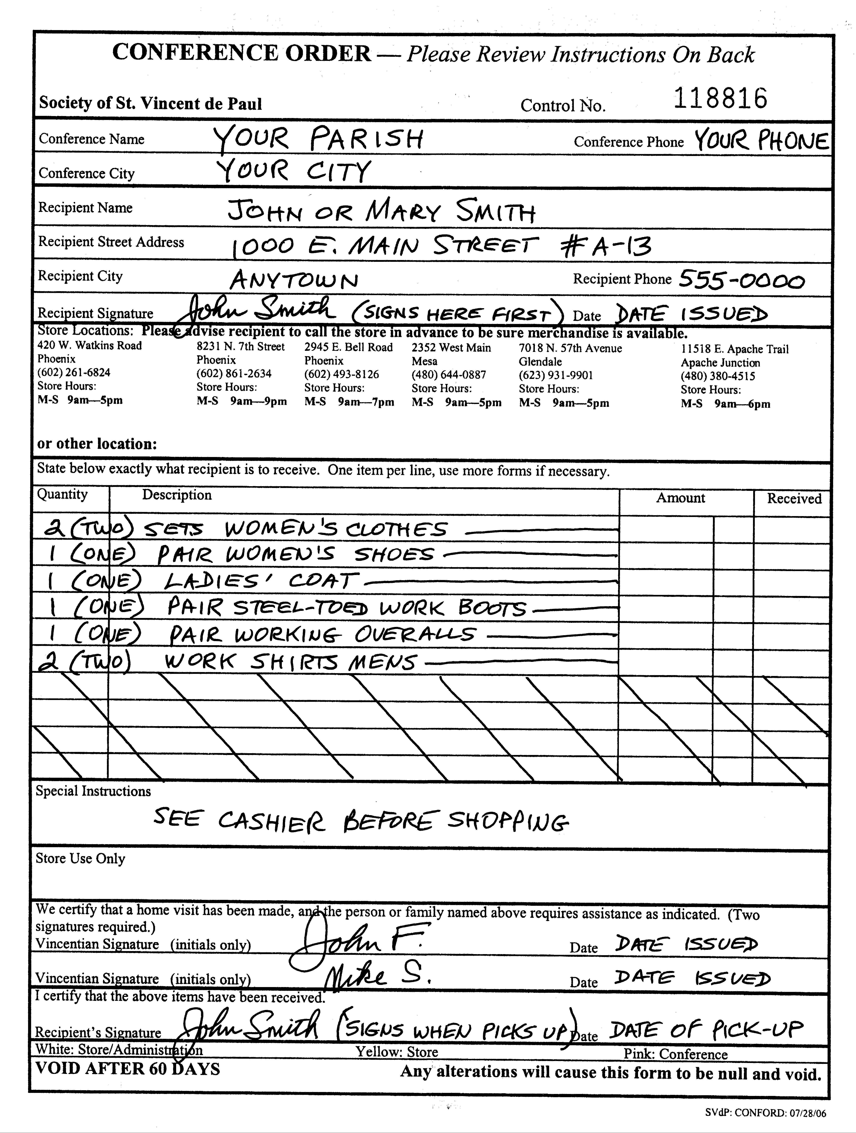

DECEMBER 2008 PAGE 11-35

Vouchers -- a Request for Service -- are a tremendous asset to SVdP conferences. They allow us to purchase needed merchandise for those we serve without our being physically present during the transaction. They also allow for our conferences to be billed for the merchandise so that no money is actually exchanged at the time of the transaction.

The Conference Order (shown on the previous page) is the "voucher" commonly used by our conferences. Some conferences have established their own vouchers which are accepted at local motels, gas stations, grocery stores, etc.

There are some important factors to remember about using vouchers. First, they are as good as money, so keep close track of the blanks so no one has access to them who shouldn’t. Second, make sure that all of the blanks are filled that should be, that all of the i’s are dotted and t’s are crossed. And, third, make sure that the voucher cannot be altered by the guest or someone else to gain more than you intended to pay for.

Only the Conference Order form will be described in this document. Similar considerations can be assumed for some other vouchers, but the possibilities are limitless and we will focus here on only one format.

A couple of general comments first. The form is a three part form, so press hard enough so that what is written can be seen clearly on the third copy. Never use a pencil. The form can be altered too easily when pencil is used. Never scratch something out to make a change. This could look like the voucher recipient tried to alter the voucher and it may not be accepted. Try to use black ink rather than another color because it is generally easier to read.

The information at the top of the form (Conference Name, Conference Address, Recipient Name, Recipient Address) are self explanatory. One comment on conference name: please do not write "St. Vincent de Paul" as the conference name unless you are from St. Vincent de Paul Parish.

Recipient Signature appears at both the top and the bottom of the form. When the voucher is issued, the recipient must sign at the top. When the merchandise is picked up, the recipient will sign at the bottom and signatures can be compared.

Several Store Locations are listed. Store hours are also listed but these change for various reasons. Have the guest call ahead to verify store hours. If something other than clothing is to be picked up, it is a good idea for the guest to call ahead to the store they intend to visit to see if the merchandise is available.

DECEMBER 2008 PAGE 11-36

Quantity and Description of the items to be picked up.

Be as exact as possible as shown in the example. State the quantity as a numeric value -- 1, 2, 3, etc. -- as well as write it out in longhand in parentheses -- (one), (two), (three), etc. This reduces the possibility of alteration.

Be sure you describe the item clearly. When the word "clothing" is used, it refers to an appropriate set of clothing for that individual. Make sure that there are no blank lines left. This avoids alteration.

Leave "Amount" blank. This will be filled in by Store personnel with the appropriate amount for those items for which the conference will be expected to pay.

There are two areas set aside for Special Instructions. One is for your use to indicate anything special about the person or family that the store personnel need to know. The other is specifically for use by store personnel only.

Conference Member Signatures - Two are required since two members are required on each home visit. It is recommended that first names and last name initials be used instead of full names. This maintains the anonymity of the conference members.

Should you forget these instructions, the back of the pink copy has a full set of instructions on how to fill out the voucher.

Once the voucher has been filled out properly, the pink copy is kept by the conference for its records. The white and yellow copies are given to the recipient to take to the store. If the store staff is able to fill the request completely, they will keep the white and yellow copies for store/administration record keeping and billing purposes. If the voucher is not completely filled, the store staff will keep the white copy and give the yellow to the recipient indicating which items have been given. The recipient then brings the yellow copy back at another time to get the remainder of the merchandise.

All vouchers are valid for only 60 days. After that they will not be honored by the store. If a recipient cannot get the voucher filled in that time, you will have to void it and issue another. Your home visit team may even consider accompanying the recipient to the store to be sure all goes well. This, in fact, does add to the personal touch, to the caring service which we Vincentians should be giving those we serve.

As mentioned earlier, some of what is described here can be used as general guidelines for filling out other types of vouchers.

DECEMBER 2008 PAGE 11-37

Glossary of Vincentian Terms

Active Members - see Full Members -- term formerly used (pre-2006) to describe the highest level of membership in the Society.
Aid to Those in Need - This is to include all monies expended for goods and services provided to those we serve. This entails all direct money grants; value of vouchers for food or merchandise; payment of bills, such as utilities, rent, etc.
Associate Members - Those who participate in the Society's works of charity but do not regularly attend meetings (or may be non-Catholic).
Blood Donations - This refers to the number of times members (or those we specifically solicited) had donated blood to hospitals or blood banks.
Case - One call from one person or family responded to by the Conference counts as one case. Each call for help is a separate case. If one call results in multiple types of assistance, it is still one case.
Case # - An obsolete and impersonal system once in use by the Society where each case was assigned a number by the Conference secretary. The recommended numbering scheme was simply to start from "1" at the beginning of each fiscal year and sequentially number cases from that point on. With a deeper understanding that those we serve are "friends" or "guests" as opposed to "clients", it was generally agreed that a guest should not be a number, but, like a personal friend, someone we know by name.
Church/Poor Box Collections - This includes: (1) church collections; (2) poor box collections; (3) all other church related offerings. For those conferences whose parish is operating under a stewardship basis, this would also include an allocation from parish funds for the conference rather than an actual collection from the congregation.
Client Aid - See Aid to Those in Need.
Client Aid: Adopt-a-Family - Expenditures for Christmas food baskets/presents are included here: from the District Council's Adopt-a-Family program or local conference sponsorships.
Client Aid: Food - This includes all funds spent for food, either groceries or prepared meals.
Client Aid: Funeral Expense - This would include any payments made toward a funeral, funeral arrangements, or funeral reception.

DECEMBER 2008 PAGE 11-38

Client Aid: Furniture, Appliances, Clothing, Other - This will include furniture, appliances, clothing and anything else which is spent on behalf of someone in need that is not designated in one of the other Client Aid categories.
Client Aid: Medical Expense - This would be anything spent directly for medical purposes: doctor bills, hospital charges, prescriptions, dental work, etc.
Client Aid: Shelter - This is the amount being expended for housing, permanent or temporary, apartment or house. For motels and shelters, see Lodging
Client Aid: Special Works - Some conference members are involved in special works such as volunteering at non-conference food banks, free dining rooms, medical-dental clinics, etc. This also refers to special works operated by SVdP but not by the conference.
Client Aid: Transportation - This is the amount being expended for travel (bus tickets and monthly passes, train and airline tickets, etc.), car repairs and gas vouchers.
Client Aid: Utility Expense - The amount spent for gas, electric and water utility payments is indicated here.
Client Aid: Youth Clothes - A back-to-school clothing program operated by the conference or a district council is what is reflected in this column.
Contact Hours - This is the number of hours spent in service on the case(s) described.
Contributing Members - Those who contribute financial or other resources to the Society on a regular or significant basis.
Contributions to Upper Councils - This includes any funds that are given by the conference to some upper (National, e.g.) council of the Society.
Disaster Contributions - This includes all monies sent to our National Office in response to a request for relief for victims of a disaster anywhere in the world.
Donations From Members - The Rule defines three types of members: Full, Associate, Contributing. This includes specific contributions from all three types of members.
Full Members - Those who fully participate in the life of the Society - Catholic, attending meetings regularly, promoting the ideals of the Society, fulfilling obligatory training, and participating in the conference's works of charity.
Fund Raising Expenses - This item includes all expenses associated with fund raising efforts (raffles, bingos, poor man suppers, sale of merchandise, etc.). The distinction here is that, if you have to work and ask for the funds, it is fund raising; if you don’t ask for funds, it is a donation.

DECEMBER 2008 PAGE 11-39

Fund Raising Gross Income - This includes gross income from special appeals and collection efforts not exclusively church centered (raffles, bingos, poor man suppers, sale of merchandise, etc.). The distinction here is that, if you have to work and ask for the funds, it is fund raising; if you don’t ask for funds, it is a donation.
Home Visit - This is a visit made to the home of someone who has asked for assistance.
Hospital/Nursing Homes- This refers to the number of times members called at a hospital, overnight medical facility or nursing home to visit patients; the number of patients visited is entered; and the number of service hours spent by the visitors.
“In Kind” Service Given - This reflects anything of value given to someone in need that the conference did not pay for. For these items, three amounts are requested: number of cases in which this in-kind service was given, number of persons served, and estimated value of the materials or service provided.
Lodging - Lodging refers to temporary housing (primarily motel rooms and shelters). See also Client Aid - Shelter.
Number of Food Boxes Distributed - This refers to the number of boxes or bags of food distributed. We realize that the value of a box or bag varies with size and the person filling it. It also varies with the size of the family being served. It is fairly easy to keep track of this number. Have a Vincentian who still has to shop for a large family estimate the value of the average food box.
Number of Persons Served - This is the number of people assisted by the services.
Operational Expense - This includes ordinary and extraordinary expenses incurred by the conference in carrying on its work. Examples: postage, stationary, printing, meeting expenses, rent or utilities paid to the parish for a pantry or office, purchase of religious materials for distribution, etc. The conference is also permitted if not encouraged to vote to help a conference leader or leaders attend regional meetings for education and training purposes by underwriting reasonable costs of travel and/or registration and/or accommodations.
Other Contacts - This is the number of contacts made with the guest anywhere other than in the home (i.e. parish office, SVdP pantry, local restaurant, etc.).
Other Disbursements - This includes all other expenses, such as Mass stipends and bank adjustments.
Other Institutional Visits- This refers to the number of times members called at some other type of institution or executed some special project; the number of persons visited; and the number of service hours spent by the visitors.

DECEMBER 2008 PAGE 11-40

Prison Visits - This refers to the number of times members called at a jail or prison to visit inmates; the number of inmates visited is entered; and the number of service hours spent by the visitors.
Receipts - Co-Pays – This includes monies received from individuals or organizations which are used to partially pay the bill of a specific guest. These funds are considered to be a pass-through and no tithing is required.
Receipts - Other - Embraces all special types of income, such as interest, bank adjustments, legacies, government subsidies or foundation grants. Also included are contributions from non-members and organizations.
Receipts - SVdP Sources - This includes monies received from other SVdP units, twinning from other conferences or financial assistance from district or District councils. No tithing is required on these funds since it is assumed that the SVdP sending unit already tithed on the funds.
Referral - This indicates we recommended those we serve contact other specific private or public agencies for assistance.
Religious Items Distributed - This refers to the number of items that are religious in nature (bibles, rosaries, prayer books, etc.) that were given to those served.
Special Works - Some conference members are involved in special works such as volunteering at non-conference food banks, free dining rooms, medical-dental clinics, etc. This also refers to special works operated by SVdP but not necessarily by the conference.
Spiritual Aid - If there was a referral to a priest or minister for spiritual guidance or if a direct spiritual discussion took place, this is spiritual aid. A prayer shared and distribution of religious materials is also included.
Team - The two (or more) members who handling the case.
Tithing to Council - A 10% tithe of all income (except that from other SVdP sources or co-pays) is required of all conferences to be given to their district council.
Total Hours (Conference) - All members’ keeps a record of the hours they give in service to SVdP charitable and organizational work since they last reported this to the conference. This includes all time spent in Vincentian: meetings, home visits, food box preparation, workshops, retreats, and all travel time to and from these activities.
Total Hours (SVdP Special) - Each member states hours given by him/her to a SVdP facility or project (thrift store, dining room, food reclamation, etc.) where the hours are recorded separately.

DECEMBER 2008 PAGE 11-41

Total Persons Served - For every case reported, the number of people served or visited is identified. This is the total number of people served since the last meeting.
Transportation - This is travel assistance given to non-resident persons or families. This also includes bus tickets and monthly passes, train and air tickets when applicable, vehicle repairs and gas vouchers issued for various reasons.
Travel Aid - same as "Transportation", above.
Twinning (Domestic) - This is financial assistance given by the conference to other conferences or councils in the U.S.
Twinning (Foreign) - This is financial assistance given by the conference to other conferences or councils outside the boundaries of the U.S.
Utility Payment - Payments sometimes made toward gas, electric and water utility bills: etc. Sometimes these are made for the complete amount due, sometimes partially.
Young Vincentian Projects This refers to the number of times our young (high school age) Vincentian members executed a special service project on behalf of those in need; the number of persons served; and the number of hours spent by the young Vincentians.

DECEMBER 2008 PAGE 11-42

