Conference Database

Your New Account: Getting Started

Congratulations on your new account! You should have received an email telling you your individual username and an initial password. This document explains how to get started.

If you have questions, please reach out to the person who gave you your username and password.

STEP ONE: Log in
Click https://seattle.confdb.org/confdb to visit the site. You should see a welcome page that looks like this:
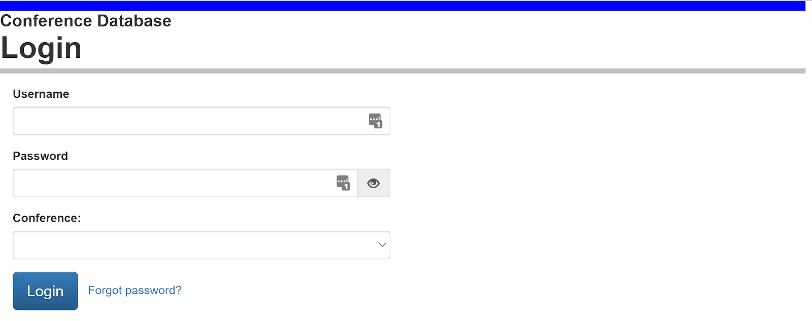

Enter your username and password and select your conference from the list. Click Login.

If you had a typo in username and/or password you will get an error message, and an opportunity to try again.

If you still cannot get in, please contact whoever assigned you the username and password and ask them for help.

STEP TWO: Change Your Password
The password you received is good for one-time use only. You now have an opportunity to select your own password.

You should get this screen:

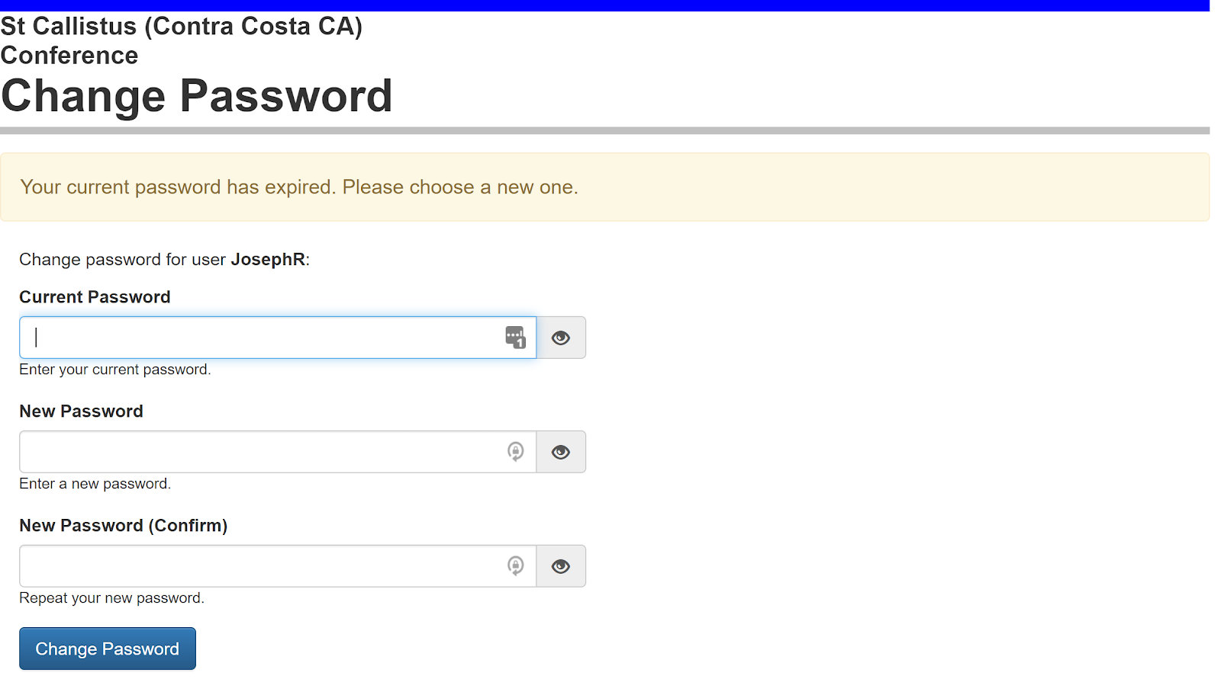

Tips to select a good password:
- Must be 8 characters or longer. Longer is generally better.
- Cannot contain your first name, last name or username.
- Cannot be the same as anyone else in your conference (be unique!).
- Passphrases can work really well. Spaces are allowed. Examples:
  - A sentence that has meaning to you but which no-one else would guess.
  - Randomly choose 5 words for example: "fuzzy green hornets snore loudly" (but of course do not choose this exact example!)
- Password managers also provide a way to generate a strong password that you don't have to remember.

STEP THREE: Verify Your Email

Why verify your email?

- So you can click Forgot password in the future (see login page above) if you forget!

- So you get an automatic email notice when others assign client cases to you. Very convenient!

- So we avoid sending private information to the wrong address!

Request a verification email

Here's what the verification page looks like. Read and follow the instructions, 1, 2, 3…

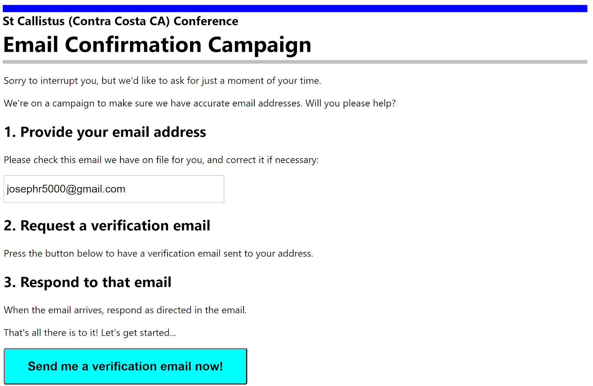

Respond to the verification email

1. Don't forget that you need to respond to the verification email. This is how the system knows that really is your email! The email looks something like this:

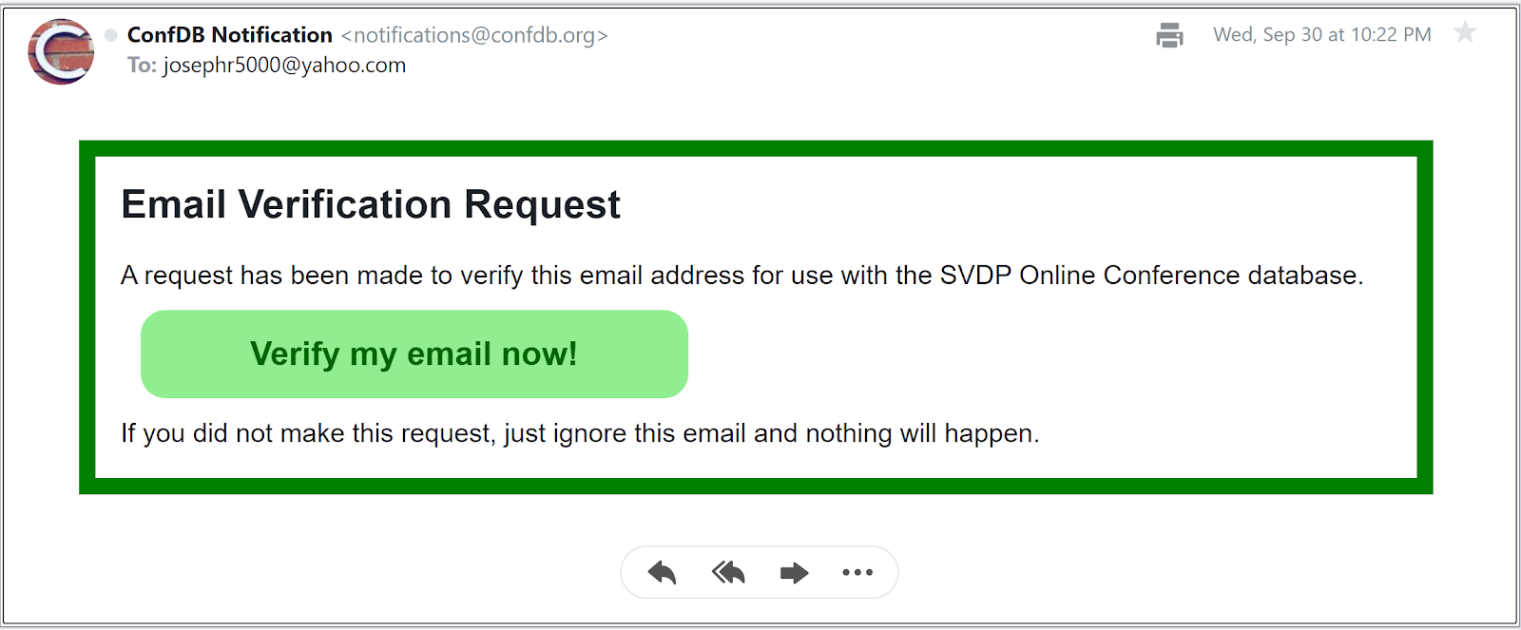

2. Click Verify my email now! to complete the verification. If you are successful, you will see this confirmation:

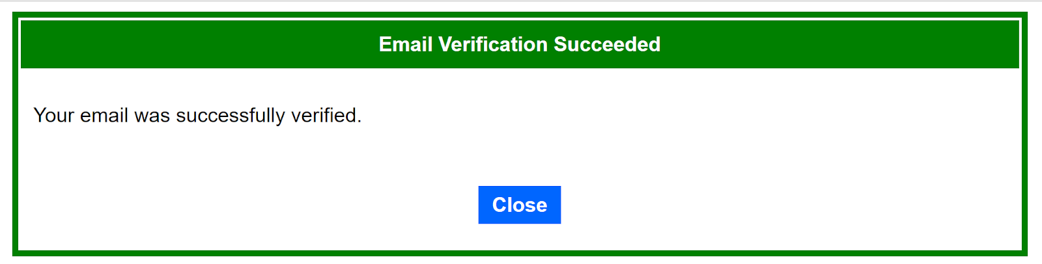

3. Press Close to proceed to the main page of the database.

STEP FOUR: Update your profile
The person who set up your account will not have entered all of your contact and demographic information. Please fix that now, so you know everything will be accurate! Here's how:

1. In the upper left of the main page, click the Account menu and select Profile:

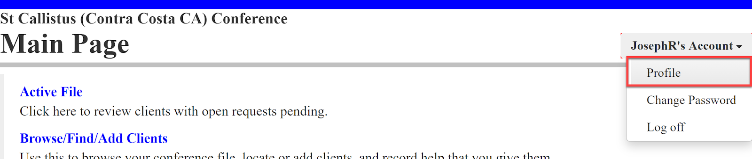

2. In the profile screen, please complete/correct your contact and demographic information.

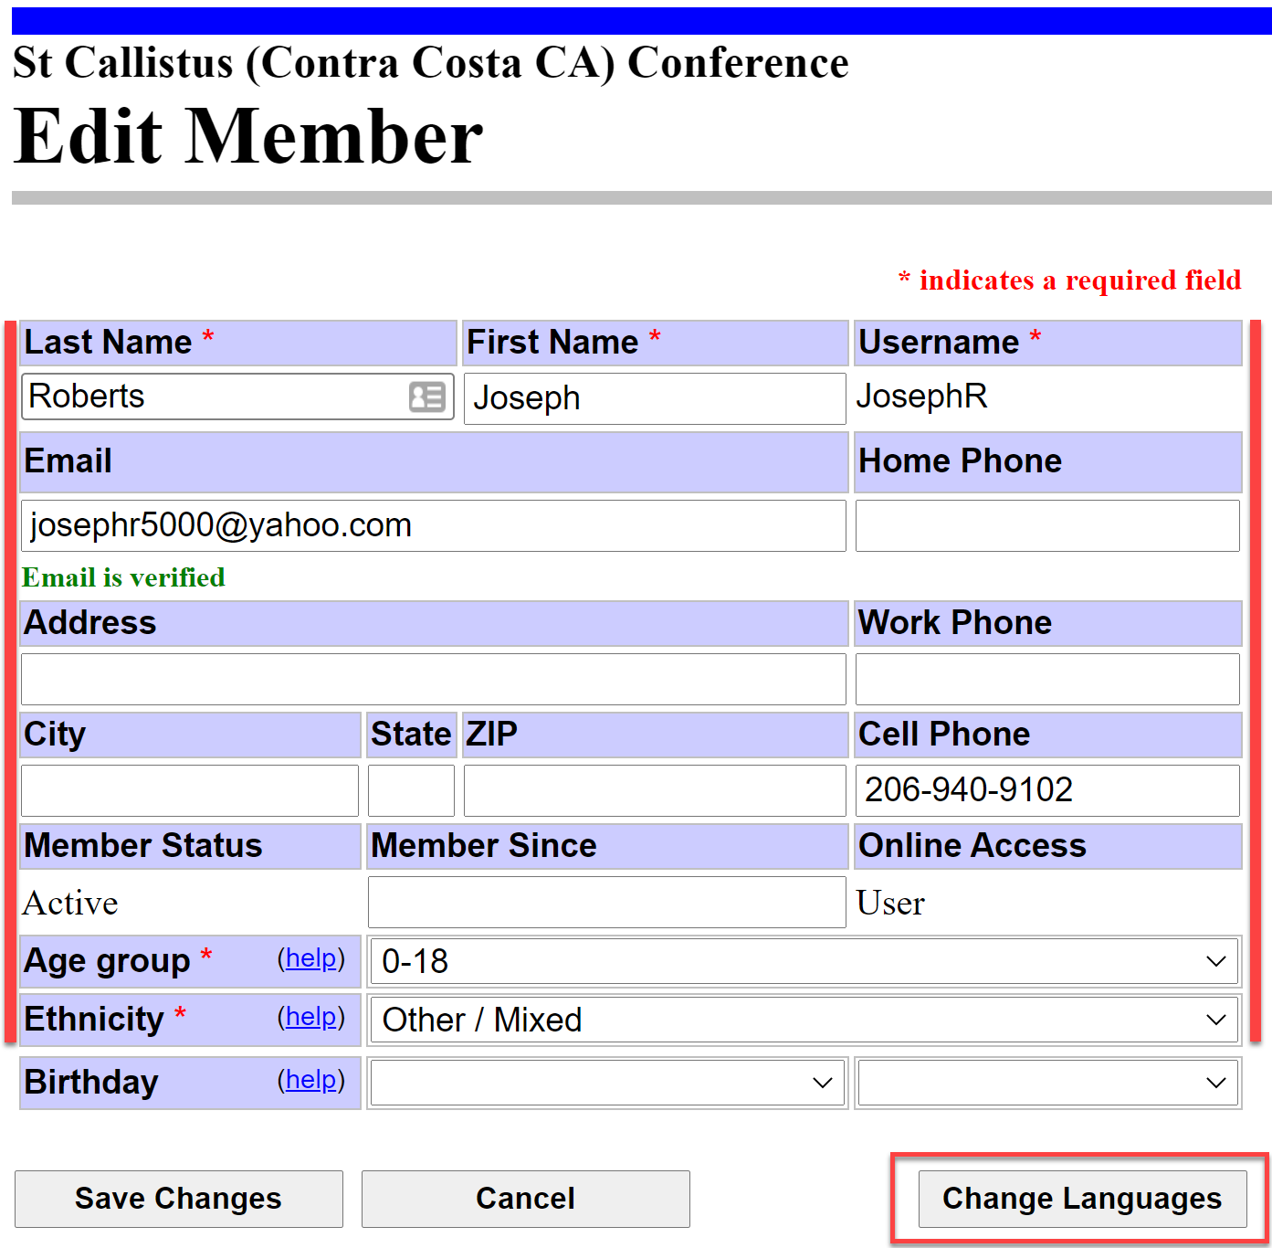

3. Finish by clicking Change Languages to update which languages you speak well enough for home visits.

CONGRATULATIONS! Your new account is now ready to use.

