# EVICTION BAN – 1-26-21

# [Advanced Search](https://search.cdc.gov/search/index.html#advanced)

# [CDC Newsroom](https://www.cdc.gov/media/index.html)

# Section NavigationMedia Statement from CDC Director Rochelle P. Walensky, MD, MPH, on Extending the Eviction Moratorium

# Media Statement

# For Immediate Release: Wednesday, January 20, 2021 Contact: Media Relations (404) 639-3286

# As a protective public health measure, I will extend the current order temporarily halting residential evictions until at least March 31, 2021. The COVID-19 pandemic has presented a historic threat to our nation’s health. It has also triggered a housing affordability crisis that disproportionately affects some communities.

# Despite extensive mitigation efforts, COVID-19 continues to spread in America at a concerning pace. We must act to get cases down and keep people in their homes and out of congregate settings — like shelters — where COVID-19 can take an even stronger foothold.

###  
[U.S. DEPARTMENT OF HEALTH AND HUMAN SERVICESexternal icon](http://www.hhs.gov/)

# CDC works 24/7 protecting America’s health, safety and security. Whether disease start at home or abroad, are curable or preventable, chronic or acute, or from human activity or deliberate attack, CDC responds to America’s most pressing health threats. CDC is headquartered in Atlanta and has experts located throughout the United States and the world.

# ___________________________

# Governor Newsom, Legislative Leaders Issue Statement on Eviction Moratorium Extension

# Published: Jan 25, 2021

# SACRAMENTO – Governor Gavin Newsom, Senate President pro Tempore Toni Atkins and Assembly Speaker Anthony Rendon today issued the following joint statement on the extension of the eviction moratorium to protect Californians impacted by COVID-19:

# “COVID-19 continues to devastate communities across our state and too many Californians remain one paycheck away from losing their apartments or homes. These families need protection and relief now.

# “Today, we are announcing an agreement to extend the eviction moratorium in California through June 30, 2021 – protecting tenants and small landlords from losing their housing as the nation continues to confront the pandemic. We are also moving forward as quickly as possible to deploy California’s share of the latest federal stimulus bill – ensuring that up to $2.6 billion in renter aid is administered quickly, equitably and accountably.

# “These critically needed federal funds, targeted to the most at-risk households with unpaid back rent, will help tenants stay afloat during and after this pandemic. Income-qualified tenants and their landlords can choose to receive direct rental assistance in exchange for forgiving prior rental debt.

# “While we are proud of this agreement, which maintains California’s COVID eviction protections as the strongest statewide rules in the nation, our work is far from over. This eviction moratorium and rapid deployment of funds to the most at-risk are among our top priorities. But we have more work to do, together, to tackle the structural housing cost crisis in California. The pandemic exacerbated these issues, it did not create them. And our work to address these fundamental issues must continue with urgency and resolve.

# “We thank the many stakeholders who have engaged in this process for the past several months, and we recommit ourselves to the work ahead to maintain California’s position as the most compassionate, progressive state in America.”

# ________________________________________________________________________

# Biden extends the national ban on evictions through March 2021

**PUBLISHED WED, JAN 20 202112:14 PM ESTUPDATED WED, JAN 20 20217:19 PM EST**

[**Annie Nova**](https://www.cnbc.com/anne-nova/)[**@ANNIEREPORTER**](https://twitter.com/AnnieReporter)

[**Carmen Reinicke**](https://www.cnbc.com/carmen-reinicke/)[**@CSREINICKE**](https://twitter.com/csreinicke)

**SHARE**Share Article via FacebookShare Article via TwitterShare Article via LinkedInShare Article via Email

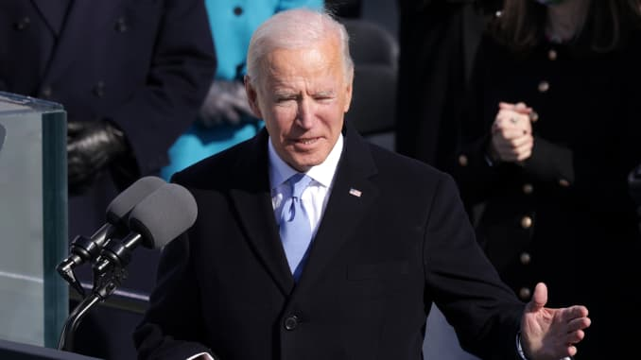

**President Joe Biden delivers his inaugural address on the West Front of the U.S. Capitol on January 20, 2021 in Washington, DC. During today’s inauguration ceremony Joe Biden becomes the 46th president of the United States.**

*Alex Wong | Getty Images*

President Joe Biden on Wednesday extended the federal ban on evictions through March 2021 with an executive action in one of his first official acts following inauguration.

The ban on evictions has helped millions of Americans struggling amid the coronavirus pandemic. The moratorium on evictions was set to expire at the end of the month.

The move is one of a long list of actions Biden took after he was sworn in as the President of the United States, including an extended pause on student loan payments, rejoining the Paris Agreement on Climate Change and rolling back various orders put in place by the Trump administration.

**More from Invest in You:**  
[Biden pledges to help fix the child-care crisis. Here is his plan](https://www.cnbc.com/2021/01/15/biden-has-a-plan-to-help-fix-the-child-care-crisis-in-america.html)  
[Mother of five’s plan to freeze her spending for January](https://www.cnbc.com/2021/01/10/when-a-spending-freeze-may-work.html)  
[Deepak Chopra: We’re experiencing 3 pandemics. How to cope](https://www.cnbc.com/2020/10/26/deepak-chopra-were-experiencing-3-pandemics-right-now-how-to-cope.html)

By one estimate, [14 million Americans](https://www.cbpp.org/research/poverty-and-inequality/tracking-the-covid-19-recessions-effects-on-food-housing-and) are behind on their rent during the crisis. In addition to extending the eviction ban through March, Biden is also expected to ask Congress to keep the moratorium in place through September 2021.

Research has found that [evictions lead to significantly more coronavirus cases and deaths in an area](https://www.cnbc.com/2020/11/27/evictions-have-led-to-hundreds-of-thousands-of-extra-covid-cases-.html).

“This is a time where it’s not an overstatement to say that for many people, eviction can lead to death,” said [Helen Matthews](https://www.linkedin.com/in/helen-matthews-41685497/), communications manager at City Life Vita Urbana, a nonprofit in Boston.

Advocates say extending the eviction ban is just a first step, and that there also needs to be enforcement to make sure landlords follow the law.

[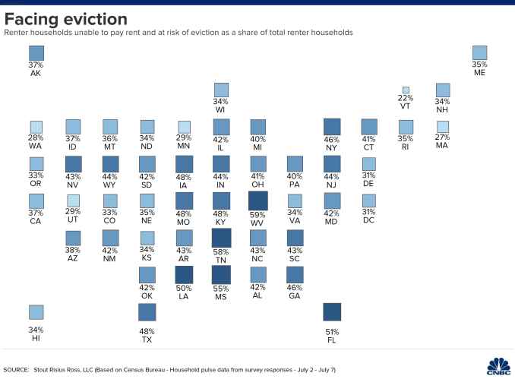](https://www.cnbc.com/2021/01/20/biden-to-extend-the-national-ban-on-evictions-through-march-2021.html)

[“The existing moratorium is flawed and some landlords exploit loopholes to evicttenants despite the protections,” said Diane Yentel, president and CEO of the](https://www.cnbc.com/2021/01/20/biden-to-extend-the-national-ban-on-evictions-through-march-2021.html)[National Low Income Housing Coalition](https://nlihc.org/), in a statement. “No federal agency is enforcing the order’s penalties for unlawful evictions.”

In addition, there are growing calls for the ban to be matched with adequate rental assistance so that an eviction crisis is prevented rather than merely delayed. So far, Congress has allocated $25 billion in rental assistance but, after months of record job losses, rental arrears may be closer to $100 billion.