**INVITATION TO SERVE**

**For**

**Recruitment**

*Inviting and forming* ***NEW MEMBERS*** *into existing*

*Adult, Young Adult and Youth Conferences*

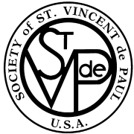

## **National Council of the United States**

**Society of St. Vincent de Paul**

**58 Progress Parkway**

**Maryland Heights, MO 63043**

**314-576-3993**

**www.svdpusa.org**

Introduction

“The Society is open to all those who seek to live their faith loving and committing themselves to their neighbor in need.” (*Rule*, Part I, 3.1)

It is important for existing Conferences to strengthen themselves, and eventually an effort must be made to persuade members of the parish to join the Society. Even strong Conferences must recruit. A healthy Conference will have a slow but steady turnover of membership. Attrition is inevitable because even good Vincentians move out of the parish, become heavily involved in other ministries and have family conflicts. New members bring fresh ideas and fresh energy to the Conference and reinforce older members in their commitment.

If a Conference is open to new members and its works are well known in the parish, new members will be attracted. Little active recruiting is required. But even such Conferences must periodically reach out so that the congregation knows that they are open to new members. They must also reach out to seek diversity within the Conference – men and women, young people, members of various ethnic groups in the parish.

Basically there are two approaches to recruiting.

* public appeal attempts to reach a large audience in search of anyone who might be interested in learning more about the Society. Public appeals may be made through pulpit announcements, parish bulletin announcements, talks to parish or school groups, parish open houses, or brochures in a rack. The *Invitation to Serve* program is a proven tool for public appeals.
* personal appeal is an individual invitation to encourage someone to join the Society who has either expressed an interest or been identified as a potential Vincentian by the Pastor, another Vincentian, or anyone else. This may be done by letter to the prospect, but more often it involves a face-to-face discussion.

Best results are usually obtained by a combination of both public and personal appeals.

The benefits that a promising member will receive are best shared by a Vincentian on a personal note:

* You will be serving God.
* You will be growing spiritually.
* You will be helping those in need.
* You will be working with a dedicated group of Vincentians.
* You are needed.

Frequently sharing the works of the Conference is enough to help people join.

This manual describes action plans for recruitment and to build up existing Conferences. It may be used at (Arch)Diocesan Council, District Council and Conference levels, and is designed to be a practical help at all stages of recruitment.

When using the *Invitation to Serve* program, you will find the materials provided to be very helpful in the recruitment process. All *Invitation to Serve* aids within this manual are on the National website in Word format so you can make the minor alterations necessary to use them.

Recruitment – Inviting and forming new members into existing Adult, Young Adult and Youth Conferences

The responsibility for building up existing Conferences lies with every Conference member, especially the Conference President. But Conferences that really need building up, those in danger of collapsing altogether, with only two or three members, simply don’t have the resources to engage in a major recruitment drive. This is where the District Council comes in. It can supply the resources to make a success of a drive. It is the duty of the District Council to take the initiative and approach the Conference President of the Conferences in need of help.

Identifying New Vincentians

The first step in recruiting is that of identifying individuals who may be interested or who may be persuaded to join the Society. In any parish there are probably many potential Vincentians but it is not necessarily easy to identify them. The Church today is increasingly dependent on the laity to carry out functions that in the past were performed by clergy or religious. This fact provides both opportunities and obstacles in recruiting: opportunities, because the laity is increasingly aware of the responsibilities that they must now shoulder but in any given parish there are many ministries seeking dedicated lay persons to carry out their works. We must make the Society known in the parish. Samples of yearly bulletin announcements may be found on the National Website, [www.svdpusa.org](http://www.svdpusa.org), under Resources.

There are several ways for identifying potential Vincentians. Once they have been identified, it will be necessary to persuade them to actually join the Conference

Pulpit Appeal

An open invitation to join the Society of St. Vincent de Paul delivered from the pulpit at Saturday evening and Sunday Mass is an effective way to reach potential Vincentians. This is the basic premise for *Invitation to Serve*.

* The Pastor should be contacted several weeks in advance to arrange for the delivery of the appeal at the Parish Masses. It is appropriate for the pastor to receive a draft of the presentation.
* A few weeks prior to the presentation at Mass, with permission from the pastor, it is beneficial to place some announcements in the bulletin about the Society of St. Vincent de Paul and the works that are being done in the parish.
* The appeal will be most effective if it is done by a Vincentian with personal experiences shared. It is also very beneficial if the celebrant can also support the presentation.

The message is short and clear and stresses the following points:

* To share the works of the SVdP Conference in this parish including the growth in spirituality
* To explain the need for new members
* To invite interesting parishioners to learn more about the Society
* To give specific instructions for those who are interested

Guidelines for the Pulpit Message

Select a Vincentian that is comfortable speaking before a group:

* Introduce yourself and your role with the Society of St. Vincent de Paul and thank the pastor and celebrant for the opportunity to speak
* Speak slowly and clearly using the microphone
* You may have a prepared speech which you will read or you may have notes that will guide you to speak from your experiences
* Sharing stories and experiences are helpful ways to share the works but confidentiality must always come first
* Share the needs of your Society’s Conference
* Inform them of an orientation meeting.
* Provide sign-up sheets after Mass to obtain contact information of potential members and have Vincentians available to answer questions

The appeal is followed up after Mass in the following ways to obtain parishioners contact information:

* Sign-up sheet in the vestibule of the Church with Vincentians there to answer questions
* Exhibit in the Parish Foyer or Parish Hall that shows the works of the Society with a sign-up sheet

Since you are familiar with the procedures in your parish, it is best to do what works in your parish. Once you have the contact information, you will follow up with an invitation to an orientation meeting.

Other Ways to Recruit New Members

* Recommendations made by the priests of the parish or members of the Parish Council
* Existing members to invite a friend or acquaintance to “Come and See” what the Society does
* Attracting new members through Stewardship Sign-ups or new parishioner registration

The Conference President ensures that the Society of St. Vincent de Paul is shown as one of the options on the registration or stewardship card or includes information material about the Society of St. Vincent de Paul in the new parishioner registration packet.

Bulletin Announcements

Appeals published in the parish bulletin can also be used to reach a wide audience of potential Vincentians. Bulletin announcements are an effective ways to prepare the parishioners for a pulpit announcement and an excellent way to follow up after a pulpit announcement is made.

Flyers inserted into the bulletin may also have a good result in helping parishioners be aware of the spirituality and works of the Society of St. Vincent de Paul in their parish. Sharing some of the facts regarding the numbers served and the amount of money given on a quarterly basis by the Society in the parish is a good way to let the Society be known.

Making use of the parish website also provides another avenue of publicity about the Society.

Bulletin Announcement Samples

**Sample 1**

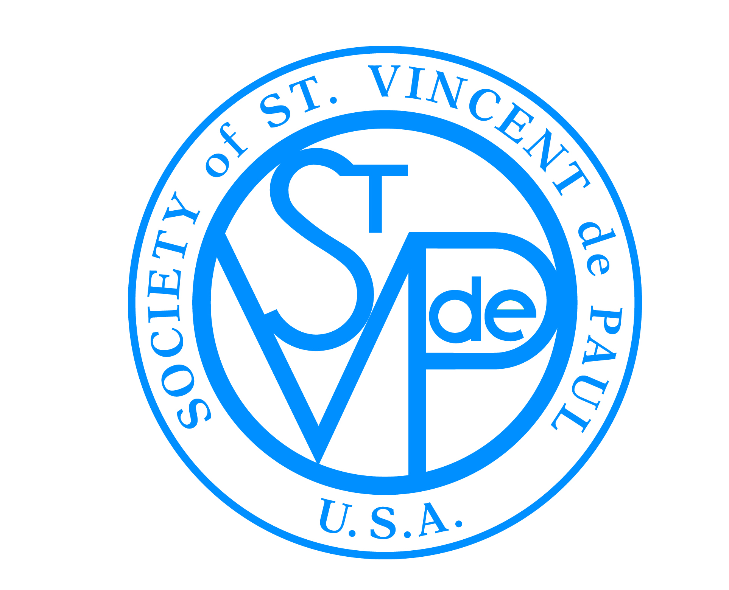

Are you looking for ways to experience God?

Members of the Society of St. Vincent de Paul invite you to share in their ministry of experiencing God in serving people living in poverty.

We see Christ in the poor because Jesus told us “whatever you do to the least of my brothers and sisters you do for me.”

Contact the ___________________, Society of St. Vincent de Paul Conference President.

**Sample 2**

Do you consider yourself a naturally caring, compassionate and giving person?

If so, come and share your gifts with people in need by joining the Society of St. Vincent de Paul.

In the coming weeks more will be share about the spirituality and works of the Society of St. Vincent de Paul at the Parish Masses.

If you are interested, contact ________________________.

**Sample 3**

You are invited to serve people in need in our (name) Parish by joining the Society of St. Vincent de Paul. Your assistance to people in our Parish area needing food, clothes, rent assistance, utility assistance and other needs will be a rewarding experience. Is it time for you to live your religious convictions and give something back for all you have received? Come join us next (Thursday) at _________(time) in the ______________(place) to learn more.

Ministry Fairs

Many parishes host “ministry fairs” especially during their Stewardship Appeal. It is helpful to have the Society of St. Vincent de Paul represented with an exhibit. It may also be a time for a sign-up of parishioners who may be interested.

#### Involvement of the Young

A parish that has a school or a religious education program may also be interested in forming a Youth Conference of the Society of St. Vincent de Paul sometimes referred to as “Minnie Vinnies”. This is an excellent way to begin forming our young people with a spirit of service, develop their spirituality and to involve them in the works of the Adult Conference. There are many resources found on the youth website at [www.svdpusa.com/youth](http://www.svdpusa.com/youth) .

#### Sample Talk from the Pulpit

Good Morning, My name is __________________________________ and I am the ___________________ of the Society of St. Vincent de Paul conference here at ________________________ Church.

I would like to thank _______________________ our pastor and _________________

for allowing me to take a few minutes of your time to share with you about the Society of St. Vincent de Paul.

The Society of St. Vincent de Paul is a Catholic lay organization that helps those in need or those living in poverty. We grow spiritually by offering person-to-person service to people in need. Because we see “the face of Christ” in those we serve as Jesus taught us when he said, “whatever you do to the least of my brothers and sisters you do to me.”

The Society of St. Vincent de Paul is an international organization founded in 1833 by a young student, Frederic Ozanam. The Society was founded in the United States in 1845 and is located in 149 countries.

Today, the need to serve those who are living in poverty is very great even in our own parish. (It is important to share some of the local needs that the Conference is experiencing and the works that the Conference does: food drive, clothing drive, home visits to assist in utilities or rent, etc.)

Our Conference is a small group of dedicated women and men who are inviting you to consider joining us and making a difference. Not only will you be helping those in need but you will also find yourself growing in God’s love and the desire to share that love with others.

After Mass, there will be members of the parish conference in the back of church to provide a sign-up sheet and answer your questions about our orientation meeting on _________________.

May you take some time to reflect in your heart, God’s calling to you to serve those in need through the Society of St. Vincent de Paul.

Thank you for the generosity you have shown to the works of the Society by your financial and material donations to our work.

God Bless

**Suggestions for the Orientation Meeting**

* Schedule meeting for an evening a week or two after the presentation at the Masses
* Hold the meeting at a parish facility and reserve the space and time well in advance.
* Contact each prospective member personally to remind them of the meeting.
* Keep the meeting within an hour
* Show the 9 minute DVD on history of the Society
* Share the history of your own Conference and the works you do
* Discuss the requirement for the safe environment policy of the (Arch) Diocese
* Share the experience of a home visit and the confidentiality required
* Share the importance of Vincentian spiritual formation
* Allow for questions and dialogue
* Invite them to the next official conference meeting

**Orientation Meeting Agenda**

Opening prayer

Spiritual reading and reflection

Introduction of Vincentians

Introduction of Guests

History of the Society of St. Vincent de Paul -- DVD

Describe our work and how it is done

Home visits

Work in pairs

Confidentiality

Meeting times and duration

Society in the Arch/Diocese

Vincentian Formation Opportunities

Meeting the Safe Environment Policy of the Arch/Diocese – Give some dates

Closing Prayer

Refreshments and Social

Sample Letter to Conference Presidents

Date (September is the recommended time.)

Dear President,

The Council Office is coordinating, in association with Districts, Parish Conferences and Special Works Conferences, the (first) annual Diocesan-wide recruitment drive.

It is called an *Invitation to Serve for Recruitment*. The goal is to obtain new members dedicated to the Vincentian mission. The drive will assist in the raising awareness of our Conferences, solicitation of Pastoral involvement, identification of candidates, initial contact, orientation, training and development of ways to recruit and retain new members. A number of aids have been developed for your use and are enclosed.

We plan to complete the drive prior to our busiest time in late Fall still allowing time for orientation and basic training. The new members will then be available to assist in activities such as annual food drives, special holiday programs, Christmas programs, etc. Their involvement in these annual events will help initiate them into our Society’s work.

The drive will be your choice of any weekend in September, following within a couple of weeks by an orientation meeting. A series of Ozanam Orientations will be scheduled in October in various locations in the Diocese.

Your Conference will be asked to participate in several ways.

1. Communication with the Pastor for his support and encouragement.
2. Assist in getting notices in the bulletin.
3. Give a short talk at each Mass.
4. Provide and staff information tables at each Mass.
5. Secure a meeting room for the week of the talk from the pulpit.
6. Conduct an orientation meeting.
7. Have new members complete the Safe Environment Program of the Diocese.
8. Require the new candidates to attend an Ozanam Orientation.
9. Report back the results of your *Invitation to Serve*.
10. Offer suggestions for next year’s drive to make it even more successful.

Our goal is to develop an effective annual increase in our membership by attracting those who wish to live their faith by service to Christ’s poor.

We need your help and the help of your Conference to fulfill our mission to serve those in need and give others an opportunity to serve as well.

In the name of St. Vincent and Blessed Frederic,

(NAME),

**Sample Letter to Pastors**

Date

Dear Pastor,

The Society of St. Vincent de Paul ministers to the poor in parishes throughout the Diocese. As our Diocese has grown, the need for our Society’s assistance has grown. We are inviting Catholics in all parishes to live their religious convictions by serving Christ through His poor and through our Society.

We are offering this invitation because of our need for help. Perhaps more importantly, it allows people to fulfill their personal needs to be involved with a ministry that goes to the very heart of Christ’s teaching to love and care for all people.

Our *Invitation to Serve*will be offered during the early Fall. All of our parish Conferences will participate in inviting, informing and educating parish members of the opportunities to serve.

We would like your support to allow an article in your parish bulletin, a short announcement from the pulpit by a Vincentian at each Mass, and any further assistance that seems appropriate to you.

After the Invitation to Serve we will be holding informational orientation meetings at each parish. After the orientation those who feel inclined to follow this ministry will be given basic training called an Ozanam Orientation (named for our founder Blessed Frederic Ozanam). Each new member will work with experienced Vincentians in visiting and assisting those in need and be included in our Diocesan service.

This ministry is not for everyone. Most Vincentians realize we were not the ones to choose this work for Christ. We were chosen, perhaps because of a deeper need within us to serve. To give others the opportunity to do this work is one of our primary responsibilities. We are trying to fulfill this responsibility with this *Invitation to Serve.*

Can we count on your support?

Yours in the spirit of our founder, Blessed Frederic Ozanam and patron, St. Vincent de Paul.

Sign

**St. Vincent de Paul**

**Invitation to Serve**

|  |  |  |  |
| --- | --- | --- | --- |
| **NAME** | **STREET** | **CITY - ZIP** | **PHONE/EMAIL** |
|  |  |  |  |
|  |  |  |  |
|  |  |  |  |
|  |  |  |  |
|  |  |  |  |
|  |  |  |  |
|  |  |  |  |
|  |  |  |  |
|  |  |  |  |
|  |  |  |  |
|  |  |  |  |
|  |  |  |  |
|  |  |  |  |
|  |  |  |  |
|  |  |  |  |
|  |  |  |  |
|  |  |  |  |
|  |  |  |  |
|  |  |  |  |
|  |  |  |  |

Invitation to Serve

Initial Response Report

**Date Number Number Number**

**District Conference Contact of of of at**

**Invitation Masses Signups Orientation**

**Meeting**

________ ____________________________________ ____________________________________ ______/______ ________ ________ _________

________ ____________________________________ ___________________________________ ______/______ ________ ________ _________

________ ____________________________________ ___________________________________ ______/______ ________ ________ _________

________ ____________________________________ ___________________________________ ______/______ ________ ________ _________

________ ____________________________________ ___________________________________ ______/______ ________ ________ _________

________ ____________________________________ ___________________________________ ______/______ ________ ________ _________

________ ____________________________________ ___________________________________ ______/______ ________ ________ _________

________ ____________________________________ ___________________________________ ______/______ ________ ________ _________

________ ____________________________________ ___________________________________ ______/______ ________ ________ _________

________ ____________________________________ ___________________________________ ______/______ ________ ________ _________

By ____________________________________________