**Pantry Operation Guide**

**Master Template**



This table of contents will guide you through the sections of this template. It is composed of common areas of essential information that would address the needs of *any* pantry. You may need to create a comprehensive table of contents to follow the path of your individual operation guide. Remember to include any necessary information that may be specific to your organization, if it is not covered in this example.

Table of Contents

|  |  |
| --- | --- |
| About Your Organization | 01 |
| Mission & Vision of Your Organization | 02 |
| Acknowledgments | 03 |
| * Days & Hours of Operation | 04 |
| Service Area | 04 |
| * Staff Directory | App 43 |
| * Legal & Tax Information | App 43 |
| * Board Of Directors | App 44 |

* When you see this symbol in the *Table of Contents*, you will find a worksheet to help you catalogue information. Also, look for helpful tips, examples, and reminders in boxes like this one or the “post-it” notes throughout this document!

|  |  |
| --- | --- |
| Food Pantry Operations & Responsibilities  Table of Contents | 05 |
| * Check-In Process & Required ID | 06 |
| Distribution Policy | 06 |
| * Open To Close, Daily Operations | 07 |
| Orders & Inventory | 09 |
| eHarvest Orders | 09 |
| * Inventory | 11 |
| * Alternate Sources of Food | 12 |
| Shopping Visits & Emergency Boxes | 13 |
| Food Safety | 13 |
| Storage | 15 |
| Temperature Log | 16 |
| * Floor Plan | 17 |
| Keeping Records | 18 |
| * Tracking Statistics | 19 |
| * Documenting Donations | 20 |
| Holiday & Emergency Plans | 21 |
|  |  |

|  |  |
| --- | --- |
| Volunteer Management | 24 |
| * Volunteer Agreement   Table of Contents   |  | | --- | |  | | 24 |
| Recruiting Volunteers | 25 |
| * Training Volunteers | 26 |
| Volunteer Code Of Conduct | 28 |
| * Tracking Volunteer Hours | 29 |
| Volunteer Appreciation | 30 |
| Finances & Budgets | **31** |
| Annual Budget | 31 |
| * Assessing Financial Responsibilities | 32 |
| * Bookkeeping | 33 |
| * Fundraisers & Food Drives | 34 |
| Grant & Proposal Writing | 35 |
| Donor Thank You Letter, Sample | App 44 |

|  |  |
| --- | --- |
| PLAN: Pantries Learning to Assess Needs | 36 |
| Beyond Food: Services We Offer | 36 |
| Public Benefits | 37 |
| Building Relationships With Clients | 38 |
| Identifying Client Needs | 39 |
| Staying Committed To Your Organization | 40 |
| Nutrition Education | **40** |
| My Plate | 41 |
| Stocking Shelves & Offering Healthy Choices | 41 |
| * Addressing Clients With Specific Dietary Restrictions | 42 |
| Community Garden | 42 |
| Appendix | **43** |
| * Monthly Cleaning Checklist | 45 |
| Shelf Life Storage Guide | 45 |
| Food quality and expiration guidelines | 46 |
| * Succession Plan | 46 |

Table of Contents

Use this space to give detailed information and a brief history about your organization. Give specific examples of the progress your agency has made since it started.

About Your Organization

|  |
| --- |
|  |
|  |
| *Example:*  Mid-Ohio Foodbank was originally known as the Operation Feed Foodbank until 1986. The doors opened in 1980 and 60 member food pantries were served. Mid-Ohio become a member of Feeding America in 1981. In its first year 205,200 pounds of food was distributed. Today Mid-Ohio Foodbank has over 550 partner agencies and distributes over 40 million pounds of food annually…… |
|  |
|  |
|  |
|  |
|  |
|  |
|  |
|  |
|  |
|  |
|  |
|  |
|  |
|  |
|  |

* If your organization does not have a “**mission**” formally stated, take the time to define your purpose. Summarize that information and convert it into a statement. This is your mission.
* Need a “**vision”** statement? The vision should show the desired future state of the organization and/or an ideal picture of what the organization wants to accomplish.

Mission & Vision of your organization

|  |
| --- |
|  |
| Our Mission:  *Example:*  **Mission**  To end hunger one nourishing meal at a time and  co-create a sustainable community where everyone thrives.  **Vision**  A hunger-free, healthier community |
|  |
|  |
|  |
|  |
|  |
|  |
|  |
| Our Vision: |
|  |
|  |
|  |

Use this space to recognize all of the important contributors to your organization, for its insured and continued success.

*Example:*

Major donors, sponsoring organizations, private businesses, volunteers, staff, etc….

Acknowledgements

|  |
| --- |
|  |
|  |
|  |
|  |
|  |
|  |
|  |

Purpose of the Best Practice Guide

|  |
| --- |
|  |
|  |
|  |
|  |
|  |
|  |
|  |

Please describe the reason for this guide. It will help readers understand how to implement the practices discussed, and give a clear look at how the manual should be used.

*Example:* The intent of this guide is to reveal how to operate the *Kroger Community Food Pantry*, allowing for a more sustainable emergency feeding program. It is designed for staff and volunteers to utilize in order to gain an understanding of daily responsibilities and overall general policies & procedures.

Fill in the hours of operation for your organization. Please fill in “closed” for days that you are not open for business. You may also want to make a standard holiday schedule listing the **holidays observed** by this establishment, it is acceptable to leave the actual dates out as some may change annually.

Days & Hours of Operation

Observed Holidays

New Year’s Day

Thanksgiving Day

Christmas Eve

Christmas Day

*Hours of operation must be posted for public display

|  |  |  |  |  |  |  |
| --- | --- | --- | --- | --- | --- | --- |
| Sunday | Monday | Tuesday | Wednesday | Thursday | Friday | Saturday |
|  |  |  |  |  |  | C:\Users\akirk\AppData\Local\Microsoft\Windows\Temporary Internet Files\Content.IE5\AE01CNQL\MC900441572[1].wmf |

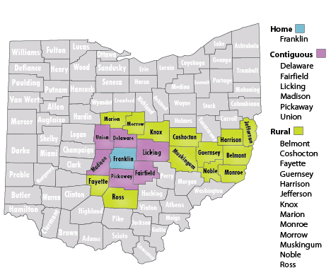

Service Area

***Example:* Service area for Mid-Ohio Foodbank**

Does your organization serve anyone, or do you have distinct zip codes that you serve? Remember upon the first visit regardless of stipulations clients must be served for that visit, they can then be referred to a different pantry.

**Add a picture!**

An image is an interesting way to add a visual representation of the material you are covering. **Here, you can include a map of the zip codes your organization serves.**

|  |
| --- |
|  |
|  |
|  |
|  |
|  |
|  |
|  |
|  |
|  |
|  |

Do you offer a choice or traditional model pantry? What benefits are there to the style mentioned?

*Example*:

* We are a ***choice pantry*** because it gives our clients dignity to shop for the items they need, and it reduces waste.
* We are a ***traditional pantry*** due to limited space. This arrangement allows for greater efficiency when serving clients.

Food Pantry Operations & Responsibilities

Please explain individual responsibilities for the pantry director and pantry coordinator. In the event of leadership transition, how would the responsibilities transition? *See the succession planning worksheet in the appendix*.

|  |
| --- |
|  |
| Director Responsibilities: |
| *Example:*  Coordinator is responsible for unlocking doors and ordering food from eHarvest. |
|  |
|  |
| Coordinator Responsibilities: |
|  |
|  |
|  |

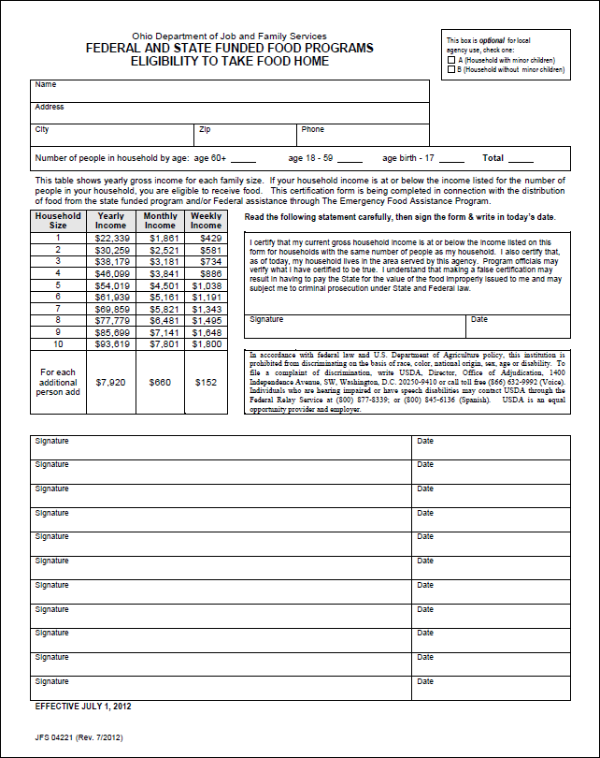What is the check-in process for clients at your pantry? What documentation do you require for clients to take food home? What is your proxy policy?

Check-In Process & Required ID

*Example:* A piece of mail must accompany new clients to show residency.

Acceptable forms of Identification for this location are as follows: photo ID, birth certificate for children under 18, school ID, health insurance cards, passports…..

|  |  |  |  |  |  |  |
| --- | --- | --- | --- | --- | --- | --- |
| Age | Driver’s  License | State ID | Passport | Naturalization  Papers | School  Id | Health  Card |
| Over  18 |  |  |  |  |  |  |
| Under  18 |  |  |  |  |  |  |

|  |
| --- |
| How often can a family receive food from your pantry for a full shopping visit? How many times a week can they receive bread & produce only, or emergency boxes? |
|  |
|  |
|  |
|  |
|  |
|  |

Distribution Policy

Pantries usually agree to serve clients depending on food supply, storage capacity, and staffing. Please describe the current policy in place for your pantry.

**Keep all client information confidential!**

Adjust the table below to reflect the types of identification **you accept**.

Each food pantry operates differently. Please take the time to catalogue daily tasks and responsibilities performed by staff and volunteers. A checklist may be the easiest way to guarantee all tasks are completed each day.

Open to Close Daily Operations

|  |
| --- |
| * Daily Task *Opening* Checklist |
|  |
|  |
| How do you get your day started in the pantry? What is the first thing that you do when you come in? What tasks need accomplished immediately? **Are there different tasks for different days?** If so, make lists specifically for certain days of the week! |
|  |
|  |
|  |
|  |
|  |
|  |
|  |
|  |
|  |
|  |
|  |
|  |

**You can make many more lists to identify important tasks that need completed throughout the day**. An opening and closing checklist will ensure the most important things are done regularly.

Open to Close Daily Operations

|  |
| --- |
| * Daily Task *Closing* Checklist |
|  |
|  |
| What is the last thing that you do before you leave? How do you end your day in the pantry? **Do you have specific things that need cleaned, turned off, or locked?** Are there different tasks for different days? If so, make a list exclusively for those days.  *See appendix for a sample cleaning checklist |
|  |
|  |
|  |
|  |
|  |
|  |
|  |
|  |
|  |
|  |
|  |
|  |

Inventory

Knowing what products you have in stock makes it convenient to order more food when you can see exactly what items you may be out of, or to keep track of what stock is running low. Having access to that information before ordering will give you a scope of what to shop for, and how much space you have for new items.

|  |  |  |  |  |  |
| --- | --- | --- | --- | --- | --- |
| Shelf-Product  Inventory list | Date:  / / | Date:  / / | Date:  / / | Date:  / / | Date:  / / |
| **Beverages** |  |  |  |  |  |
| **Canned Meat/Soup** |  |  |  |  |  |
| **Cereal** |  |  |  |  |  |
| **Canned Fruit** |  |  |  |  |  |
| **Grains: rice, pasta, etc…** |  |  |  |  |  |
| **Protein-non meat** |  |  |  |  |  |
| **Canned Vegetables** |  |  |  |  |  |

Making a few spreadsheets to keep track of your inventory is easy. You can group the categories and have a list for dry goods, refrigerated/frozen items, and household products.

Inventory

All agencies do not receive food solely from a Foodbank. If your organization receives food through other sources, document the details of the relationship to ensure that the staff at your organization will be able to anticipate deliveries or pick-ups that need maintained. You may also want to create a standard list of main contacts, and even local gardeners that bring you food regularly. Include names, address, whether food is picked up or delivered, and phone numbers.

Alternate Sources of Food

|  |  |  |  |  |  |  |
| --- | --- | --- | --- | --- | --- | --- |
| Company | Monday | Tuesday | Wednesday | Thursday | Friday | Saturday |
| ***Example:***  **Kroger**  3211 E. Broad St. |  | * Pick-up * 3 pm * Ask For David |  |  |  |  |
| **Mid-Ohio**  **Foodbank**  3960 Brookham Dr. |  |  | Produce Wednesday  1-3:30pm |  |  |  |
|  |  |  |  |  |  |  |
|  |  |  |  |  |  |  |
|  |  |  |  |  |  |  |

To help manage inventory some pantries provide emergency or overnight boxes for clients that do not have an appointment to shop at the pantry. Typically these boxes contain enough food to feed a household for one to three days. Having a *packing chart* makes it easy for volunteers to pre-pack the boxes with shelf stable products. Make multiple charts to catalogue what each box should contain. **You can even use the same chart template to determine how much food per family size is allotted during a full pantry shopping visit.**

Pantry Shopping Visits & Emergency Boxes

|  |  |  |  |  |  |
| --- | --- | --- | --- | --- | --- |
| Emergency Pack Selection Chart | |  |  | Name of Packed Item  *Ex. Canned Fruit* | |
| **Family Size** | **1-3** | | **4-6** | | **7 or More** |
| **Number of choices** |  | |  | |  |

It is vitally important for agencies to implement proper food handling measures to ensure that any product being distributed to clients is safe for consumption. Many Foodbanks require a representative of their organization to undergo a food handling certification course. If the representative with the food safety certification leaves the organization, a new representative will need to attend the class.

The following food storage guidelines highlight some of the practices member agencies should follow:

Food Safety

* **Baby food and formula should NOT be distributed after the expiration date.** All baby food and formula products stored that are beyond date of expiration should be discarded and not distributed to clients.
* **A best by date is not an expiration date!** Other food may still be eligible for distribution past the best by or use by date. See the food quality expiration guidelines in the appendix for more information.
* Clean floors, pallets and shelving regularly.

**Food Safety Tip**

Date products as you receive them; it is an easy way to ensure older items are distributed first.

* Food must be stored and distributed so that cases

with the oldest receiving date are used first. Utilize

the first in, first out method.

* Keep doors, windows and roofs well-sealed to prevent pest entry and water damage.
* There should be no smoking or eating in food preparation areas.
* Maintain pest control systems; have a contract with a licensed pest control firm.
* Maintain equipment regularly; check freezer and refrigeration units for temperature, leaks and malfunctions.

Proper storage of food is an integral part of food safety. It insures that the food you serve to clients will be healthy and safe to eat.

Storage

* Store food and other products 6” off the floor (or a pallet) and 4” away from the wall, and 4” from the ceiling.
* Non-food items such as cleaning and maintenance supplies must be stored separately from food.

|  |  |
| --- | --- |
| Storage Method | Proper Storage Temperature |
| Refrigerator | C:\Users\akirk\AppData\Local\Microsoft\Windows\Temporary Internet Files\Content.IE5\230ROZXZ\MC900413624[1].wmf41 degrees or below |
| Freezer | 0 degrees or below |
| Dry Storage | 50-70 Degrees |

* Maintain proper temperatures in all storage areas; keep thermometers in all cold storage units; maintain temperature logs.

*For more information about the shelf life of food please see the shelf life reference guide the appendix.

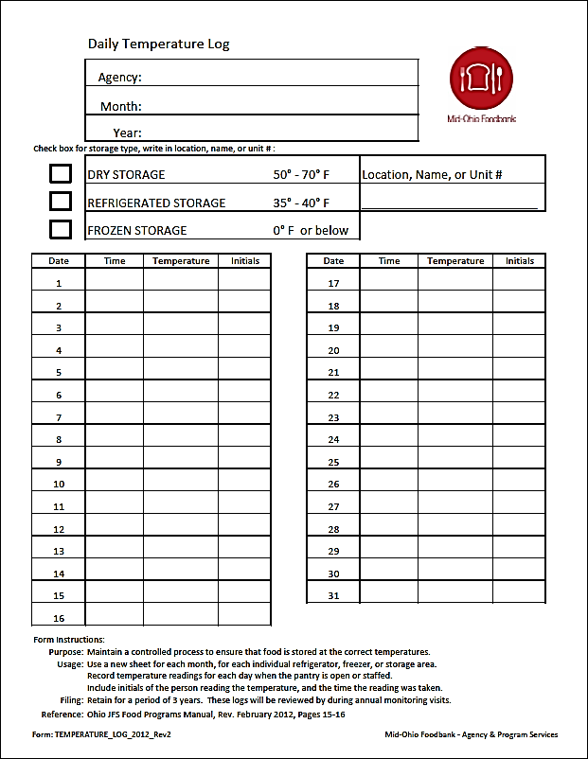Here is a basic example of a daily temperature log that all food service agencies should have. A thermometer should be in dry, refrigerated, and frozen storage areas. Information should be updated every day the pantry is operational.

Storage, *Temperature Log*

Having a designated area for all of the items in your pantry is helpful to both volunteers and clients. A smart layout can be great for traffic flow, as well as mapping the areas that house particular items. It may even help you to organize or rearrange your space. Use the grid below, or create your own grid. **Rearrange the boxes** to correspond with your current layout. Arrows can be used to draw traffic flow patterns. It is also a great way to identify emergency exits!

Enter Exit

Floor Plan

|  |  |  |  |  |  |  |  |  |  |
| --- | --- | --- | --- | --- | --- | --- | --- | --- | --- |
| Waiting Room/Front desk Reception |  |  |  | Dessert Snacks | Bread |  |  | Refrigeration |  |
|  |  |  |  |  |  |  |  |  |  |
|  |  |  | Soup |  | Cereal |  |  |  |  |
|  |  |  |  |  |  |  |  |  |  |
|  |  |  | Canned Vegetables |  | Canned Fruit |  |  |  |  |
|  |  |  |  |  |  |  |  |  |  |
| Produce |  |  | Grains |  | Storage |  |  |  |  |
|  |  |  |  |  |  |  |  |  |  |



Keeping Records

Keeping an accurate account of the people served by your organization will lend easy access to valuable statistics.

This can be particularly useful when writing grants, contacting elected officials to advocate for your program or funding, or even the occasional unexpected media article about your organization.

Knowing how many people you serve on a regular basis will also help with placing orders.

There are various types of records that should be

tracked, including client eligibility forms, donations,

volunteer hours, invoices, and finances.

**Reminder!**

Check with your foodbank to see how long to keep copies of client intake forms, temperature logs, agency monitoring acknowledgement forms, civil rights training documents, client statistics, and ordering invoices.

Your Foodbank may require all program sites to report monthly service records.

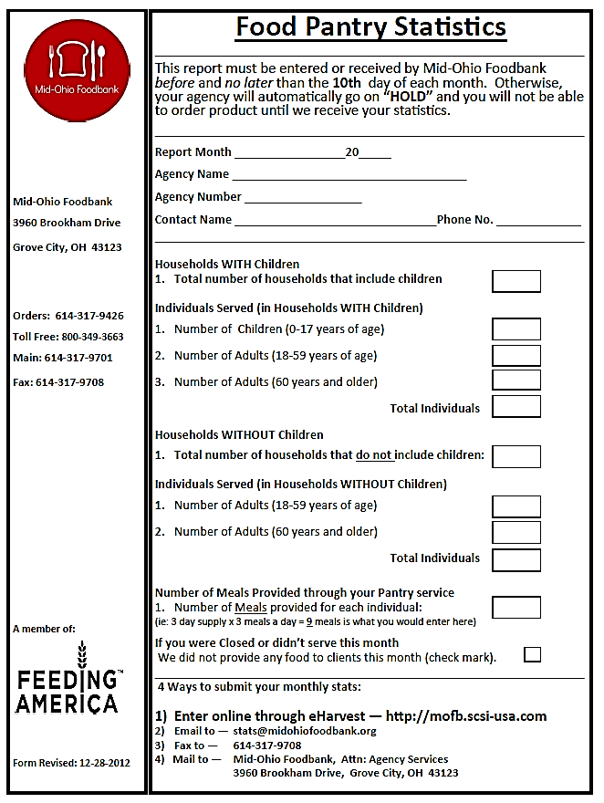Here is a brief example of a statistics form distributed by Mid-Ohio Foodbank.

If you are using **PantryTrak** is a great way to capture statistics for each month.

Keeping Records, *Tracking Statistics*

C:\Users\akirk\AppData\Local\Microsoft\Windows\Temporary Internet Files\Content.IE5\230ROZXZ\MC900060175[1].wmf**The Good Samaritan Law** is in place to “*protect citizens, businesses, and nonprofit organizations that proceed in good faith to donate, recover, and distribute excess food. It limits liability to acts of gross negligence or intentional misconduct and, absent these, donors and others shall not be subject to civil and criminal liability arising from the nature, age, packaging, or condition of the apparently wholesome food of the apparently fit grocery products received as donation*.”

Keeping Records, *Documenting Donations*

|  |  |  |  |
| --- | --- | --- | --- |
| Name & Address of Donor | Date of Donation | Donation Type | Amount of Donation |
| John Doe 108 E. Street  Columbus, OH 41111 |  | Food  Dry goods | 126 lbs.  Questions to Consider:   * Is there a certain area where large food donations should arrive? * Do you weigh all food donations prior to stocking them? * What is the salvage process? * Do you have a donation receipt book? * What information should be captured from the donor?   *See the appendix for a sample thank you letter to donors. |
|  |  |  |  |
|  |  |  |  |
|  |  |  |  |
|  |  |  |  |
|  |  |  |  |
|  |  |  |  |
|  |  |  |  |

Describe the process for documenting donations that come into your organization. Include instructions for monetary, food, and in-kind contributions.

What actions are taken to effectively shut down the facility for an extended holiday? What is the plan for closing down for a level 3 emergency?

Holiday & Inclement Weather Plans

|  |
| --- |
|  |
|  |
|  |
|  |
|  |
|  |
| C:\Users\akirk\AppData\Local\Microsoft\Windows\Temporary Internet Files\Content.IE5\AE01CNQL\MP900449089[1].jpg |
|  |

Questions to consider:

* How do you notify the public that you will not be operational?
* What needs turned off or stored?
* Who is on call for fire/security alarms while the pantry is closed?

Emergency Plan, *Resources*

|  |  |  |  |
| --- | --- | --- | --- |
| Resources | Name | Address | Phone |
| Rent a generator |  |  |  |
| Buy dry Ice |  |  |  |
| Hospital |  |  |  |
| Fire station |  |  |  |
| Police station |  |  |  |

What resources are close to your facility that can aid in a disaster or emergency?

Are these items easily accessible?

* First Aid Kit
* Flashlights & batteries
* Tools for shutting off gas/water valves
* Fire extinguisher

It is vital that staff, as well as volunteers are trained on how to handle disasters and basic emergencies. Key staff should be assigned emergency circumstance tasks. The chart below may help with identifying fundamental personnel. Assigning responsibilities like this can be useful even in minor emergencies such as extended power outages.

Emergency Plan, *Staff*

|  |  |  |
| --- | --- | --- |
| Position for staff or volunteers | Description of responsibilities | Who carries out responsibilities? |
| Strategic Incident Organizer | **Leads** the overall response effort, organizes relief effort plan | Manager |
| Operations Workforce | Directs the carrying out of initial responsibilities, and does initial **work**, may delegate additional needs to other available staff/volunteers |  |
| Resource Acquirement Specialist | Responsible for **obtaining resources** for continued functionality of the organization, and to ensure safety |  |
| Finance Supervisor | **Tracking** activities and costs, overseeing documentation of all disaster related expenses for insurance purposes. May take photos of property damage. |  |
| Information Communication Expert | Keeps all outside resources, such as the supervising organization, aligned with **updates** and information about the situation at hand. |  |

If your organization does not already have a disaster preparedness plan, consider developing safety procedures and include a comprehensive approach for dealing with various emergencies.

Evaluate the total number of clients that could be at your site in the case of a disaster. Is there sufficient space to house clients? If not, what is the backup plan?

Questions to Consider:

* Without access to transportation, how many clients would have to stay at the facility?
* Are there clients who could need assistance evacuating the facility?

|  |
| --- |
|  |
|  |
|  |
|  |
|  |
|  |
|  |
|  |

Emergency Plan, *Clients*

|  |
| --- |
|  |
|  |
|  |
|  |
|  |
|  |
|  |
|  |

What is needed in order to continue providing services after a disaster?

Most nonprofits rely on the help of volunteers to keep their organization running efficiently. Many pantries could not operate without the wonderful group of volunteers that dedicate their time and energy to support the mission of the organization. In order to maintain a group of dedicated volunteers and positive continuous relationships see that volunteers are well managed, expertly trained, respected, and always appreciated.

Questions to Consider:

* What primary service can you continue to provide?
* What critical resources do you need to maintain operation?
* Which neighboring agencies can you share resources with, or refer clients to for services?

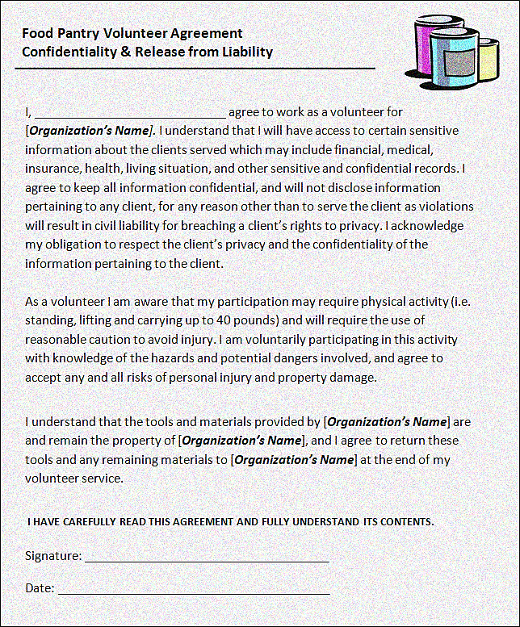

If you don’t already have one, **consider putting together a volunteer manual and training packet**. Here is a sample volunteer agreement letter that outlines expectations and release of liability.

Volunteer Management

Volunteer relationships are mutually beneficial. Although most organizations appreciate a stable group of experienced core volunteers, single instances of service can also be valuable to the organization. Anyone can be a volunteer, and all skillsets should be respected. You may never know how allowing someone to be a part of the work you do, will affect them in the future. Also, creating group opportunities can be a great way to get larger projects done, while incorporating team building activities and strengthening relationships.

Places to find volunteers:

* Clients of the food pantry
* Local intramural sports teams
* Churches & other religious institutions
* Youth groups
* High school & college students, including staff & faculty
* Volunteer fairs, or even job fairs
* Young Professional Associations
* Civic/Fraternal Organizations

Recruiting Volunteers

|  |
| --- |
| Where do you normally recruit volunteers? How? |
|  |
|  |
|  |
|  |
|  |
|  |
|  |

**Does your organization have a formalized way of communicating with volunteers?** Have you considered utilizing online volunteer mobilization resources such as Volunteer Match or other sites that connect volunteers to nonprofits? What about social media like Twitter or Facebook? There are many benefits to using social media to find volunteers for your program. Being a part of a social network not only connects you to volunteers and funders, but also makes you a visible part of the community.

Services like, *Constant Contact*, are online resources that will allow you to stay in touch with volunteers, donors, board members, and the community.

**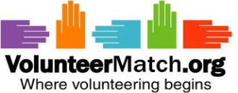

Training Volunteers

|  |  |  |
| --- | --- | --- |
| Volunteer Positions | Description of Responsibilities | How To Implement Training |
| Front  Desk | Greet families and check clients in, fill out eligibility forms, inspect identification, file forms, assign numbers to waiting families, schedule appointments |  |
| Shelf Stocker | Help unload truck or pallets, moving product from stock area to shelves and coolers, organizing the storage area, keep storage area and pantry clean |  |
| Shopping Assistant | Escort families through the pantry while helping them make selections of various food items, enforce compliance of the amount of food received for household size, may need to load carts and help elderly/disabled clients to vehicle |  |
| Box  Packer | Fill emergency boxes with non-perishable items in specified quantities, assist shelf stocking team when needed, help keep stock area and pantry area clean |  |

All pantries want to provide the opportunity for volunteers to undertake a results-driven service opportunity, especially one designed to meet the food access and hunger relief needs of the residents they serve. In doing this, volunteers can see how their work supports food distribution to hungry families through their work at the pantry. Remember to include civil rights training as part of your overall education process.

Important points to consider when training volunteers:

* Model good customer service; ensure all families are treated with respect.
* Make sure volunteers understand the check-in and check-out process. Clearly communicate the number of visits a family can come in to receive food each month, how to schedule appointments, and whether walk-ins are allowed.
* Give guidelines of how the shopping process occurs.

Training Volunteers, *Responsibilities*

With all of the wonderful work volunteers do, you may not think that a volunteer code of conduct is entirely essential. Implementing standards for responsibly carrying out assigned duties, and outlining expectations may actually be beneficial. Construct a system that identifies violations, accompanied by clear consequences. This can also be used as an opportunity to discuss the organization’s formal grievance policy.

Volunteer Code of Conduct

|  |  |
| --- | --- |
| Our Policies: | How we address violations: |
| Adhere to family size distribution guidelines. | Volunteer will be reminded of guidelines; further action will result in a transfer from shopping assistant to an alternate position. |
|  |  |
|  |  |
|  |  |
|  |  |
|  |  |
| Questions to Consider:   * Do you have set practices or policies in place that address missed volunteer shifts? * Is there a dress code (must wear nametags, or closed toe shoes)? * When are rest breaks? * What are the stipulations for volunteers shopping at the panty (should they be accompanied)? * Can volunteers be terminated? If so what is the dismissal procedure? |  |
|  |  |

There are a variety of reasons to keep an account of all of the hours volunteers contribute to the success of your organization. Some may be students that need to satisfy an educational obligation. Others may need to fulfill community service requirements, whether court ordered, or through an employer. No matter the circumstance the hours should be tracked so that you have an accurate account for both the volunteer and your organization. You may want to have them sign in and out of each shift.

Tracking Volunteer Hours

|  |  |  |  |  |  |
| --- | --- | --- | --- | --- | --- |
| Volunteer Name | Week  1 | Week  2 | Week  3 | Week  4 | Total Hours For January  2013 |
| *Example:*  Ashley Smith | 4 Hours | None | 5 hours | None | 9 Hours |
|  |  |  |  |  |  |
|  |  |  |  |  |  |
|  |  |  |  |  |  |
|  |  |  |  |  |  |
|  |  |  |  |  |  |
|  |  |  |  |  |  |
| Total Volunteer Hours |  |  |  |  |  |

**You may need to make your chart more specific**. Larger organizations with a lot of volunteers may need a more sophisticated database to track hours; some online resources such as *Volunteer Hub* have a service to help you do just that.

It is clear that volunteers serve a special purpose when it comes to the functionality of food pantries. Why not express how much they are appreciated? Have a gathering or write a newsletter; you can list how volunteers have helped the organization to reach goals, recognize all of the work they have achieved, and explain why they are important to the community you serve. This also improves volunteer retention!

Volunteer Appreciation

|  |
| --- |
| How does your organization strive to show volunteers they are appreciated? |
| Can volunteers evaluate their experience with your organization? |
|  |
|  |
|  |
|  |

Volunteer appreciation should start even before volunteers show up for their shift. A welcome letter can really make new volunteers feel well received into the organization, and should stress the importance of volunteers in fulfilling the mission of the organization.

*Example: Volunteer Welcome Letter*

Dear *Volunteer,*

Thank you for choosing to volunteer with *Our Organization*. We are thrilled to welcome you to our team of volunteers. We believe volunteers are a vital part of supporting the mission of this organization. We hope that you find the responsibilities of your volunteer duties to be fulfilling, and that your experience with us is quite rewarding.

If you have any questions, please feel free to contact us at XXX-XXX-XXXX

Sincerely,

***The Food Pantry***

Many organizations will require the budget to be approved by The Board of Directors before the beginning of the fiscal year**. Who approves and maintains your budget?**

Effective management of finances can be crucial to organizational success. It can outline the major costs and give an overview of available resources. Donors also find it useful when tracking their contributions to see how their funds are being utilized. Having a comprehensive budget can establish credibility with your donors, and provide a clear view of goals that can be set for the following year.

Annual Budget

Finances & Budgets

Why is having an annual budget important?

* + - * **It shows realistically what you can afford and where gaps lie in funding, which might help with making tough decisions about what programs to cut or expand.
      * It affords you the opportunity to plan to meet needs, and to decide what you're actually able to accomplish in a fiscal year concerning current and future endeavors
      * A budget can motivate you to be creative in seeking out other sources of funding.
* It facilitates discussion of the financial status of the organization.
* It helps you avoid surprises and maintain financial control, which can help you gage current annual income and set goals for annual increases in funds raised.

Budgets must be drawn to cover your fiscal year, and should be ready before the beginning of each fiscal year. While any budget should be easily understood, the amount of information needed may vary by organization. Set reasonable projections of financial need, and account for any programs that may be introduced during the fiscal year.

Annual Budget, *Assessing Financial Responsibilities*

|  |  |  |  |  |
| --- | --- | --- | --- | --- |
| Annual  Financial Needs  *Fiscal year 2014 | Financial Resources | Projected Dollar Amount Required | Current Amount Allotted | Amount We Need to Raise/Secure |
| Food |  |  |  |  |
| Paid staff |  |  |  |  |
| Facility Rent | Church, government grant, private donation | $26,400/year | $2,200/month | $0 |
| Facility Utilities |  |  |  |  |
| Office supplies |  |  |  |  |
| Miscellaneous |  |  |  |  |
| New Programs |  |  |  |  |

This table can be used to project annual need. You can incorporate information to help you plan or create a budget for the upcoming fiscal year. Show which funds are allocated, and which funds will be deducted from the amount of money you currently have available.

C:\Users\akirk\AppData\Local\Microsoft\Windows\Temporary Internet Files\Content.IE5\AE01CNQL\MC900233228[1].wmfImplement an accounting system for your program that is easy to use and understand. If your agency has a computer, you may want to consider using a simple accounting program, such as QuickBooks or Microsoft Excel. Having your budget on the computer will make it easier to generate reports for yourself and donors.

If your organization does not have access to a computer, you can set up a manual bookkeeping system. You just need to keep an accurate account of the amount of money that comes in and out of your program.

Bookkeeping

|  |  |  |  |  |  |
| --- | --- | --- | --- | --- | --- |
| Date | Check # | Memo | Check Amt. | Deposit Amt. | Balance |
|  |  |  |  |  |  |
|  |  |  |  |  |  |
|  |  |  |  |  |  |
|  |  |  |  |  |  |
|  |  |  |  |  |  |
|  |  |  |  |  |  |
|  |  |  |  |  |  |

Basic bookkeeping is quite similar to maintaining a personal checkbook. It is simply the recording of financial transactions including purchases, receipts, and monetary donations.

 Feeding hungry people is a priority; some organizations may find it difficult to do this with a limited budget. A lack of financial resources can sometimes stifle organizational growth. You may need to host fundraisers or food drives to keep your program running. Fundraisers and food drives can be fun, and will engage the community in your mission.

Fundraisers & Food Drives

What types of fundraisers or food drives do you host?

|  |  |  |  |  |  |
| --- | --- | --- | --- | --- | --- |
| Type Of Campaign | Date/Duration of Campaign | Location of Campaign | Contact At Collection Site | Person In Charge of Collection | Amount Raised This Year |
| Food Drive |  |  |  |  |  |
| Fundraiser |  |  |  |  |  |
|  |  |  |  |  |  |
|  |  |  |  |  |  |
|  |  |  |  |  |  |

Identifying your audience and applying for grants that support your specific mission can really improve your chances of receiving a grant. Having accurate documentation of your program and the people you help will be a part of your application, always have this information available!

You may need to make a more elaborate chart to detail your food drives and fundraisers. Be sure to secure a collection method or provide materials for food drive host sites, such as boxes to collect all of the food. You may want to initiate friendly competition to drive up quantities. Remember almost anyone can give something to help out another person in need, make it as easy as possible for people to participate and donate.

Remember when writing a grant you want to paint a picture of all the great work your organization has accomplished, and what the grant will mean to the people you serve as you have continued success alleviating hunger.

Most grant and proposal applications clearly state what information must be submitted to be eligible for funding. Below is an outline of general information most donors request.

Grant & Proposal Writing

The government, religious sources, and private or corporate foundations usually have grants available. Before you apply, make sure your program fits the funder’s guidelines. Maintaining a professional relationship with funders will aid in your success of securing future grants. **Does your organization depend on or apply for certain grants annually? If so, which ones?**

Most clients of emergency food programs usually need much more than food. What other services does your program offer? Do you offer financial counseling or job training opportunities? Do you use other providers to expand your services, or do you provide referrals?

|  |
| --- |
|  |
|  |
|  |
|  |
|  |
| Questions to consider:  Who is in charge of each external program, or who is the main contact? What is the training process if the program is offered through pantry staff? |
|  |
|  |
|  |
|  |
|  |
|  |
|  |
|  |
|  |
|  |

**PLAN: P**antries **L**earning to **A**ssess **N**eeds

The following lists *some of the most important programs* that your clients should know about, both food related and beyond.

Public Benefits

|  |  |
| --- | --- |
| Program | Description of Service |
| SNAP  Supplemental Nutrition Assistance Program | Formerly the food stamp program, SNAP provides a monthly stipend for food on an EBT (Electronic Benefit Transfer) card. SNAP is intended to supplement users’ food budgets, encourage clients to come to the pantry before using up their SNAP benefits to stretch their SNAP dollars. |
| WIC  Women, Infants  and Children | Provides healthy foods, nutrition information and referrals to health and social services to pregnant, breastfeeding, and non-breastfeeding postpartum women, and to infants and children up to age five. |
| CSFP  Commodity Supplemental  Food Program | Provides monthly food and assistance to participants 60 years of age and older. |
| Free/Reduced  School Lunch | Students from low income households qualify for free or reduced-price school lunch. SNAP participants automatically qualify for free school meals. |
| Summer Meal Program | Provides meals for children over the summer vacation |
| HEAP  Home Energy  Assistance Program | Pays part of winter energy bills for low-income renters and homeowners. |
| Medicaid | Pays for medical care for some low-income and medically needy people. |
| TANF  Temporary Assistance for Needy Families | Provides temporary cash assistance to needy families with minor dependent children. |
| Housing Assistance | Provides subsidized rents, public housing and homeowner education and assistance. |
| Free Tax Filing | Provides free tax preparation services |
| Domestic Violence shelters | Provides emergency housing and counseling to victims of domestic violence. |
| Title XX | Child Care Assistance |

Does your pantry have annual giveaways like holiday baskets, or a Thanksgiving turkey distribution? Do you make special birthday gifts to give to clients, or their children? Do you give away school supplies at the beginning of the school year?

Building Relationships With Clients

|  |
| --- |
|  |
|  |
|  |
|  |
|  |
|  |
|  |
|  |
|  |
|  |
|  |
|  |
|  |
|  |
| C:\Users\akirk\AppData\Local\Microsoft\Windows\Temporary Internet Files\Content.IE5\AE01CNQL\MC900439764[1].png |
|  |
|  |

List any special giveaway programs you host or participate in, and describe the process of obtaining and distributing those items:

C:\Users\akirk\AppData\Local\Microsoft\Windows\Temporary Internet Files\Content.IE5\9A113Z01\MC900318880[1].wmfServing each client with dignity and respect is a standard right that every client should experience. All clients should be treated fairly and equally when entering your establishment, and when distributing goods to each household. Clients should be assured that their information is always kept confidential.

Identifying Client Needs

 If you have many clients that speak little to no English, try offering information in their native language. Think about having someone on staff or a volunteer that can communicate with clients with limited English skills. If you serve a largely ethnic population consider ordering more food that is appealing to those clients, try keeping cultural sensitivities and differences in mind when serving all clients.

C:\Users\akirk\AppData\Local\Microsoft\Windows\Temporary Internet Files\Content.IE5\9A113Z01\MC900199364[1].wmfSome clients may have special diets due to health or religion; some may have limited literacy or limited mobility. Other clients may have vision, or hearing disabilities. Consider training volunteers, or having materials to accommodate these specific needs.

|  |
| --- |
| What policies do you have in place that protect client’s rights and privacy? |
| Question to Consider?  Do you have someone that conducts outreach to offer services or resources to eligible people beyond the clients that walk through your doors? |
|  |
|  |
|  |
|  |
|  |
|  |
|  |
|  |
|  |
|  |

C:\Users\akirk\AppData\Local\Microsoft\Windows\Temporary Internet Files\Content.IE5\AE01CNQL\MC900078739[1].wmfWhen you are feeling mentally, physically, or emotionally exhausted it can be difficult to ensure high quality service for those who depend on you. Staying positive and encouraging staff to be positive when encountering so much despair on a regular basis can be hard. Try planning occasional staff and volunteer events to relieve stress and strengthen relationships. Attempt to restrain judgment of clients; you never know what situation caused them to come into your pantry. Sometimes reaching out to clients can help you to offer resources that can help them out of a bad situation.

Staying Committed To Your Organization

|  |
| --- |
| What do you do to keep a positive work environment? |
|  |
|  |
|  |
|  |
|  |
|  |
|  |

Nutrition Education

Do you hold any type of nutrition education classes, or give out nutrition related information or recipes?

There here are many health concerns associated with food insecurity. Some food insecure people may find it more convenient to purchase high calorie, low-nutrient foods. Healthy food choices are not always obvious. Choosing high calorie, low nutrient foods can contribute to various conditions such as diabetes, heart disease, stroke, and some cancers.

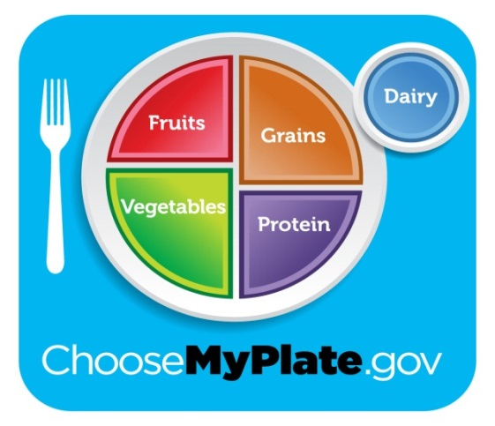My Plate by the USDA is one way to encourage people to eat well-balanced meals. The My Plate concept shows proper proportions of food from each food group. For example, half of every plate should contain fruits and vegetables. Offering a lot of fruits and vegetables in your pantry, along with displaying the My Plate graphic can inspire people to eat healthier. When shopping, encourage people to choose whole grains. Explain how replacing sugary beverages with water can be an extremely valuable part of better health.

Do you see sweets or an area for fatty foods on the My Plate graphic? They are omitted because they should not be a part of every meal.

Nutrition Education, *My Plate*

|  |  |  |  |
| --- | --- | --- | --- |
| Food Group | Healthy Options | How We Offer More Healthy Choices: | |
| Fruit | Fresh fruit is great, but if you only have access to canned try to find options with light syrup. | |  |
| Vegetables | Look for fresh vegetables or low sodium canned vegetables | |  |
| Grains | Whole grains are the best option. Try offering more whole grain pasta and bread. | |  |
| Protein | Whether it is a canned protein option or meat find low fat, low sodium options. | |  |
| Dairy | Shelf stable 1% milk or non-fat dry milk is always a great choice; try to find more low fat dairy products to offer. | |  |

Stocking Shelves & Offering Healthy Choices

Highlighting “Healthy Options” by accenting your shelves can help people see better food choices. Make signs to draw attention to healthy items. What steps can you take to offer more healthy options to your clients?

If many of your clients have diabetes, add more whole grain and high fiber foods to your inventory and decrease the amount of refined grains and sugars. To accommodate special religious dietary restrictions survey clients to see if you need to offer more food that encompasses their needs.

Are most of your clients elderly, or mainly children? How do you choose items that will serve that population?

Addressing Clients with Specific Dietary Restrictions

|  |
| --- |
| How do you make sure the dietary restrictions of your clients are met? |
|  |
|  |
|  |
|  |
|  |

Addressing Clients with Specific Dietary Restrictions

Community Garden

|  |  |  |  |
| --- | --- | --- | --- |
| Season | Month | Type of Seed Planted | Lbs. of Food Produced |
| Spring |  |  |  |
| Summer |  |  | C:\Users\akirk\AppData\Local\Microsoft\Windows\Temporary Internet Files\Content.IE5\LSHGVFRD\MC900295899[1].wmf |
| Fall |  |  |  |

A garden is a great way to expand resources, offer healthy food, and engage the community. If you have a community garden describe your process for planting each year and detail your garden plan.

Legal and Tax Information

Appendix

|  |  |
| --- | --- |
| Reference Material | Organization Information |
| Food Pantry’s Legal Name |  |
| Federal Tax ID Number |  |
| Sponsor Agency’s Name & Federal Tax ID Number |  |

|  |  |  |
| --- | --- | --- |
| Title/Company | Name/Department | Phone/Email |
| Program Director |  |  |
| Pantry Coordinator |  |  |
| Mid-Ohio Foodbank |  |  |
| Mechanic |  |  |
| Pest Control Company |  |  |
| Liability Insurance Carrier |  |  |
| Bank |  |  |
| Volunteer |  |  |
|  |  |  |
|  |  |  |
|  |  |  |

Staff Directory & Important Contacts

Board of Directors

Appendix

|  |  |  |
| --- | --- | --- |
| Board Member’s Name | Title/Affiliation | Email Address |
|  |  |  |
|  |  |  |
|  |  |  |
|  |  |  |
|  |  |  |
|  |  |  |

Donor Thank You Letter, *Sample*

By law, you must acknowledge in writing all gifts over $250, but every donation should be acknowledged with gratitude. It is best if each letter has a personal message of appreciation included!

Dear *Donor*,

Thank you so much for your generous gift to help with our mission. We are dedicated to feeding hungry people in our community and truly appreciate your efforts to assist us in turning dollars into nourishing meals. Our food pantry is a 501 (c) 3 approved organization, and your contribution is tax-deductible to the full extent allowed by the law.

Please note that no goods or services were rendered in exchange for this contribution.

Thank you,

Your Local Community Food Pantry

.

|  |  |  |  |  |  |  |  |  |  |  |  |  |
| --- | --- | --- | --- | --- | --- | --- | --- | --- | --- | --- | --- | --- |
| Cleaning Duties | Jan | Feb | Mar | Apr | May | June | July | Aug | Sept | Oct | Nov | Dec |
| Wipe Down Shelves |  |  |  |  |  |  |  |  |  |  |  |  |
| Wash All Windows |  |  |  |  |  |  |  |  |  |  |  |  |
| Clean Refrigerator |  |  |  |  |  |  |  |  |  |  |  |  |
| Defrost Freezer |  |  |  |  |  |  |  |  |  |  |  |  |
| Clean Floors |  |  |  |  |  |  |  |  |  |  |  |  |

Sample Monthly Cleaning Checklist

Appendix

|  |  |  |
| --- | --- | --- |
| Product | Estimated Shelf Life | When to Discard |
| Baby Food | Use by expiration date | Broken seal, expired |
| Bread/Bakery items | 3-10 Days | Visible mold, package defect |
| Cans/Bottles | 1-several years | Bulging, severe dents |
| Cereal | 6 months-2 years | Stale, infestation |
| Crackers | 1-2 years | Stale, infestation |
| Dry Beans | 1-2 years | Infestation, mold, open |
| Freezer items | 3 months-1 year | Freezer burn, malodorous, previously thawed |
| Prepared Salad/Dips | Use by date | Past date |
| Refrigerated Juices | 1-4 weeks | Mold, discoloration |
| Rice | 1 year | Infestation, mold, open |
| Yogurt | 1-3 weeks | Mold, open, malodourous |

USDA Shelf Life Reference Guide

Food Quality & Expiration Guidelines

|  |  |
| --- | --- |
| Date Code | Description of Code |
| Expiration  Date | The date past which a product, such as food or medicine, must be sold or removed from availability because it is no longer expected to be fresh or effective. |
| Sell by | Tells the store how long to display the product for sale. Retailers rotate stock to be sure they sell the oldest first. The consumer can add days to this before eating it. |
| Best by | The product is at its highest quality, is freshest and tastiest by this date. The “Best when used by” date is not a purchase or safety date. Most people would notice no difference after the date is passed. |
| Use by | This is the last date for use of the product at peak quality. This date has been determined by the manufacturer of the product. |
| Production  Date | Tells you when the product was produced. It does not tell you anything about the quality or safety of the product, as it does not tell you anything about shelf life. Production dates are used to track product, they are not meant for the consumer. |

|  |  |  |
| --- | --- | --- |
| Description of Duty | Person Currently Responsible for Task | Person That Will Take Over Responsibilities |
|  |  |  |
|  |  |  |
|  |  |  |
| Who would carry out the responsibilities of running the pantry if you were to retire, get sick, or had to relocate? A succession plan can give clear direction to staff and volunteers concerning who will take over each responsibility in the event of leadership change, or if unexpected situations occur. |  |  |
|  |  |  |
|  |  |  |

Succession Plan

Appendix