PG&E INFORMATION Revised 1-5-22
This write-up reviews the process to help a client with their PG&E bill and lists some programs that they may qualify for.

INITIAL VISIT WITH CLIENT
Here are some important points to cover when you meet with the client:
1)Look at the most recent bill.
A) Is it a 15 day notice or 48 hour shutoff notice? PG&E will call before they come to shut off the power.
Have they called? Sometimes if a client tells them to hold off due to meeting with SVdP they will
delay the shutoff;
B) Is the bill in the name of the person you are meeting;
C) Are you sure that it is the most recent.
D) If there is a possibility that your conference will pay the bill record the following information from the
Bill: Name, address, account #
2)Ask if them if they have discussed a payment plan with PG&E and if not why not;
3)Ask if they have gone to LIHEAP;
4)Ask if PG&E will accept a check from them.

Of course, there are also the general questions of any home visit. How did they get behind in their payments and what is their plan for this to not happen again?

BILLING PROCESS
Bills are issued monthly. There is no grace period, but also no late fees. If two or more bills are unpaid, the collections process is triggered. A 15-day notice is given, then a 48-hour notice and then a final phone call from PG&E to the client before service is cut off. Up to and including the final phone call, payment arrangements can be made. Usually 30% of past due bill is due within 7 days. As soon as the bill is paid the shutoff notice is cancelled immediately.

Payment Arrangements Available from PG&E
Payment extensions;
Payment arrangements for 3 to 6 months;
Budget Billing (formerly known as Balanced Payment Plan) which evens out payments based on the last 12 month average usage. Then PG&E adjusts the monthly amount once every 4 months if the actual energy usage has significantly changed. The amount may go up or down.

HOW TO PAY A CLIENTS PG&E BILL
Per the guidelines of the Society payments are made directly to PG&E. Checks are never given to the client, even if they are made out to PG&E. Payments can be done by check, cash or money order, depending upon the client, not the bill. No 3rd party checks will be accepted, but checks from SVdP are accepted. Due to some client’s credit history with PG&E, PG&E may require cash or money orders. It is best to determine that prior to showing up at PG&E’s office to pay the bill. If the client doesn’t know then it is best to have them call PGE at 800-743-5000(English) or 800-660-6789 (Spanish). The Vincentian will then go to the local PG&E office to pay the bill. In Antioch it is at 800 W 2nd St. Hours are 8:30 to 5 Monday through Friday. Here is the form that must be filled out and taken to the window. Please note that it requires the name on the account, the service address and the account ID.
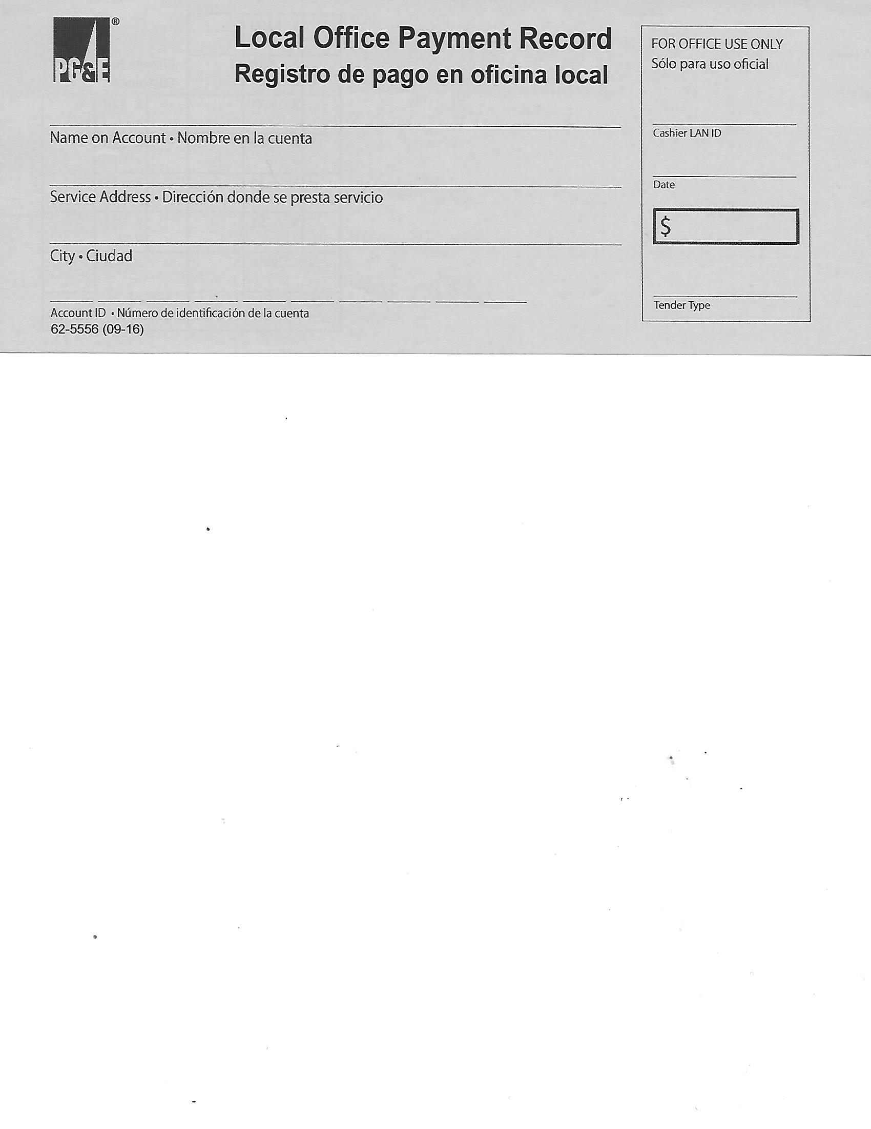
When visiting the client either write down that information, take the bill from them or take a photo of it. Due to privacy concerns PG&E will not provide any of that information to you. All they will tell you is if any of the information doesn’t match up. They will give you a receipt.

PG&E has an agency pledge program which allows conferences to pledge to pay a client’s bill over the internet or by phone and make payments via check later. Best to read the fine print on this before signing up to participate in it.
PROGRAMS AVAILABLE TO HELP PAY PG&E BILLS
All of PG&E’s programs can be found at:
https://www.pge.com/en_US/residential/save-energy-money/help-paying-your-bill/payment-assistance-overview/payment-assistance-overview.page

AMP (Arrearage Management Plan)
https://pgesupport.zendesk.com/hc/en-us/sections/360011725031-AMP-Program
This is a new program that was created in June 2020 that will forgive eligible customer’s debt in return for on-time monthly payments.

CARE (California Alternate Rates for Energy)
https://www.pge.com/en_US/residential/save-energy-money/help-paying-your-bill/longer-term-assistance/care/care.page?WT.mc_id=CARE_EN_adwords_20161003_search&gclid=EAIaIQobChMIzJrE5-Xk1QIVB2p-Ch2MhAkXEAAYASAAEgKrTfD_BwE
CARE eligibility is based on public assistance program participation or based on the number of individuals in the household and total gross household income. See income guidelines on website. Qualified households receive deep discounts on their energy bills. See the end of the write-up for the CARE form or get one from the local PG&E office or the internet.

FERA (Family Electric Rate Assistance)
https://www.pge.com/en_US/residential/save-energy-money/help-paying-your-bill/longer-term-assistance/fera/fera.page?WT.mc_id=Vanity_fera
Similar to CARE it can provide a monthly discount on electric bills. The program is designed for households of three or more persons with a slightly higher income that required for CARE. Same application as for CARE. Form is at the end of this document and available at the local PG&E office or from the internet.

Energy Savings Assistance Program
https://www.pge.com/en_US/residential/save-energy-money/help-paying-your-bill/energy-reduction-and-weatherization/energy-savings-assistance-program/energy-savings-assistance-program.page
It provides qualified customers with energy-saving improvements at no charge. Participants must live in a house, mobile home or apartment that is at least five years old. Income must meet the certain guidelines, which are the same as those for CARE.

Medical Baseline Allowance
https://www.pge.com/en_US/residential/save-energy-money/help-paying-your-bill/longer-term-assistance/medical-condition-related/medical-baseline-allowance/medical-baseline-allowance.page

Medical Baseline is a financial assistance program for residential customers that have special energy needs due to certain qualifying medical conditions. Eligible customers may receive a “standard” Medical Baseline quantity of approximately 500 kilowatt-hours (kwh) of electricity and/or 25 therms of gas per month, in addition to regular Baseline quantities. Please note that this description does not say that PG&E will not shut off power to a residence that has medical baseline. It will.
To qualify, a California-licensed physician must certify that a full-time resident in your home has one of the following medical issues:
- Dependency on life-support equipment at home. For a list of equipment, visit Life-Support Equipment.
- Paraplegic, hemiplegic or quadriplegic condition
- Multiple sclerosis with special heating and/or cooling needs
- Scleroderma with special heating needs
- Life-threatening illness or compromised immune system, and special heating and/or cooling are needed to sustain life or prevent medical deterioration
The physician’s form is only good for two years. Form is available at the local PG&E office or on the internet.
REACH (Relief for Energy Assistance through Community Help) administered by the Salvation Army
https://www.pge.com/en_US/residential/save-energy-money/help-paying-your-bill/one-time-assistance/reach/reach.page?WT.mc_id=Vanity_reach
Maximum payout - $300 and only once every 18 months.
Must have a notice that the power is going to be shut off.
The reason that they can’t pay their bill has to be caused by some outside event not of their own making.
Can’t be on section 8
Income has to be less than 200% of the federal poverty level
The total amount owed to PG&E must be under $300 so that once the Salvation Army puts in their portion the balance is zero.
Monday-Friday 7:30AM - 4:30PM 925-778-0808
LIHEAP or HEAP (Low Income Home Energy Assistance Program)
https://www.benefits.gov/benefits/benefit-details/1540
The Low Income Home Energy Assistance Program (LIHEAP) Block Grant is funded by the Federal Department of Health and Human Services (DHHS) and provides two basic types of services. Eligible low-income persons, via local governmental and nonprofit organizations, can receive financial assistance to offset the costs of heating and/or cooling dwellings, and/or have their dwellings weatherized to make them more energy efficient. This is accomplished through these program components:
The Weatherization Program provides free weatherization services to improve the energy efficiency of homes, including attic insulation, weather stripping, minor housing repairs, and related energy conservation measures.
The Energy Crisis Intervention Program (ECIP) provides payments for weather-related or energy-related emergencies.
In order to qualify, you must also have an annual household income (before taxes) that is below 60 percent of the State Median Income
A person who participates or has family members who participate in certain other benefit programs, such as the Supplemental Nutrition Assistance Program (SNAP), Supplemental Security Income (SSI), Temporary Assistance for Needy Families (TANF) or certain needs-tested Veterans benefits may be automatically eligible.
This program is being serviced through:
Contra Costa County Employment & Human Services Department, Community Services Bureau
1470 Civic Court, Suite 200
Concord, CA 94520
Utility Payment Assistance: (925) 681-6380
Emergency Services: (925) 681-6380
Weatherization Services: (925) 674-7214
Fax: (925) 229-6784
Monday through Friday (Office Hours): 8 a.m. to 5 p.m.
Monday through Friday (Phone Hours): 9 a.m. to 4 p.m.
Utility Assistance Website: http://ehsd.org/headstart/energy-assistance/
Weatherization Assistance Website: http://www.cccounty.us/weatherization

