**AGENDA ST. VINCENT DE PAUL**

**PRESIDENT’S TRAINING**

**10-16-21**

**1 Welcome and introductions**

-Contra Costa is a big county and we have a lot of variety within our SVdP conferences. Conferences are set up to meet the particular needs of their parish area.

**2 Communication**

-between District Council and Conference members

-decisions made by consensus when possible

-make time to listen

-schedules are helpful

-essential: spirituality, service and friendship

Example: **PANTRY SCHEDULE FOR OCTOBER**

**Tuesday:**

Food bank pick up Concord 9:00 John Rebar and Rob Schneider e/o week

Sprouts pick up 10:00 Joe Flannigan

Safeway pick up 10:00 Dan Bonnici

Target pick up 11:00 Vic Allessio, Ted Todd and Joe Flannigan and Mary Stark (10/12, 19 and 26)

Good Shepard Jess Garcia pick up from pantry 11:30

Shelf stocking 9:30 Angela Brothers and Mavis Sonnier.

Mavis Sonnier to take inventory and place food bank order.

**Wednesday:**

Safeway pick up 10:00 Thomas or Andrew Baker

Sprouts pick up 10:00 Ted Todd and Vic Allessio

Shelf stocking 9:30 Angela Brothers

**Thursday:**

Sprouts pick up 10:00 Jerry and Melanie Harris

Shelf stocking and set up 10:00 Mike Miller (Irene 10/7) and Larry Sanchez

White Pony delivery to the pantry 10:30

Distribution Team on Sign Up Genius

Barb Erickson to file weekly report to Food Bank

**Friday:**

St. Bonaventure (Ann and Bob Koch) pick up from pantry 8:00 Ted and Joy Todd

Barb Erickson (Larry 10/1) and Rafael Martinez to clean.

**3 Conference Meetings**

-send out agenda and invite everyone

-meet at least twice a month

-use The Rule, as your guide

**Example AGENDA ST. VINCENT DE PAUL**

**ST. MARY CONFERENCE MEETING**

**9-20-21**

*Opening prayer

*Roll call

*Spiritual Reading and reflection (Maria)

*Review of minutes (Sheila T.)

*President’s Report (Barb)

-The Rule

-Report from the District Council meeting

-Update on the pantry

*Prayer box cards, phone messages and emails (Barb)

*Treasurer’s Report (Katie)

*Business (Barb)

-Client Kenia

-Client Andrea

-ROTA Care dinner 10/27 20 people 5 pm Pittsburgh

-Review info from survey

-FOP Walk 9/25 9-12 St. Isidore

-Bocce Ball fundraiser. John Rebar and Brian Kavanagh’s team wins! $37,000 raised

- -Next meeting 10/4 at 4:00 in person, outside next to the gym, Mavis to lead meeting

*Closing prayer

**4 Officers**

-Vice President. Share responsibilities.

-Treasurer. Add yourself to the bank account along with the treasurer and another officer. Work on the quarterly reports together. Forms in the Drop Box

-Secretary. Takes notes at meetings. Template available.

-Spiritual Advisor. Leads the Spiritual reading and reflection. Reflections are available on line.

 **2021**

**instructions include reporting on ppp government grants & person-to-person visits during covid-19**

**Quarterly Conference Report**

|  |  |  |
| --- | --- | --- |
| **Fiscal year:** | **2020-2021** |  |
| Deadline: | October 1, 2020 (90 Days) | December 31, 2020 |

(Arch)Diocesan Council: __Oakland______________________________ District Council: Contra Costa

________________________________________

Conference Name: ____St. Mary of Walnut Creek

_______________________________________________________________________________________

Address: ____2051 Mt. Diablo Blvd., Walnut Creek CA 94596 925-937-2817

_______________________________________________________________________________________________

Street City State Zip Phone

Reporting period from: __10-1-2020________ to ____12-31-2020_______ **(QUARTERLY, enter quarter being reported on here)**

Frequency of meetings (check one): Weekly ____ Every other week ___X_ Monthly ____ Other ____

## Our Conference has formally adopted and is in compliance with the 2019 version of “Document 1: Bylaws for Conferences,” which can be found on [www.svdpusa.org](http://www.svdpusa.org). Yes __X___ No _____

## Membership*

(*Ethnic breakdown required for government reporting, grant applications, etc. Please assign each member to one category only.)

|  |  |  |  |  |  |  |  |
| --- | --- | --- | --- | --- | --- | --- | --- |
|  | **Asian** | **Black** | **Caucasian** | **Hispanic**  **Latino** | **Alaskan Native**  **American Indian** | **Native Hawaiian/**  **Other Pacific Islander** | **Mixed/**  **Other** |
| Active (Full) – under 19 |  |  |  |  |  |  |  |
| Active (Full) – 19 through 39 |  |  |  |  |  |  |  |
| Active (Full) – 40 and over |  |  |  |  |  |  |  |
| Total Active (Full) |  |  |  |  |  |  |  |

|  |  |  |  |  |  |  |  |
| --- | --- | --- | --- | --- | --- | --- | --- |
|  | **Asian** | **Black** | **Caucasian** | **Hispanic Latino** | **Alaskan Native**  **American Indian** | **Native Hawaiian/**  **Other Pacific Islander** | **Mixed/**  **Other** |
| Associate – under 19 |  |  |  |  |  |  |  |
| Associate – 19 through 39 |  |  |  |  |  |  |  |
| Associate– 40 and over |  |  |  |  |  |  |  |
| Total Associate |  |  |  |  |  |  |  |

## Total Membership

|  |  |
| --- | --- |
| Total Active (Full) | 31 |
| Total Associate | 8 |
| Total Members | 39 |

|  |  |  |
| --- | --- | --- |
| **Comparative Membership** | **Number** | **New This Year** |
| Total All Vincentians |  |  |
| Total – under 19 (Youth) |  |  |
| Total – 19 through 39 (Young Adult) |  |  |
| Total Minority (Non-Caucasian) |  |  |
| Total Non-Vincentian Volunteers |  |  |

### **Treasurer’s Report (includes Receipts and Expenses from Conference, Stores and Special Works)**

|  |  |
| --- | --- |
| **Last Quarter’s Ending Balance (Required)** | **$25,210** |
| **Adjustments to Last Quarter’s Ending Balance – attach an explanation** | **$** |
| **Beginning Quarter’s Balance (Required)** | **$25,210** |

### **Receipts (Please round all figures to the nearest dollar)**

|  |  |  |  |
| --- | --- | --- | --- |
| 1. Donations from Members | $ |  |  |
| 1. Church/Poor Box Collections | $21,777 |
| 3A. Fund Raising - Special Works | $ |
| 3B. Fund Raising - Stores | $ |
| 3C. Fund Raising - Special Events/Other | $ |
| 4. Other SVdP Contributions | $ |
| 5A. Less Government Grants - EACH of at least $50,000 and with admin allowance of 10% or less received:  (ENTER $0 IF EACH GRANT IS LESS THAN $50,000) | $ |
| 5B. Other - Disaster Funds | $ |
| 5C. Other - Capital Campaign Funds | $ |
| 5D. Other - Other Restricted Funds | $ |
| 5E. Other - Misc. Receipts  **include any PPP funds forgiven as grants by federal government** | $ |
| **Total Receipts (1 thru 5E)** | | | + $ |

## Expenses (Please round all figures to the nearest dollar)

|  |  |  |  |
| --- | --- | --- | --- |
| 1. Those We Serve | $5548 |  |  |
| 1. Housing Assistance/Eviction Prevention | $ |
| 1. Disaster Contributions | $ |
| 9A Domestic Twinning | $1880 |
| 9B International Twinning** | $ |
| **\*\*Attach contact list for International Twinning Partners** | |  |
| **Subtotal (A) (6 thru 9B)** | | $ |
| 1. Solidarity Contributions (Dues/Tithing) | $180 | Office Supplies  Phone, Pest, Garbage |
| 1. Contributions to Upper Councils | $ |
| 12A. Operating Expense - Special Works | $ |
| 12B. Operating Expense - Stores | $ |
| 12C. Operating Expense - Special Events | $ |
| 12D. Operating Expense - Other | $79 |
| 13. Other | $834 |
| **Subtotal (B) (10 thru 13)** | | $ |
| **Total Expenses (Subtotal A + Subtotal B)** | |  | 8,521. |
| **Ending Balance:** Beginning Balance + Total Receipts – Total Expenses = **$38,466** | | | |
|  | | | |

## Visits and Services to People

**(all responses below include conference, stores and special works)**

**Column 1 Column 2**

|  |  |  |
| --- | --- | --- |
| Person-to-Person Visits **(See instructions for visits during COVID-19)** | # of Visits | # of People Helped  (Includes In-Kind) |
| 1. **Home Visits** | 2 | 2 |
| 1. Prison/Returning Citizens Visits |  |  |
| 1. Hospital Visits |  |  |
| 1. Eldercare Visits |  |  |
| 1. **Other In-Person Visits pantry** | 728 | 2005 |
| Total Visits and Services to People (A thru E) | 730 | 2007 |

## “In Kind” Services and Goods

|  |  |  |  |
| --- | --- | --- | --- |
| “In Kind” Services | # of Times | “In Kind” Value | |
| F. Legal |  |  | |
| G. Medical |  |  | |
| H. Dental |  |  | |
| I. Other |  |  | |
|  |  |  | |
| **Subtotal 1**  **(F thru I)** |  | | **$** | |
|  |  | |  | |
| “In Kind” Goods | # of Times | | “In Kind” Value | |
| 1. Food | 728 | | 47,320 | |
| 1. Furniture |  | |  | |
| 1. Clothing hats and scarves for Christmas | 80 | | 430. | |
| 1. Other |  | |  | |
| Subtotal 2 (J thru M) | 808 | | $47,750 | |

|  |  |  |
| --- | --- | --- |
| **Total “In Kind” Services and Goods (F thru M)** | 808 | **$47,750** |

|  |  |
| --- | --- |
| Total Hours of Service: Members | 250 |
| Total Hours of Service: Non-Members | 250 |

|  |  |
| --- | --- |
| **Estimated Miles in Vincentian Services** | 100 |

_

___Barb Erickson_

___________________________ (__925__)___360-1679. Barberickson60@gmail.com_Katy Schroer 925-932-9297 Katyboylston@gmail.com________________________________ (____)_____________

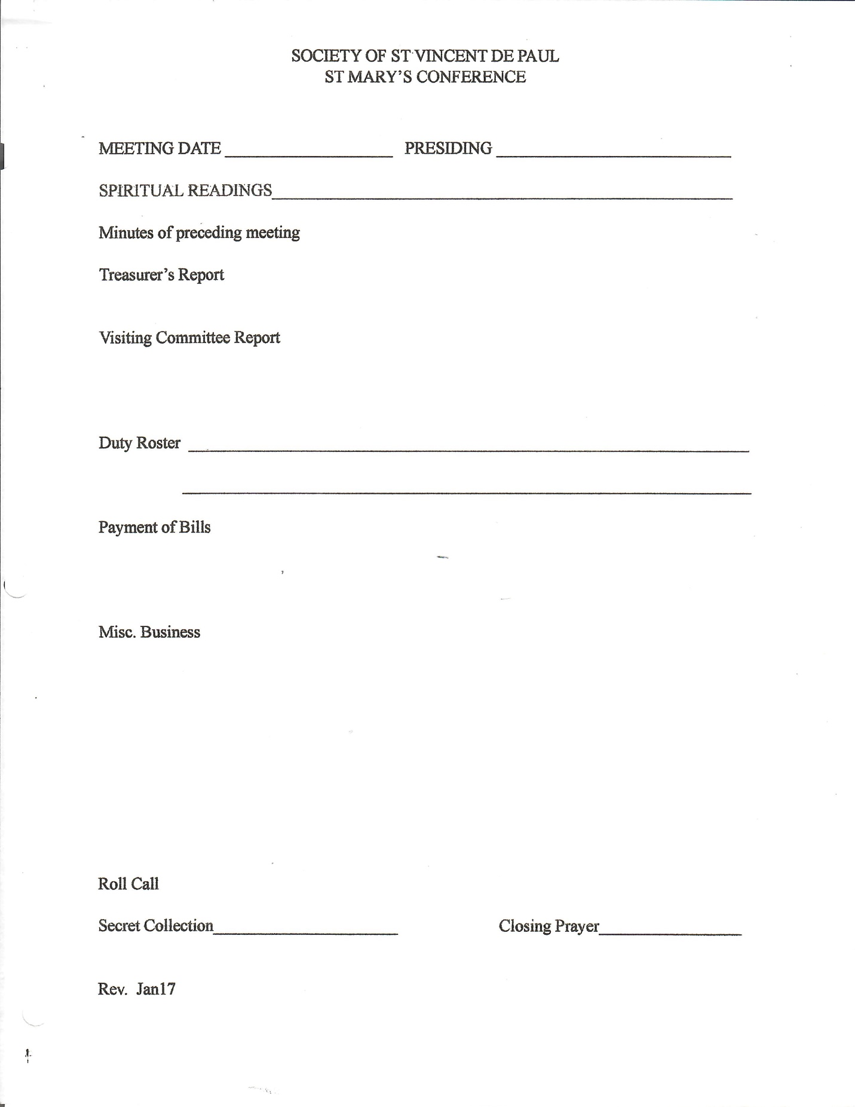

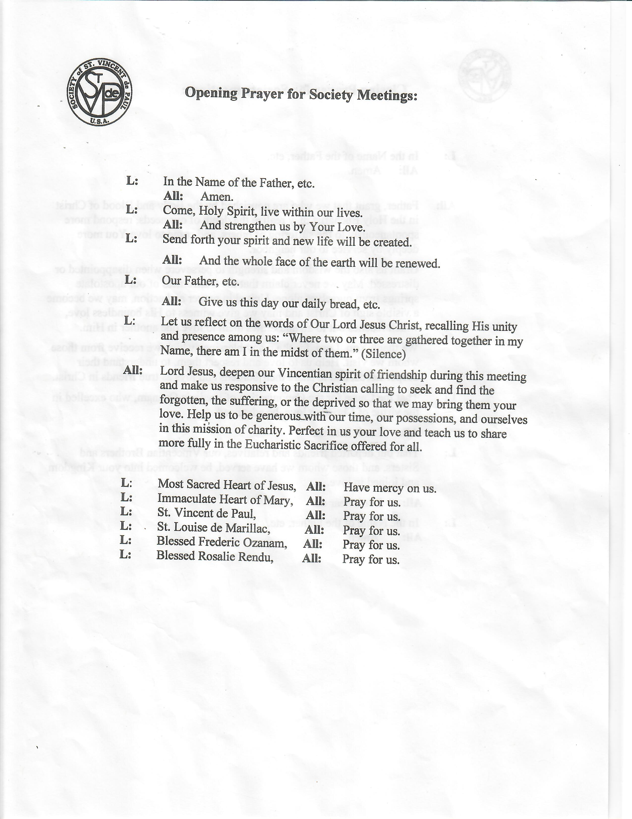



**5 Clients/Neighbors in need**

-meet in person when possible and go in twos.

-say a prayer before you meet

-make time to listen

-look for ways to give people a hand up, rather than a hand out

-discuss plan with conference or with officers, to decide how your conference will help the client

-Twinning

**6 Parish Relationship**

-The Pastor is the boss. Ask permission, share information, keep him in the loop.

-Enlist the parish, the school, the youth group, faith formation, Bible study groups etc. to work with the conference

-Write a blurb in the bulletin promoting SVdP activities/projects and sharing info. Pictures are nice. Publish on parish website and parish Facebook page as well. Meet and work with parish secretary and bookkeeper.

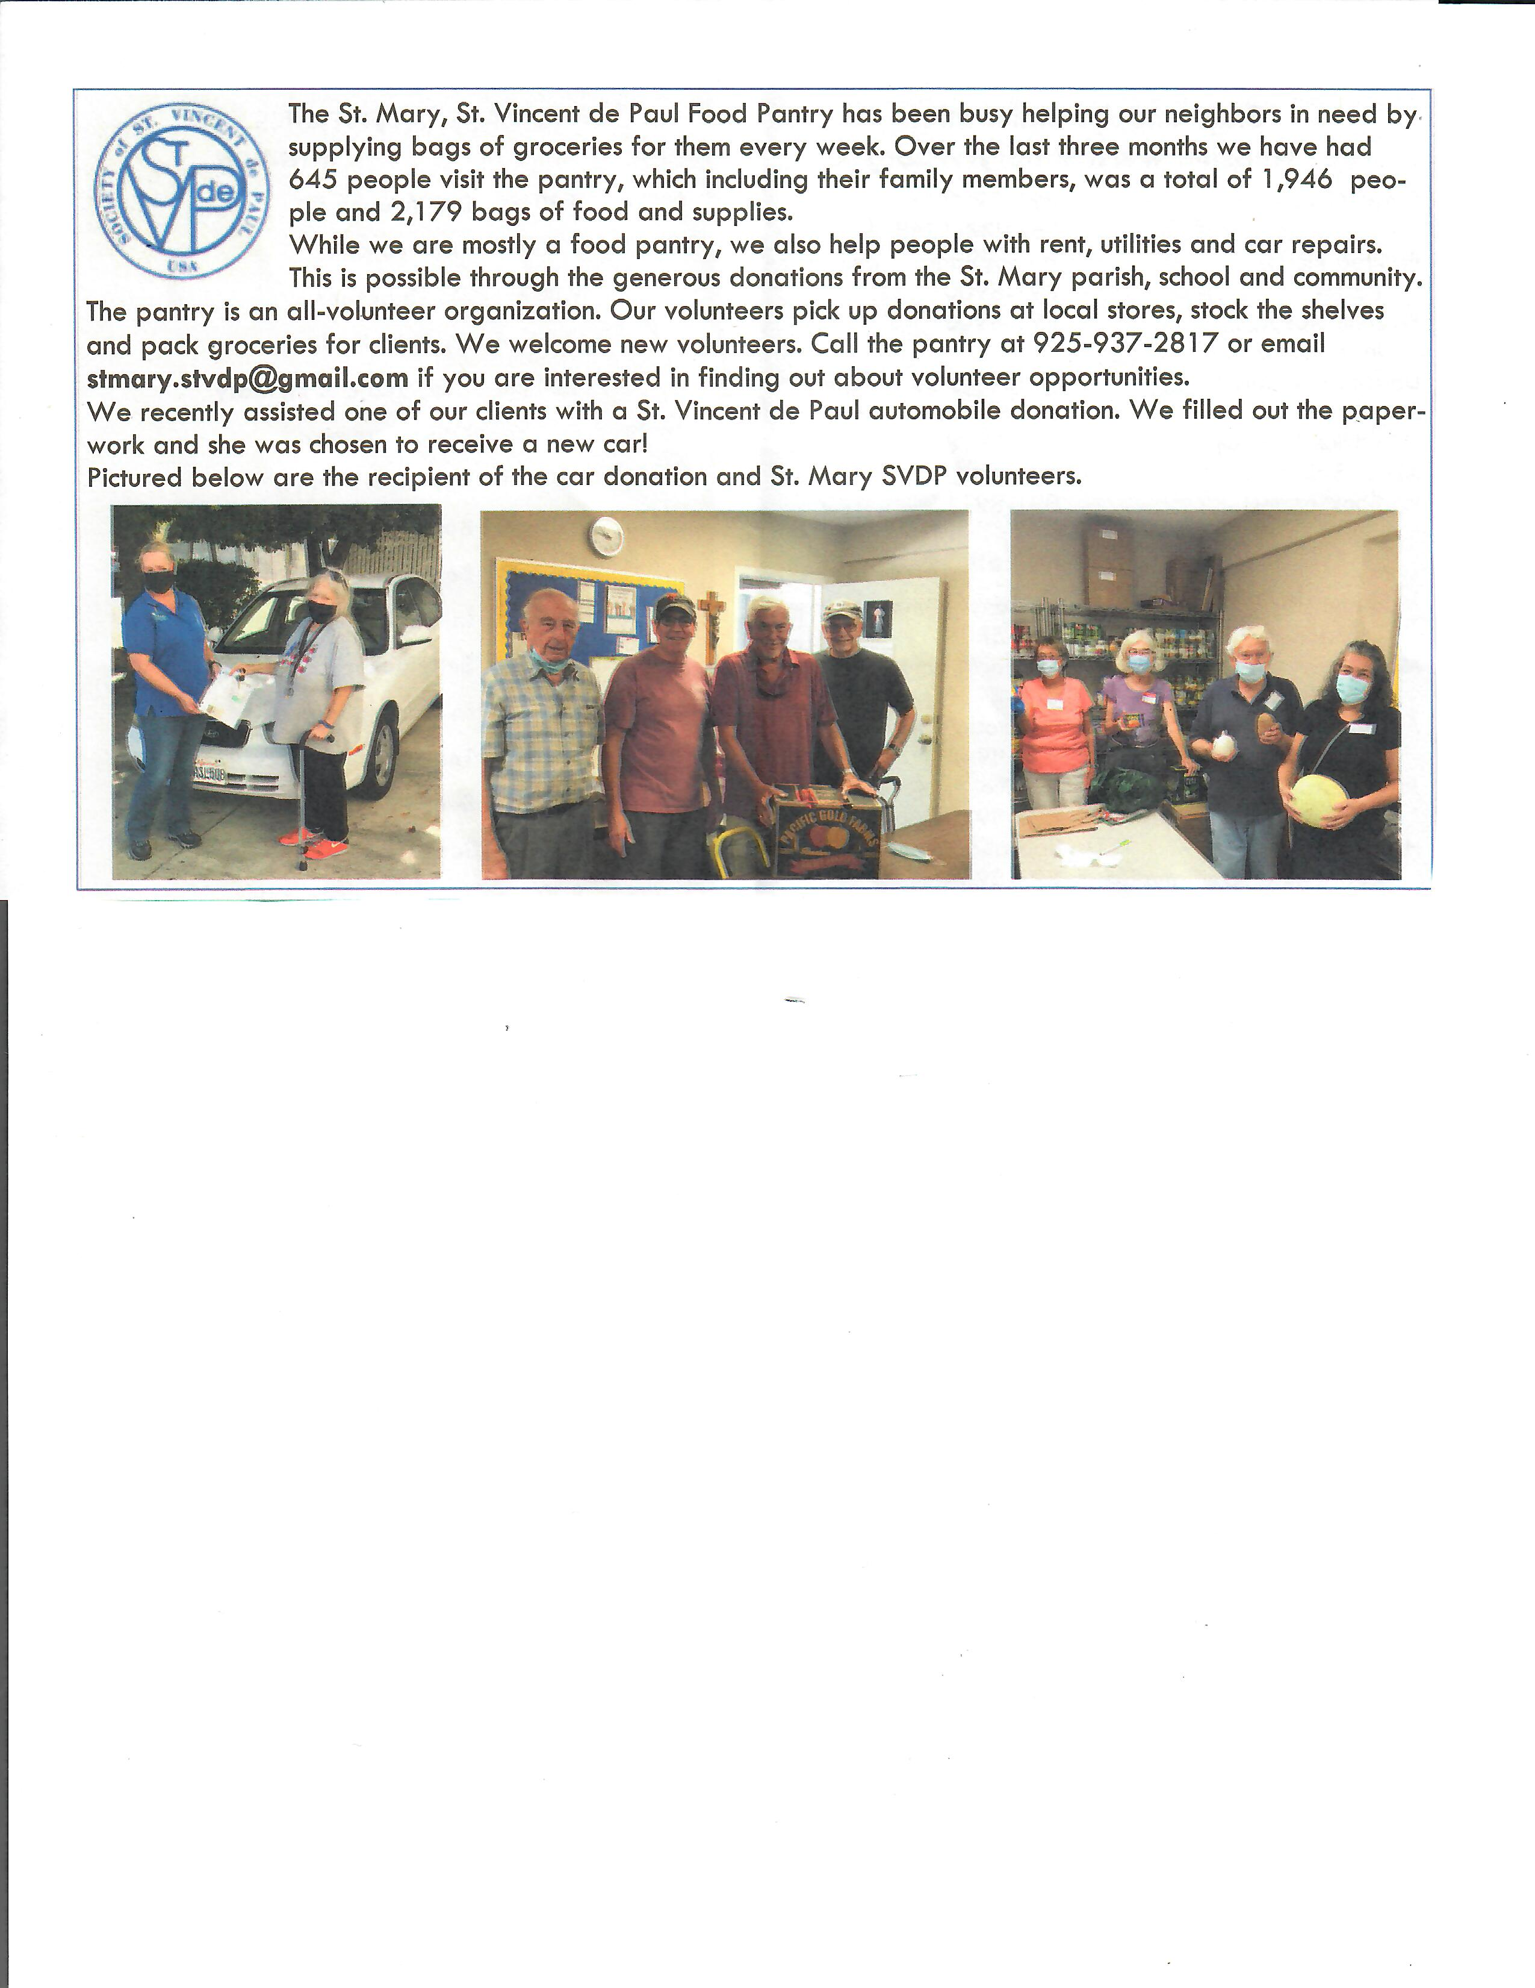**7 District Council**

-attend meetings

-share info from council with conference. Monthly newsletter is great.

-encourage conference members to attend trainings, especially Ozanam training

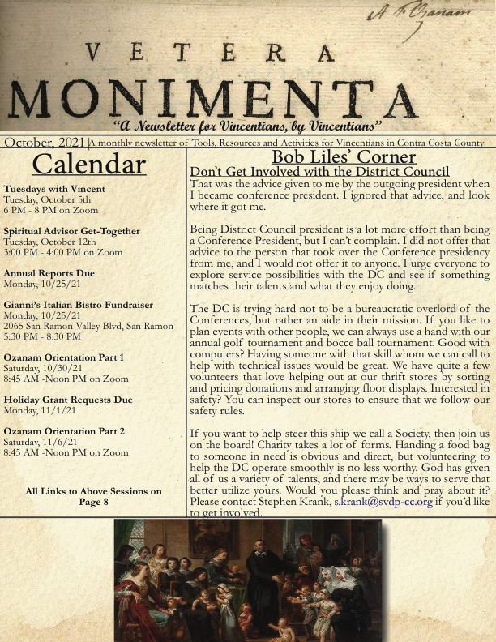

**8 Closing**

-Questions