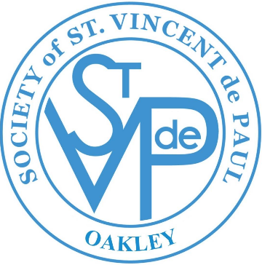**St. Anthony 2018 Impact Report - TEMPLATE**

“No work of charity is foreign to the Society”. – Founder Blessed Frédéric Ozanam

# Mission of the Society of St. Vincent de Paul

A network of friends, inspired by Gospel values, growing in holiness and building a more just world through personal relationships with and service to people in need.

**Vincentian Members/Volunteers Needed**

**Active members:** XX

**Goal:** To increase and create a diverse group of members who can help spread actions of love to people in need.

If you can help once a month or once a week, join us on Thursday, March 21, 2019 at 7pm in the Parish Hall for more information!

For more information visit: <https://www.stanthonyoakley.com/>





**Visits with People in Poverty – Your Donations**

**The vocation of the Society’s members is to follow Christ through service to those in need and so be a witness to His compassionate and liberating love. Your donations have helped members execute their commitment through person-to-person contact. In 2018, Vincentians reached out in the following ways:**

* Visited **xx** households to offer material and spiritual help
* Conducted **xx** food pantry’s
* Helped **xx** families through food pantry
* Served a total of **xx** families

**sERVICES BY vINCENTIANS**

**(APRIL 2018- March 2019)**

**St. Vincent de Paul, St. Anthony Conference**

971 O’Hara Avenue, Oakley, CA 94561 *[svdp.sac.oakley@gmail.com](mailto:svdp.sac.oakley@gmail.com) *925-325-7424

“Neighbors helping Neighbors”