***Mission Statement***

*Inspired by Gospel values, the Society of St. Vincent de Paul, a Catholic lay organization, leads women and men to join together to grow spiritually by offering person-to-person service to the needy and suffering in the tradition of its founder, Blessed Frederic Ozanam, and patron, St. Vincent de Paul.*

*As a reflection of the whole family of God, members, who are known as Vincentians, are drawn from every ethnic and cultural background, age group and economic level.*

*Vincentians are united in an international society of charity by their spirit of poverty, humility and sharing, which is nourished by prayer and reflection, mutually supportive gatherings and adherence to a basic Rule.*

*Organized locally, Vincentians witness God’s love by embracing all works of charity and justice. The Society collaborates with other people of good will in relieving need and addressing the causes, making no distinction in those served, because in them Vincentians see the face of Christ.*

*“No Work of Charity is Foreign to the Society.”*

***Questions / Interested ?***

***Join Us for an Informational Hour of Finger Food and Fellowship***

***Tuesday, March 27th***

***6:30 – 7:30p***

***Classroom B-1***

***Please sign up after mass or at the Parish Office if you plan to attend***

*Also please feel free to contact any of our Conference officers below:*

*President: Dan Gabe 408-5964*

*Vice President: Dean Lopez 285-7090*

*Secretary:: Sheila Driscoll 672-7947*

*Treasurer: John Manzeck 216-6245*

*Asst Treasurer: Agnes Cocotis 689-3069*

*Spiritual Advisors:*

*Shawnna Costanzo 200-5952*

*Nelda Asuncion 381-1944*

*Friday Foods Coordinator:*

*Diana Tegge 383-2238*

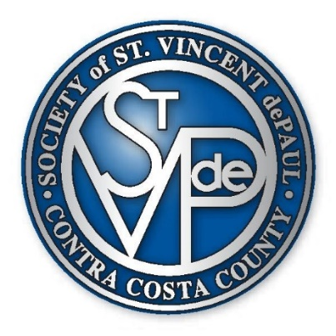

***The St Bonaventure Conference of***

***St Vincent de Paul Offer***

***An Invitation***

***to***

***Serve***

*“To Serve the Poor is to Serve Jesus Christ”*

