

**Partnership with St. Vincent de Paul**

**Employee/Volunteer Information**

Manager of Community-Based Counseling Programs: Jes Moniz, MA ([jmoniz@jfku.edu](mailto:jmoniz@jfku.edu))

**Mission**

The Community-Based Counseling Programs are offered through the Office of Clinical Training at John F. Kennedy University.  Our mission is two-fold.

* We believe that the status of one’s mental health impacts everything one does.  This determines how successful one can be in school, their career and in their personal life. Therefore, it is imperative that quality mental health services are easily accessible and affordable. The OCT aims to provide these services to schools and agencies in our surrounding community, helping individuals achieve maximum personal growth as well as academic success among clients.
* Additionally, we serve as a training facility for mental health counselors.  We pride ourselves in delivering a unique and comprehensive training experience for graduate clients and post-graduate associates learning to become mental health professionals as well as inspire and empower them to become actively involved in the community.

**About Our Counselors**

Our counseling staff is comprised of volunteer MFT, PCC and Psy D Clinical Trainees and MFT Associates. They mostly come from the JFKU graduate programs. However, we also work with counselors from St. Mary’s and other institutions. They are clinically supervised by clinicians who have been licensed for at least 2 years.

**About Our Services**

Therapy Services Offered:

* Individual
* Couples
* Family
* Group
* Psycho-ed workshops.
* Counselors will also regularly engage in advocacy for clients, and they provide resources and referrals to clients as needed and when appropriate.

**Employees/volunteers of St. Vincent will have the opportunity to engage in brief therapy (5-12 sessions) depending on need. Counselors will work with employees/volunteers on COVID-19 related matters, to help offer support and guidance during this stressful time**. Your employer may receive demographic information and the total number of clients who utilize these services including those who are clients of St. Vincent de Paul. However, your name and personal details about treatment will remain completely confidential.

**Sessions for clients of St. Vincent de Paul will have an opportunity to participate in longer term therapy, depending on their needs and the length of time a counselor will participate in our program.** Counselors can work with clients to support them with various issues or concerns. See chart below.

All services will be provided at no cost.

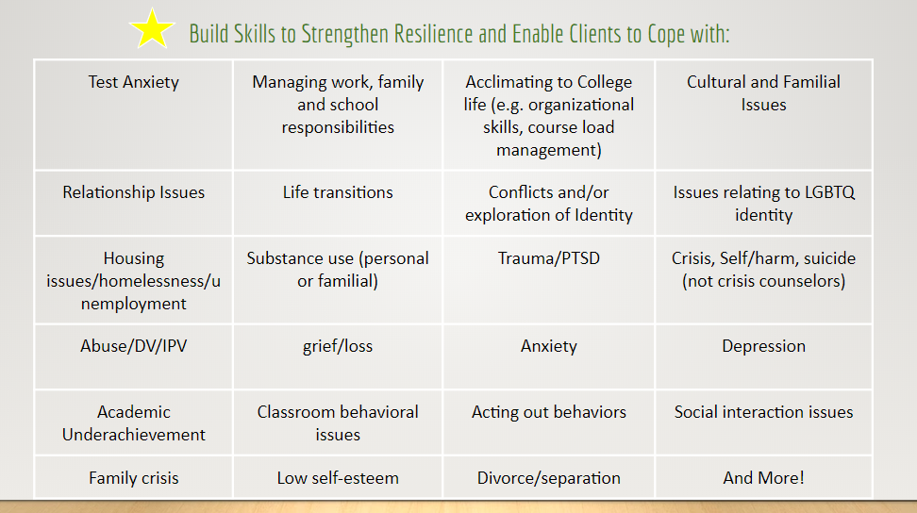

**How Will I Know Who to Refer?**

All therapists must only provide services that are within their legal scope of practice as defined by their licensing board and their scope of competence as defined by their level of education, training and experience (and/or the education, training and experience of their clinical supervisor). Therefore, there are limitations regarding the types of clients or presenting issues they will be able to support.

|  |  |
| --- | --- |
| **Refer:** | **Do Not Refer:** |
| If a client is having trouble with the aforementioned areas in the chart above.  If you notice behavioral issues that are ongoing or have significantly changed in a way that negatively impacts the client. | Clients who are known to be severely and actively suicidal, homicidal and in immediate risk. (They are not crisis counselors)   * Ask yourself, “Does this client have issues that need immediate attention or are they stable enough to be placed on a waitlist?” If they need immediate attention, refer out.   Clients who are known to have severe mental illness that is not under control (schizophrenia, bipolar, severe eating disorders, severe substance abuse/dependency). These populations often require much more intensive and long-term support. |

**What is the Process for Referring and Beginning Treatment?**

**General Flow:**

1. St. Vincent of Contra Costa County Representative, (or RotaCare Pittsburg Free Medical Clinic at St. Vincent de Paul) completes referral form for client (or for themselves if seeking brief therapy services)

To Complete referral Form, use link: <https://hipaa.jotform.com/200657652986063>

2. Referral form is sent to JFKU staff

3. Designated JFKU staff review incoming referrals

Looks for potential red flags indicating immediate crisis

If potential client appears to be in crisis, JFKU staff will contact the potential client to further assess and provide any necessary referrals.

4. Potential clients who do not have concerns that would be outside of our counselors’ scope or practice will be assigned a counselor.

5. Counselor will contact potential client to arrange an initial assessment/screening session, and if appropriate will make plans for continued treatment.