Louise Sullivan, D.C., PhD
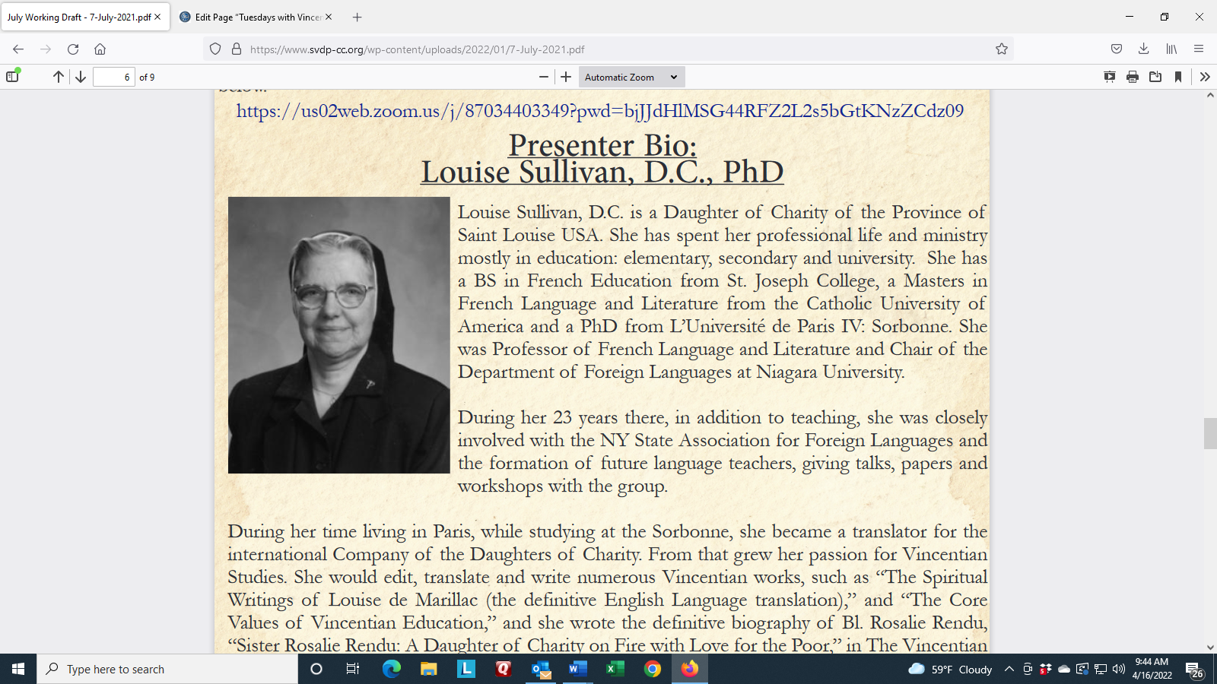
Louise Sullivan, D.C. is a Daughter of Charity of the Province of Saint Louise USA. She has spent her professional life and ministry mostly in education: elementary, secondary and university. She has a BS in French Education from St. Joseph College, a Masters in French Language and Literature from the Catholic University of America and a PhD from L’Université de Paris IV: Sorbonne. She was Professor of French Language and Literature and Chair of the Department of Foreign Languages at Niagara University. During her 23 years there, in addition to teaching, she was closely involved with the NY State Association for Foreign Languages and the formation of future language teachers, giving talks, papers and workshops with the group.
During her time living in Paris, while studying at the Sorbonne, she became a translator for the international Company of the Daughters of Charity. From that grew her passion for Vincentian Studies. She would edit, translate and write numerous Vincentian works, such as “The Spiritual Writings of Louise de Marillac (the definitive English Language translation),” and “The Core Values of Vincentian Education,” and she wrote the definitive biography of Bl. Rosalie Rendu, “Sister Rosalie Rendu: A Daughter of Charity on Fire with Love for the Poor,” in The Vincentian Studies Institute monograph series.
In recognition of her work in Vincentian Studies, she was a recipient of The Perboyre Medal from Niagara University, The Pierre Coste Prize from De Paul University and an Honorary Doctorate from Saint John’s University

