BIOGRAPHY REV. THOMAS F. McKENNA, C. M.
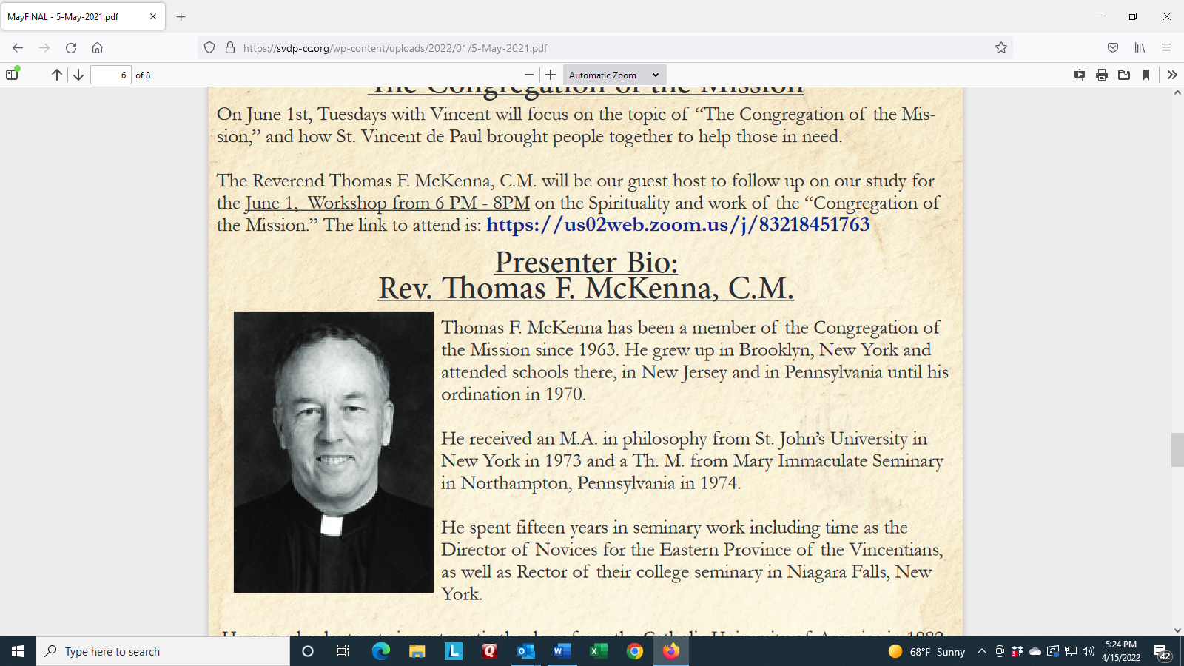
Thomas F. McKenna has been a member of the Congregation of the Mission since 1963. He grew up in Brooklyn, New York and attended schools there, in New Jersey and in Pennsylvania until his ordination in 1970.
He received an M.A. in philosophy from St. John’s University in New York in 1973 and a Th. M. from Mary Immaculate Seminary in Northampton, Pennsylvania in 1974. He spent fifteen years in seminary work including time as the Director of Novices for the Eastern Province of the Vincentians, as well as Rector of their college seminary in Niagara Falls, New York. He earned a doctorate in systematic theology from the Catholic University of America in 1982.
For ten years, he taught Spirituality as a tenured member of the theology department at St. John’s University. He has published a book on St. Vincent de Paul, articles in various theological journals and has been involved in retreat work nationally and internationally, especially within the Vincentian Family.
For more than twenty years he was part of his Congregation’s leadership team, serving as the Assistant Provincial then as Provincial completing his term in 2008.
Since then, he has taught theology at Tangaza University in Nairobi, Kenya, and also at Niagara University. Additionally, at Niagara he functioned as Assistant to the President for Mission. For six years he served in St. Louis as the Provincial Director of the St. Louise Province of the Daughters of Charity. Most recently he has worked as Formation Director for the Vincentian major seminarians in Philadelphia as well as again taking up the role of Assistant Provincial.

