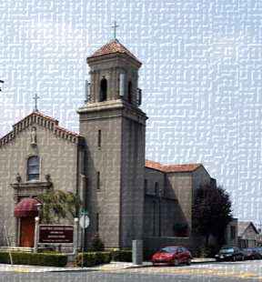
St. Paul Catholic Church
St. Vincent de Paul
August 2022 Impact Report

“No work of charity is foreign to the Society”.
– Founder Blessed Frédéric Ozanam


The mission of the Society of St. Vincent de Paul
A network of friends, inspired by Gospel values, growing in holiness, and building a more just world through personal relationships with and service to people in need.
Vincentian Members/Volunteers Needed
Active members: 7
Goal: To increase and create a diverse group of members who can help spread actions of love to people in need.
If you can help once a month or once a week, join us on Saturday:
September 3, 2022, at 8 AM in the School Parking lot for more information!
For more information visit: https://www.stanthonyoakley.com/
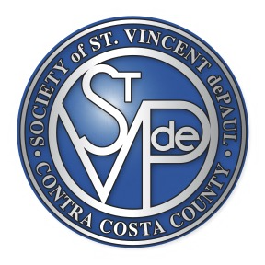
Conference of St. Vincent de Paul St. Paul Catholic Church 1845 Church Lane San Pablo, CA 94806
“Neighbors helping Neighbors.” (510) 691-6404
Visits with People in Poverty – Your Donations
The vocation of the Society’s members is to follow Christ through service to those in need and so be a witness to His compassionate and liberating love. Your donations have helped members execute their commitment through person-to-person contact. In July & August 2022, the Vincentians from the St. Paul Conference reached out in the following ways:

- Visited 25 local households to offer material and spiritual help
- Conducted 2 Drive-through food pantries helping 300 families through the food pantries
- Provided a total 30 no-cost COVID Vaccinations
- Provided 2400 Lbs. of fresh Produce
- Back to School Back Packs for 64 Children

sERVICES BY vINCENTIANS
(July 2022- August 2022)

