## **Training on St. Vincent DePaul Home Visitation Database (Seattle Database)**

1. **Log in**

At <https://seattle.confdb.org/>

(First time, refer to instructions for New Users:

[For Users: Your New Account](https://docs.google.com/document/d/1yjGyhyu_urMqEnVmxoz3sDbReovURNHCaZipahuyjjc/edit?usp=sharing))

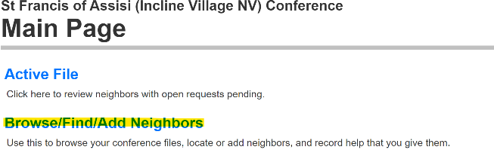

1. **Find existing neighbor or enter a new neighbor** Start from Browse / Find / Add Neighbors on Main Page

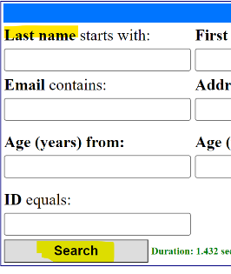

Enter Last Name or hit ‘Search’ button for list of all neighbors.

*Always do this first,* just to make sure a record has not already been entered. Add information to create a new record or update an existing record. It is important to enter their address, phone number, # in home (for record keeping purposes). Fill in the Assigned To field - enter your name or the lead person involved in the home visit.

1. **Enter a request for assistance**

From the Neighbor File screen, select **Add New Request**. You will be given an opportunity to update the Neighbor File. Do so if needed, then select **Continue** in order to enter the request.

A request form is created. Fill in the form. The first request could be *Intake Assessment*, if we are still gathering information. If the neighbor has a specific request, select that option and fill in whatever information you have. Click on **Save & Done**.

**Enter assistance that has already been provided**

From the Neighbor File screen, select **Additional Help**. You will be given an opportunity to update the Neighbor File. Do so if needed, then select **Continue** in order to enter the requestAn assistance form is created. Fill in the form. Click on **Save & Done**.

.

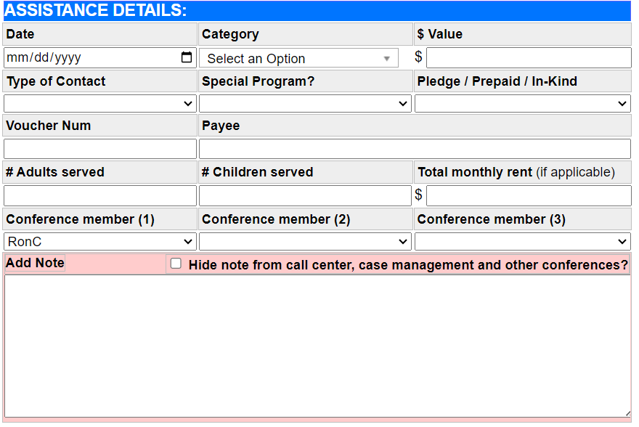

1. A red and white flag

   Description automatically generated**Respond to the Open Request.**

This is where you document the home visit. Choose either **Close (Helped)** or **Close (Not Helped)**. Below is the Close (Helped) form which results in a request to the Treasurer for funds.

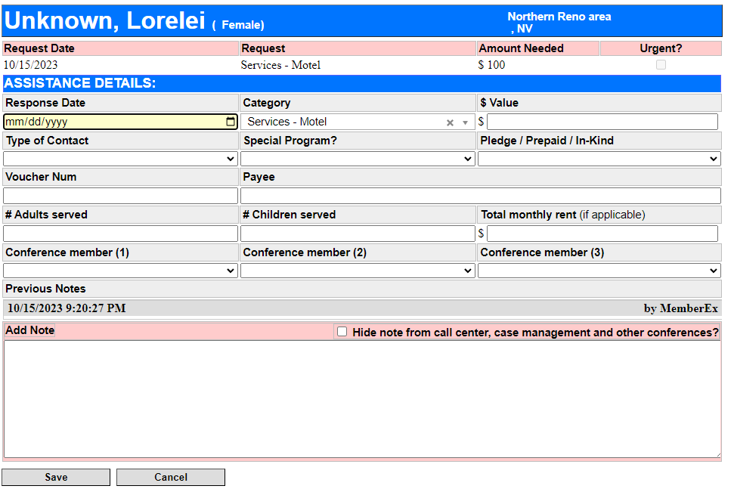

Give the details requested on the form.

Payment Type:

* Gas or Food card is Prepaid.
* Pledge is asking for $$
* InKind is bag of groceries on hand
* None if no monetary value of help

Click **Save** when done. You should get a pop-up box saying the treasurer has been notified for Closed (Helped) response.

**Additional Help**

* Contra Costa County SVdP: <https://www.svdp-cc.org/conference-operation/>
* Questions: Frank Wnuk: [gpwnuk@yahoo.com](mailto:gpwnuk@yahoo.com)