**DATA BASE PROCEDURES**

**Background:**

The Seattle Database is a computerized database used for tracking and reporting SVdP conference information and activities. It was created by a Vincentian Microsoft engineer and is used by more than 30 conferences in various states across the U.S. The data base includes:

* Basic information on and aid given to each neighbor
* Membership directory information on the SJV Vincentians
* Resource library files featuring various resources we can share with our neighbors
* Reports for expenditures and services provided to our neighbors that can be used for annual and other reporting.

**Logging In:**

The data base can be accessed on **https://seattle.confdb.org/confdb/** using:

* The SVdP laptop in the St. Vincent de Paul office at St. John Vianney,
* Your personal laptop or computer (when connected to the internet), or
* Your cell-phone, iPad or Kindle

To log on to the database, you will go to the Conference Login and enter:

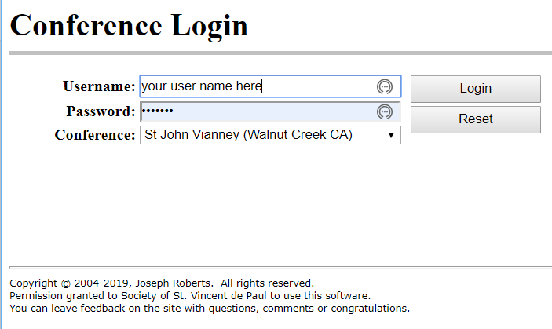

**Main Menu:**

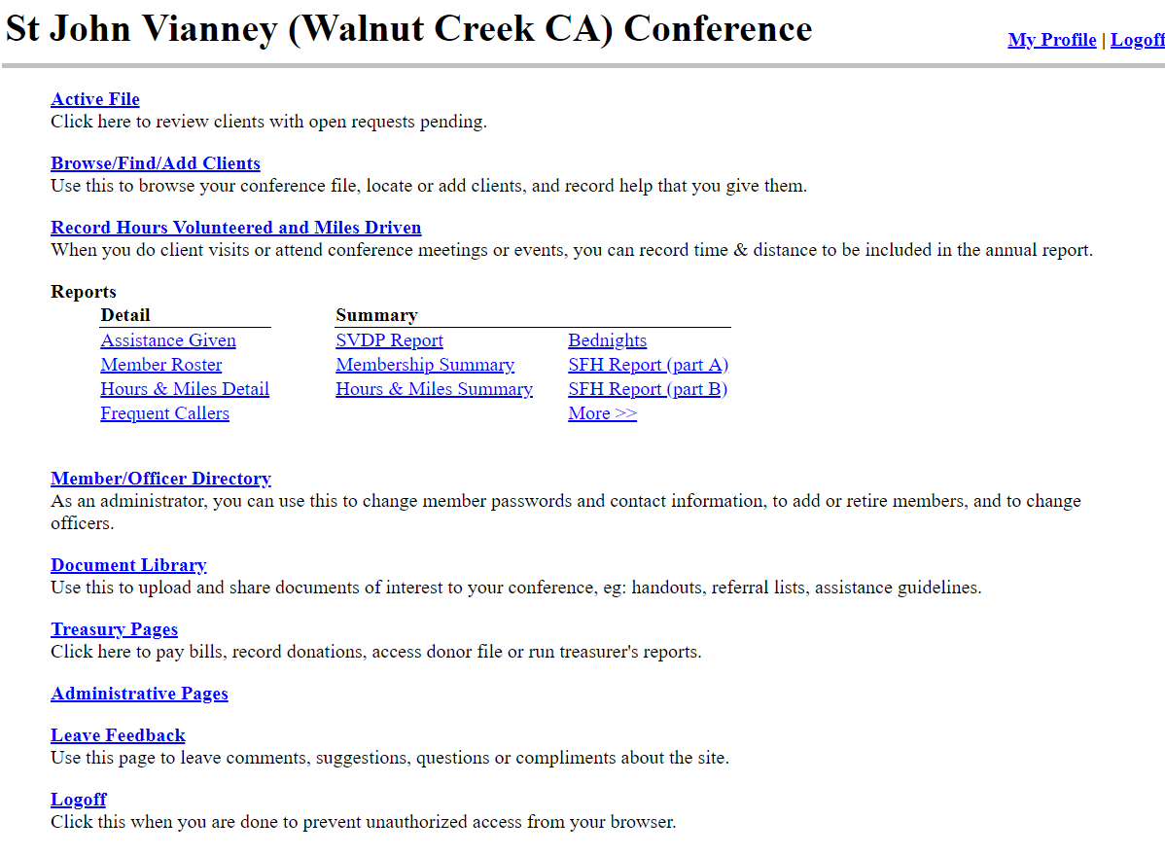

**Main Menu:**

[**Active File**](https://www.confdb.org/confdb/ActiveFile.asp) **This function is not used by our conference. It is meant for conferences that primarily do home visits and have food pantries.**

[**Browse/Find/Add Clients**](https://www.confdb.org/confdb/ClientBrowse.asp)  
**This is the starting place for entering and searching on the files of neighbors. Use this to locate or add neighbors, and record help that you give them.**

[**Record Hours Volunteered and Miles Driven**](https://www.confdb.org/confdb/HoursAdd.asp)**This function is not used by our conference. We use an estimated time allocation for our activities that are reported annually**

**Reports**

|  |  |  |  |  |
| --- | --- | --- | --- | --- |
| **Detail** |  | **Summary** |  |  |
| [**Assistance Given**](https://www.confdb.org/confdb/reports/ReportAssistance.asp) |  | [**SVDP Report**](https://www.confdb.org/confdb/reports/SvdpReport.asp) |  | [**Bednights**](https://www.confdb.org/confdb/reports/ReportBN.asp) |
| [**Member Roster**](https://www.confdb.org/confdb/reports/MemberRoster.asp) |  | [**Membership Summary**](https://www.confdb.org/confdb/reports/MbrAnnual.asp) |  | [**SFH Report (part A)**](https://www.confdb.org/confdb/reports/SFHReportA.asp) |
| [**Hours & Miles Detail**](https://www.confdb.org/confdb/reports/ReportHoursDetail.asp) |  | [**Hours & Miles Summary**](https://www.confdb.org/confdb/reports/ReportHoursSummary.asp) |  | [**SFH Report (part B)**](https://www.confdb.org/confdb/reports/SFHReportB.asp) |
| [**Frequent Callers**](https://www.confdb.org/confdb/reports/FrequentCallers.asp) |  |  |  | [More >>](https://www.confdb.org/confdb/reports/index.asp) |

[**Member/Officer Directory**](https://www.confdb.org/confdb/MemberList.asp) **Authorized administrators can use this to create or change member passwords and contact information, to add or retire members, and to indicate/update officers. This can be accessed as well by Vincentians to see member’s addresses and phone numbers.**

[**Document Library**](https://www.confdb.org/confdb/documents/code/folderview.asp) **This is important collection of resources that can be used for our neighbors. Use this to share reference documents of interest to your conference and your neighbors, e.g.: handouts, referral lists, assistance guidelines.**

[**Treasury Pages**](https://www.confdb.org/confdb/Treasury/Index.asp) **This section is used by our Treasurer. Click here to pay bills, record donations, access donor file or run treasurer's reports.**

[**Administrative Pages**](https://www.confdb.org/confdb/admin/index.asp) **– These pages are used by the administrator.**

[**Leave**](https://www.confdb.org/confdb/Logoff.asp) **Feedback  
Use this page to leave comments, suggestions, questions or compliments about this site.**

[**Logoff**](https://www.confdb.org/confdb/Logoff.asp) **Click this when you are done to prevent unauthorized access from your browser.**

**Researching Neighbor Files Prior to an Office Visit:**

* + Prior to or during an office visit, it is recommended that you research the neighbors who are signed up for appointments that night.
  + To obtain the names of those scheduled, you can send an email to the office secretary, Maryanne, at [mrichards@sjvianney.org](mailto:mrichards@sjvianney.org).
  + Or, you can visit the office to obtain the list of those who are signed up for the evening.
  + You will want to notify your partner for that evening of the appointment list or copy him/her on the email to avoid multiple contacts to the office staff.
  + Once the names are obtained, you will first click on **BROWSE/FIND/ADD CLIENTS.**
  + You can enter information in any of the fields below (other than SSN) to pull up the neighbor’s file.
  + In this example, the last name, SMITH, was inputted
  + The database will then pull up all neighbors with that last name and you can click on the correct name listed below.

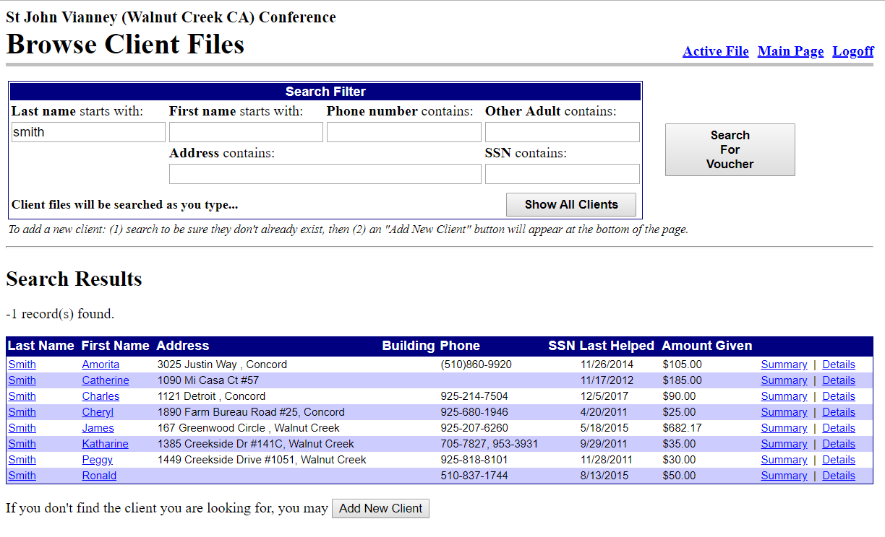

* If you don’t find the neighbor, you can then search on another field, like first name, phone number or address. (This is especially helpful if the last name is misspelled when the message is taken or if you want to verify if other neighbors served also live at the same address.)
* You may then research the neighbor’s file to see when they were last seen, what aid they have received in the past, what their presenting issues are, how long they have been coming to us, or if they are on the NFA list.

**Creating a New File for a New Neighbor After Office/Home Visit:**

When researching neighbors for an office visit, you may find that there is no record for the person who has the appointment. After the appointment, you will need to create a new file for that neighbor. To do so:

* + Click on **BROWSE/FIND/ADD CLIENTS** and enter **LAST NAME**. If you don’t see the neighbor’s name displayed, you can then search on another field, like first name, phone number or address.
  + If you still don’t see the neighbor’s file, then click on **ADD NEW CLIENT**



* **Please note that there are only 2 times you will enter the neighbor’s FIRST NAME first** – when creating a file or editing a file. Enter all information for the new neighbor - don’t forget to check applicable boxes and press **SAVE AND DONE.** To enter the aid received, press **HELP WITHOUT REQUEST**. Now you can follow the instructions on the next page.

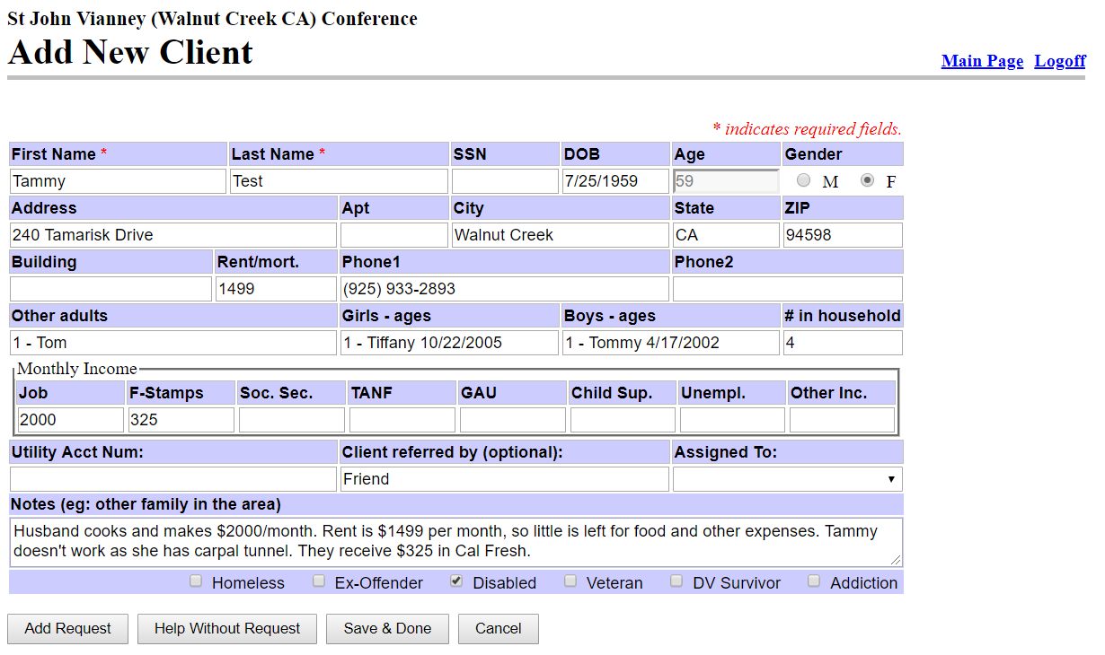

**Entering Neighbor’s Record After an Office/Home Visit:**

* After an office or home visit, you will document in the Seattle Data Base the information discussed at the visit, the aid provided and any next steps.
* From the Main Menu, you will first click on **BROWSE/FIND/ADD CLIENTS**
* You can enter information in any of the fields below (other than SSN) to pull up the neighbor. (We do not ask for SSN’s or input them into the database.).
* In this example, the last name, **TEST**, was inputted

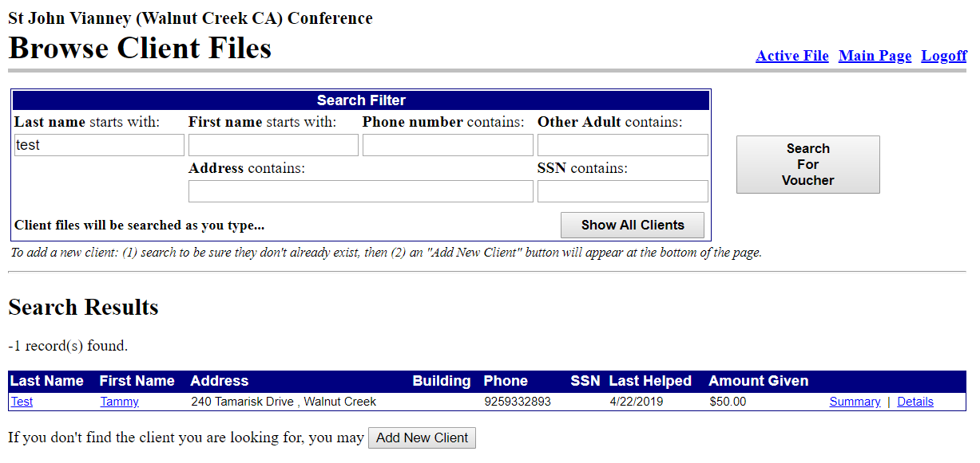

* + The database will then pull up all neighbors with that last name. Click on the correct name listed. The neighbor’s file will pull up and you can now input the information for the office visit by clicking on **HELP WITHOUT REQUEST**. Please **DO** **NOT** click on Add New Request.

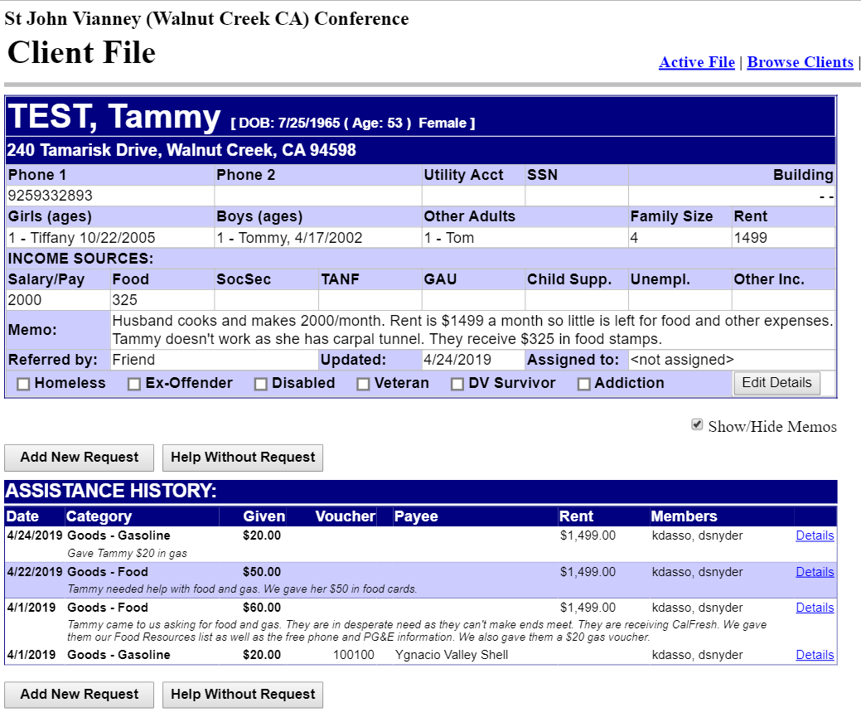

**Entering Neighbor’s Record After an Office/Home Visit, Continued:**

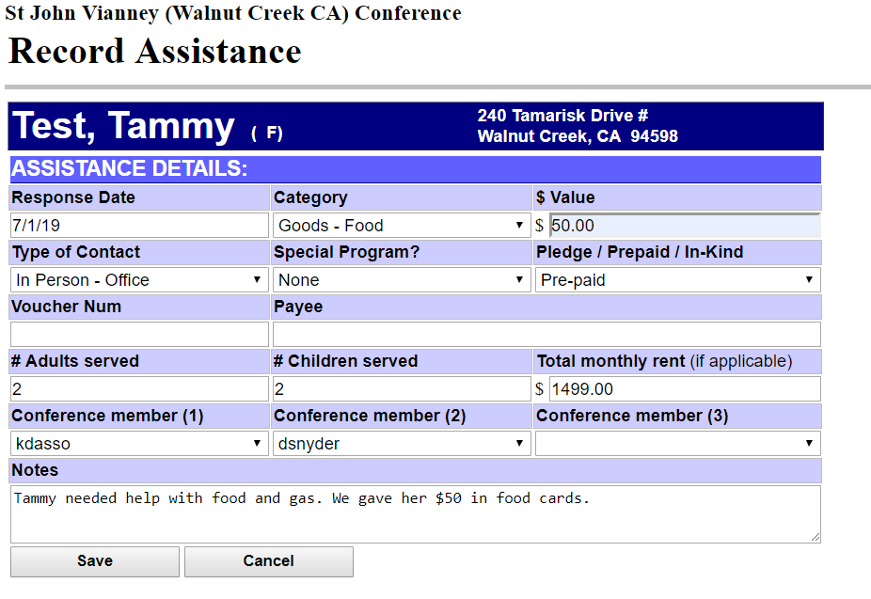

You will then enter the following information:

* + **Response Date** – Input date of office or home visit
  + **Category** – From drop down menu, choose type of aid given (i.e., beds, bus, clothes, food, gas, other, etc.)
  + **Value** – Input dollar amount of aid given (input dollars and cents)
  + **Type of Contact** – From drop-down menu, choose type of contact (i.e., In Person Home, Prison, Hospital, Eldercare, Other, Office, Email Only, Telephone Only, or None)
  + **Special Program** – From drop down menu, choose type of program (i.e., None, Thanksgiving, Christmas, Disaster Relief or Other), and be sure to follow any special program instructions.
  + **Pledge/Prepaid/In-Kind –** From drop-down menu, indicate which of the 3 types of aid has been given. (Defined later in this document)
  + **Voucher Number –** Input number of the voucher you gave the neighbor for clothing, furniture, etc. Each voucher will require a separate entry.
  + **Payee –** Input name of voucher payee (i.e., Ygnacio Valley Shell, SVdP Thrift Store, etc.)
  + **#Adults Served/# Children Served –** Inputthe number of adults and children served. Verify separately that the names and birthdates of children have been entered in the Header Section of the neighbor’s file. Update neighbor’s information in the Client File Header section if needed. (More on this later.)
  + **Total Monthly Rent –** This should be updated each time an office visit is recorded, as rent amounts and living situations can change.
  + **Conference Member (1), (2), (3) –** From drop down menu, click on appropriate names.
  + **Notes** – Input all pertinent notes, including any updates on neighbor’s situation and aid offered.
  + **Save** – Press **SAVE 1 time** or it will record the aid as many times as you press **SAVE**.

**Pledge/Prepaid/In-Kind – Separate Entries Required**

As you can see, there are different types of assistance provided to our neighbors in need, including:

**Pledge**

These include items that we plan to pay for and where monies are promised and/or checks will need to be written. **Each item listed below must be a separate entry**:

* Rent, deposits for rent, or mortgage payments
* Utilities (gas, electric, phone, water, garbage, etc.)
* Insurance (car, home, medical, etc.)
* Gas Vouchers
* St. Vincent de Paul Thrift Store Vouchers (any items we must pay for - furniture, household items, bedding etc. Clothing vouchers **are not** Pledge items.)

**Prepaid**

These items that have already been paid for. **Each item listed below must be a separate entry**:

* Food cards - $5, $10, $20 – list total value given to neighbor
* Subway cards - $10/card
* BART tickets
* Bus tickets (1 -$2, 12 - $20)
* Diapers ($5/dozen)
* Homeless items – Hand crank flashlight - $2.70, Poncho - $9, heat insulating blanket - $2, Subway food card - $10, tarp - $2.90, sleeping bag - $20 – ***Prepaid homeless* *items* c*an be entered as one entry with all items listed and total cost of items indicated*** *(see instructions in Homeless Care Kit Procedure and Checklist for more information)****.***

**In-Kind**

These include articles of clothing, shoes or toiletries, labor, assistance, mentoring, or transportation offered that have no cost to us as a conference. **Each item listed below must be a separate entry:**

* Toiletry bags ($2/bag)
* St. Vincent de Paul clothing vouchers ($10 per set of clothing, $8 per jacket, $5 per pair of children shoes/$10 adult shoes. One set of clothing is considered one change of clothing or 1 full outfit – top and bottom or dress. Shoes and jackets must be listed separately.)

**Entering Neighbor’s Record After an Office/Home Visit – Pledge:**

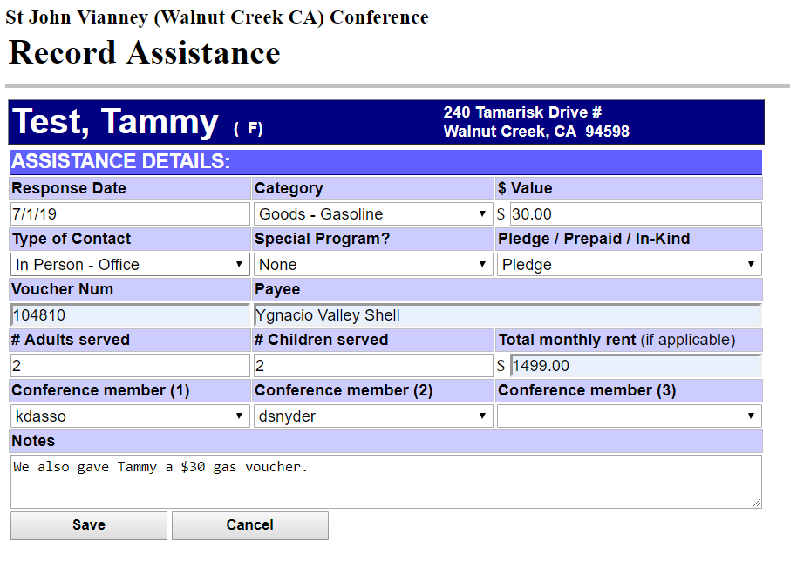

**PLEDGE ITEMS**:

* Include gasoline, utilities (PG&E, phone, water garbage, internet or insurance) or SVdP vouchers for furniture and other non-clothing items.

**STEPS REQUIRED**:

* Enter the appropriate information for the neighbor’s visit.
* Choose the type of aid given from the drop-down category listing. In this case, for a gasoline voucher, the **Category** selected will be **Goods - Gasoline**
* Choose **PLEDGE** from the next drop-down menu
* Enter the **Voucher Number** and **Payee** and a note for the $30 gas voucher given.
* When all the information has been inputted, you will press the **SAVE** button.

**NOTE:**

* Voucher numbers will only be entered for gasoline and SVdP vouchers.
* Other types of Pledge aid given, such as PG&E, Water, Gas, Phone, Internet and Insurance will not have voucher numbers. For these types of assistance, you will enter the payee’s name under **PAYEE**, as well as write a note indicating the circumstances of the service provided, i.e., 3-day notice, 24-hour notice, etc.

**Entering Neighbor’s Record After an Office/Home Visit – Prepaid:**



**PREPAID ITEMS**:

* Include food cards, Subway cards, BART/bus tickets, diapers and homeless items.

**STEPS REQUIRED**:

* Enter the appropriate information for the neighbor’s visit.
* Choose the type of aid given from the drop-down category listing. In this case, for food cards, the **Category** selected will be **Goods – Food**
* Choose **PREPAID** from the next drop-down menu
* **NOTES** - Enter a note for the $50 in food cards given.
* List any other food resources you may have provided – food pantry information, etc.
* When all the information has been inputted, you will press the **SAVE** button.

**NOTE:**

* Other types of Prepaid aid given, such as Subway cards, BART or bus tickets or diapers will require separate entries
* Homeless Prepaid items can be totaled together and entered as 1 entry. In the notes section, the homeless items given will be itemized. (See Homeless Care Kit Procedure & Checklist of the Vincentian Handbook for more information.)

**Entering Neighbor’s Record After an Office/Home Visit – In-Kind:**

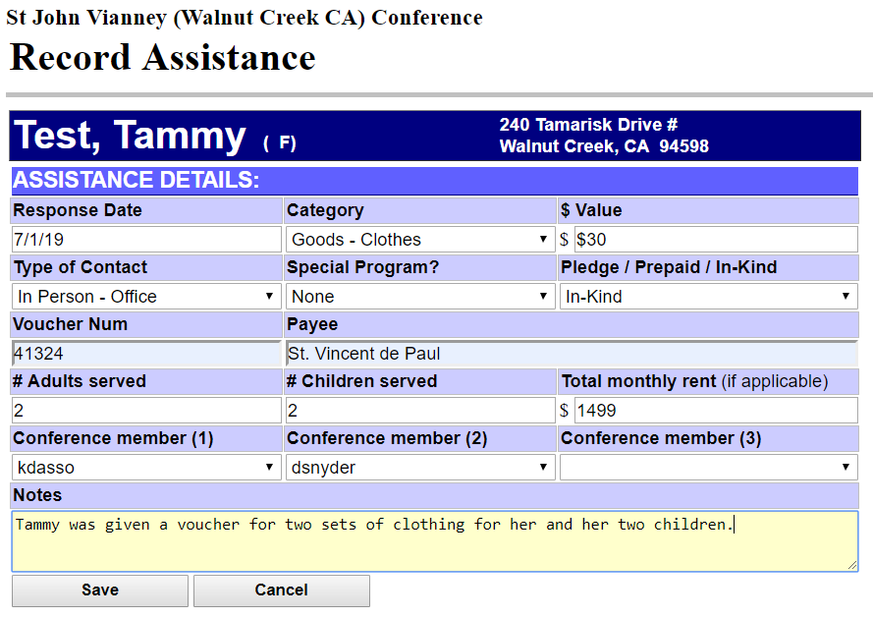

**IN-KIND ITEMS**:

* Includes clothing, shoes or toiletries, labor, assistance, mentoring, transportation. The categories selected in this example are Clothing, and In-Kind, with voucher # listed.

**STEPS REQUIRED**:

* Enter the appropriate information for the neighbor’s visit.
* Choose the type of aid given from the drop-down category listing. In this case, for a clothing voucher offered for a set of clothing for Tammy and her 2 children – for a total of 3 sets of clothing, the **Category** selected will be **Goods – Clothes**
* Choose **In-Kind** from the next drop-down menu
* Enter the **Voucher Number** and **St Vincent de Paul** and a note for the 3 sets of clothing given.
* When all the information has been inputted, you will press the **SAVE** button.

**NOTE:**

* Other types of **In-Kind** aid given, such as toiletries do not require a voucher number.

**Entering Neighbor’s Record After ‘No Show’:**

In cases where a neighbor does not show up for their appointment, you will need to update their file to show that they were a ‘no show’. If they are a neighbor we have seen before, you will pull up their file by clicking on the **BROWSE/FIND/ADD CLIENTS** link in the Main Menu.



You will then click on **HELP WITHOUT REQUEST** and enter the information and press **SAVE**:

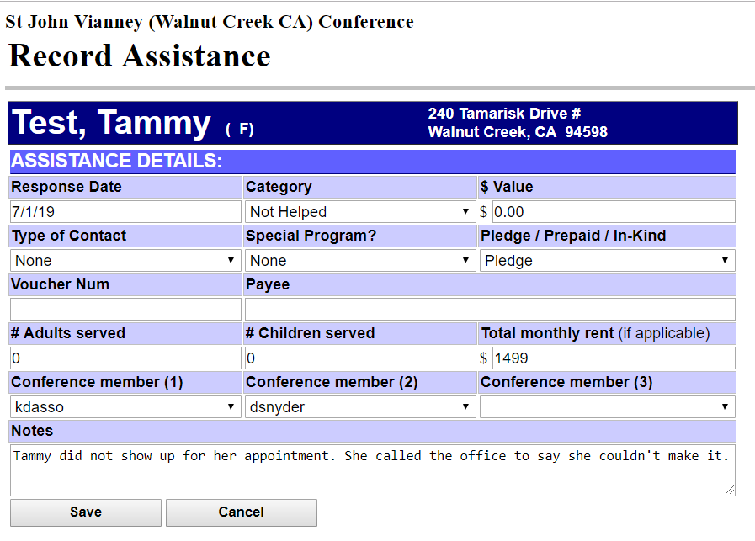

If it is the first time the neighbor is visiting and they do not show, you will need to create a new record for that person with their name and phone number and indicate that they didn’t show up.

**Modifying or Correcting an Entry:**

Sometimes, you may find you need to correct some of the information you have inputted. Let’s say in this case, you realize that Tammy was given $50 in food cards and **not $60** on 4/1/19.

**.**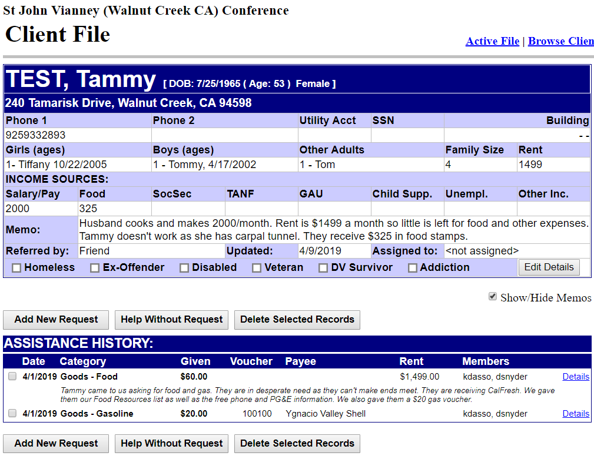

To correct the incorrect entry, click the box to the left of the **4/1/2019 Goods – Food** entry, then click on **Details** to the right of the entry. When the following screen shows up, you will press the Edit key.

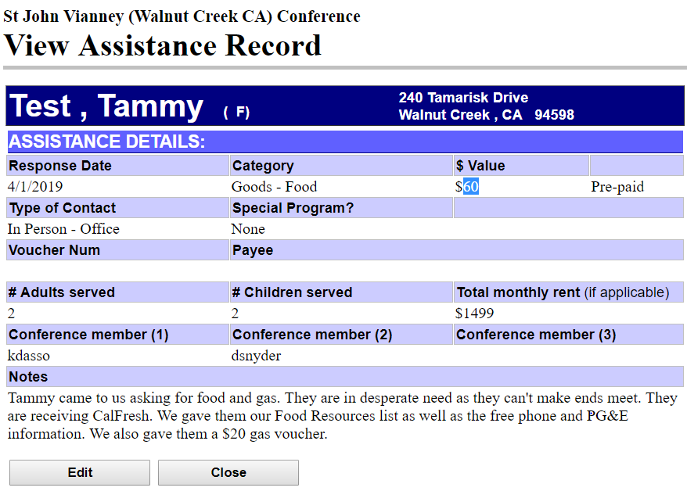

**Modifying or Correcting an Entry, Continued:**

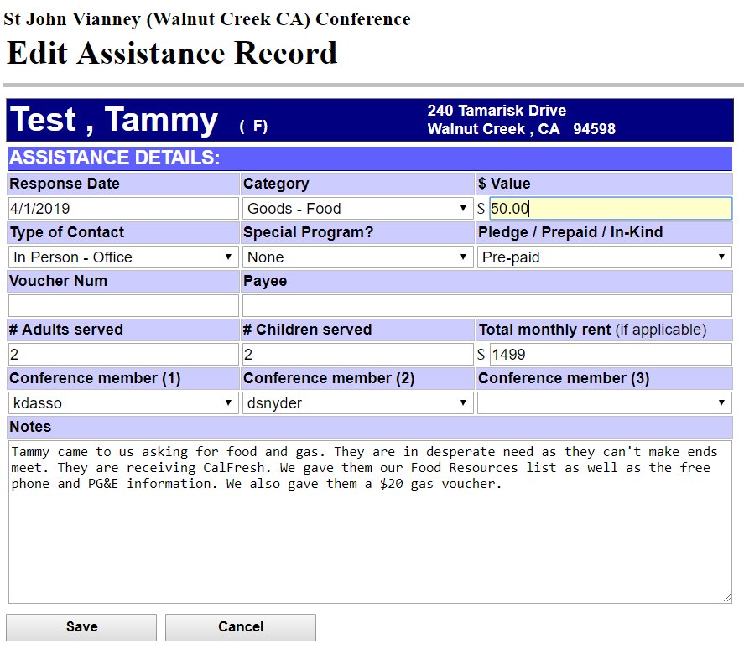

When the **Edit Assistance Record screen** shows up, you may now:

* Highlight the incorrect value and input the correct value.
* When all information is correct, you can click on **SAVE** to save the corrections.

**Updating Header Section - Information on Children/Adults:**

When you find that you don’t have the names & birthdates of the children or last names of other adults (spouse/significant other) in the record, you will need to update the information in the Header Section. To do so, click the **EDIT DETAILS** button in bottom right section of the Header.

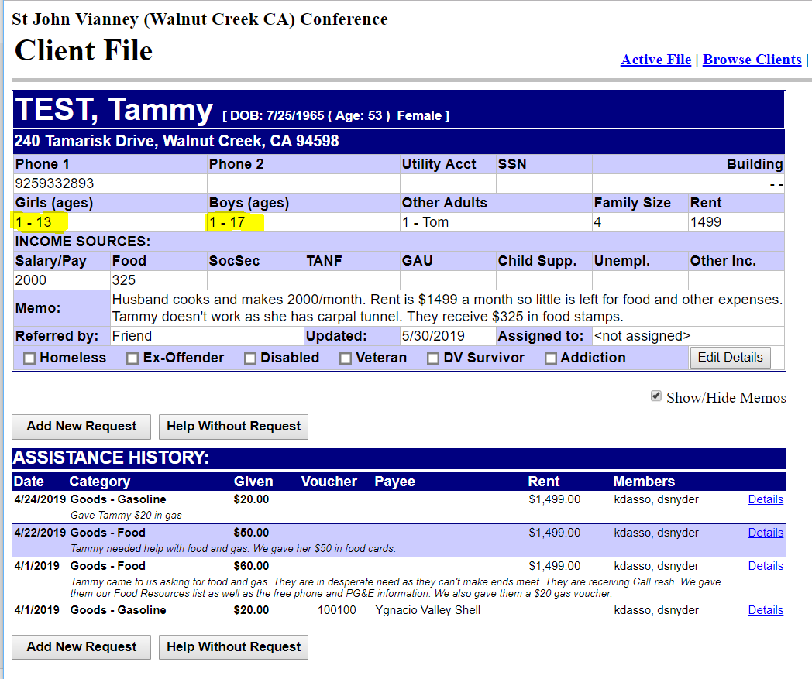

**HEADER SECTION**

The **Edit Client Info Screen** will display (as shown below) and you can enter the **husband’s or significant other’s last name,** **children’s full names** (if different than parents) and **children’s** **birth dates** and click **SAVE CHANGES**. **NOTE**: **As children become 18 years if age, you will need to move them to the adult section (at which time they will receive only $10 aid.)**

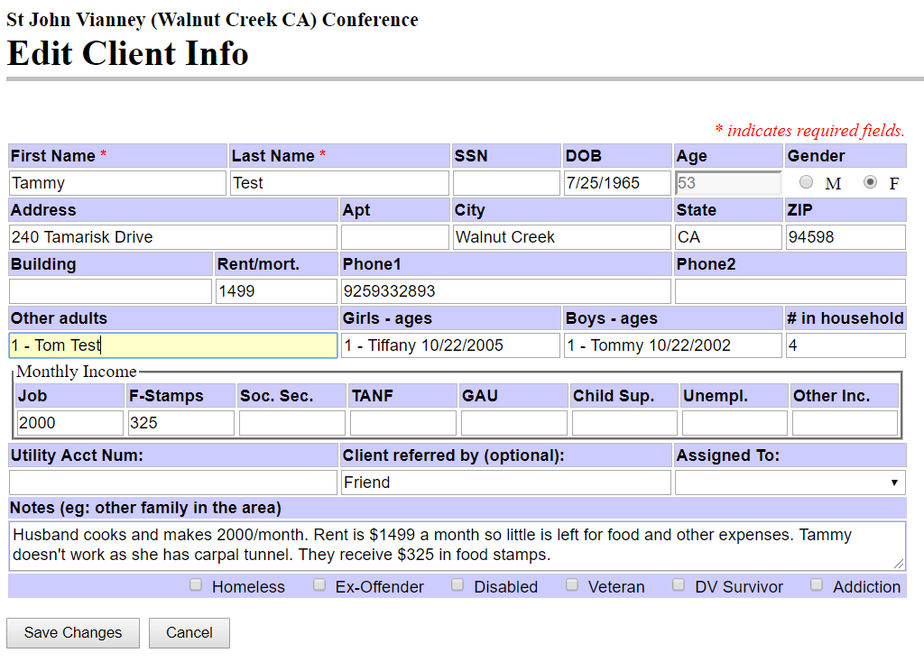

**Updating the Header Section - NFA:**

In addition to adding a note to the office binder, the Data Base Header must be updated to show that a neighbor has been placed on NFA (No Further Assistance). First, pull up their file by clicking on **BROWSE/FIND/ADD CLIENTS** in the Main Menu. Then click on **EDIT DETAILS**, and



**HEADER SECTION**

At the top of the Header Note, enter the NFA statement, date of entry & date they can return and press **SAVE**.

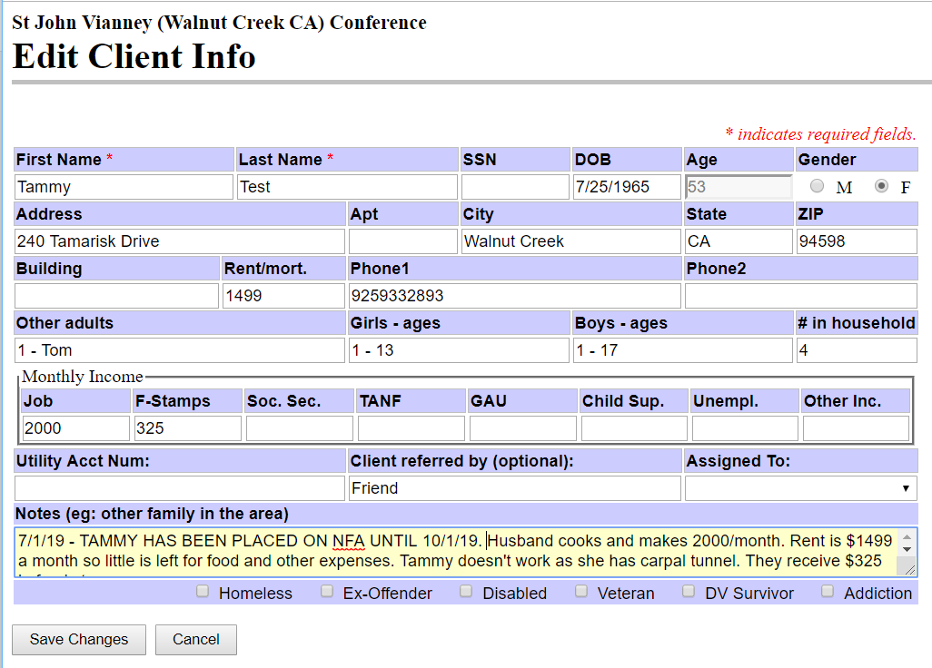

**Updating Header Section – Multiple Files for Same Household:**

There may be cases where there are two separate files for a couple or a family of adults that lives together but comes in separately for help. In cases like these, it is important to link the 2 or more files together by referencing their relationship in each of their Header Files.

For example, you have discovered that Tyler Test, who has come in separately for help, lives with Tammy and Tom. Tyler has a separate file, so you will need to click on **Edit Details** in the Header file in the top right-hand corner of each of their files. For instance, let’s look at Tammy’s file:

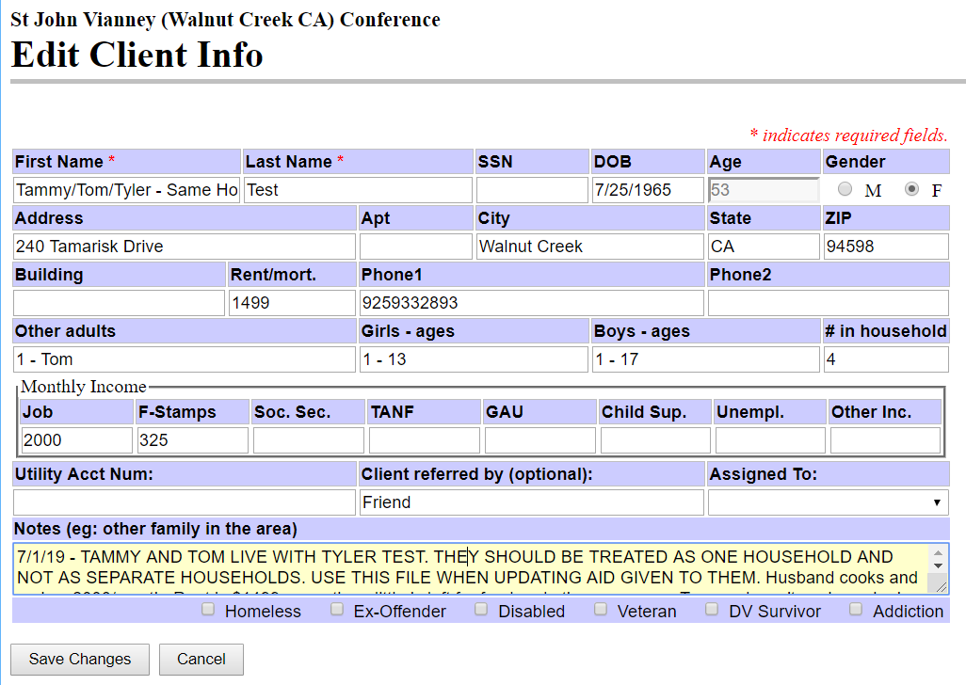

IN FIRST NAME BOX, ENTER ALL NAMES

The Header Section of both Tammy and Tyler’s files should indicate they will be considered one household and both files should indicate that Tammy’s file is the one to use for updating aid given. Changes will show:

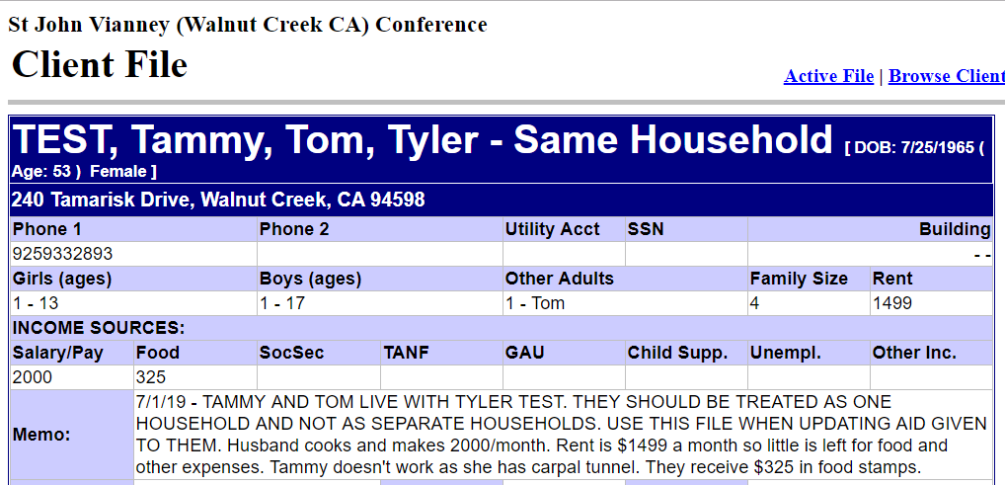

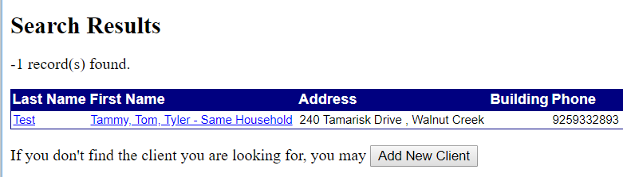

**Updating Header Section – Multiple Files for Same Household – Spanish Surnames:**

Sometimes duplicate files can exist for a single family that presents ID’s from Mexico or a Spanish speaking country. This can happen due to confusion over which last name to enter into the file. It is common in Spanish speaking countries to give a child a first name, which is followed by both the father’s family name (surname) and the mother’s family name (surname).

An example would be “Angel Romero Alejandre, which would break down as follows:

* **Angel Romero Alejandre**

**(First Name) (Father’s Surname) (Mother’s Surname)**

The common Hispanic naming convention is to use the *first* surname from the father over the *second* surname from the mother, so Angel would use the name Angel Romero, not Angel Alejandre. Although this is common, sometimes the mother may choose to name the children using her surname. Typically, the mother will keep her father’s surname, Alejandre and does not change it to her husband’s surname when married.

Many times, it is the mother who comes to us for help, so the family file will typically be under her surname. It is important to be as consistent as possible in recording all family members and children, so please be sure to record all family members names with the first and last name provided on their IDs. For example:

* In this case, if the mother, **Maria Alejandre,** comes in for aid, we would set up the family file under the surname **ALEJANDRE.**
* You will also need to add the husband’s and children’s last names as shown on the IDs provided.
* If Miguel later comes in for an office visit and fills out paperwork for **Romero**, you will need to make a separate file for **ROMERO**, with the instruction to use the **ALEJANDRE** file for recording office and home visits and aid given. This will link the 2 files together, so that we will know what aid has been previously given and to avoid duplicate assistance.

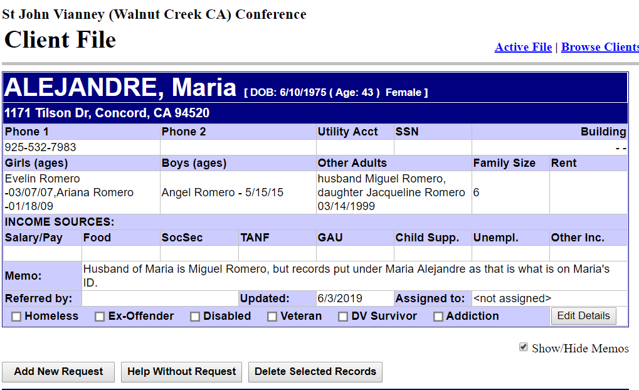

**Accidentally Adding New Request:**

Issues can occur when someone accidentally clicks on the **ADD NEW REQUEST** button. Our conference doesn’t use this function as this is used primarily for opening a case file for a home visit for which service has not been yet given. This type of file is an active file for which any aid that has been given will not show in the system’s reports.

If you accidentally press this button, the screen will look like this:

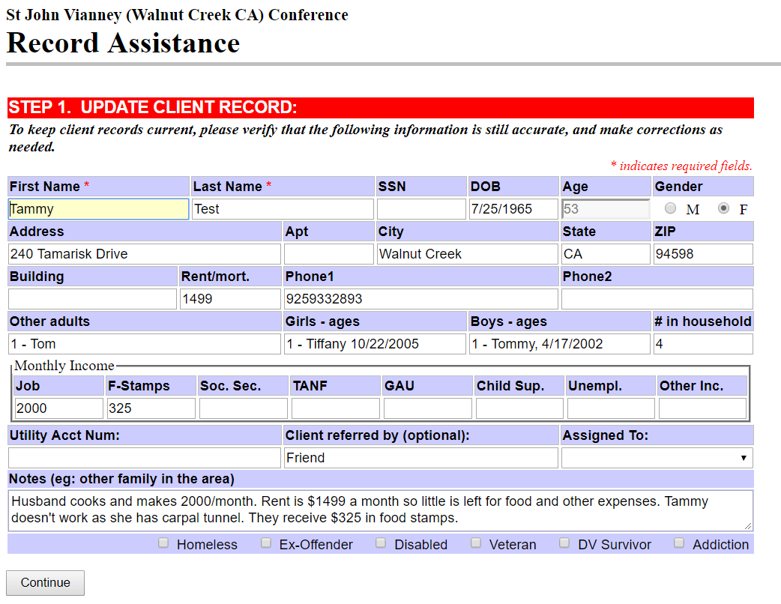

If you press CONTINUE, the following screen will pull up:

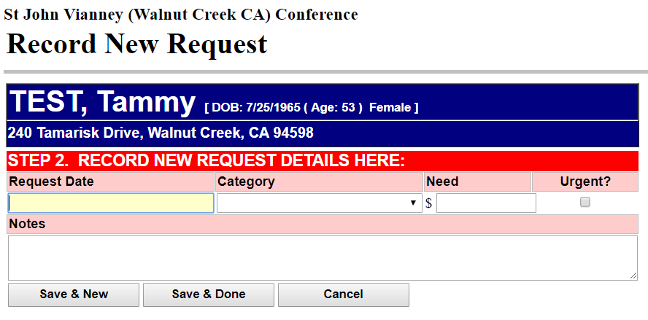

**Accidentally Adding New Request, Continued:**

If you record:

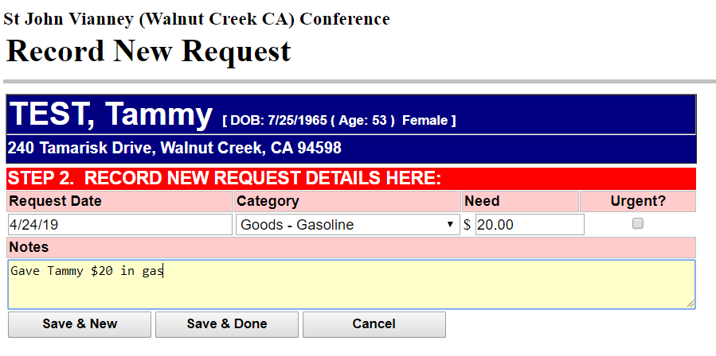

And click **SAVE & DONE**, you will see the following screen:

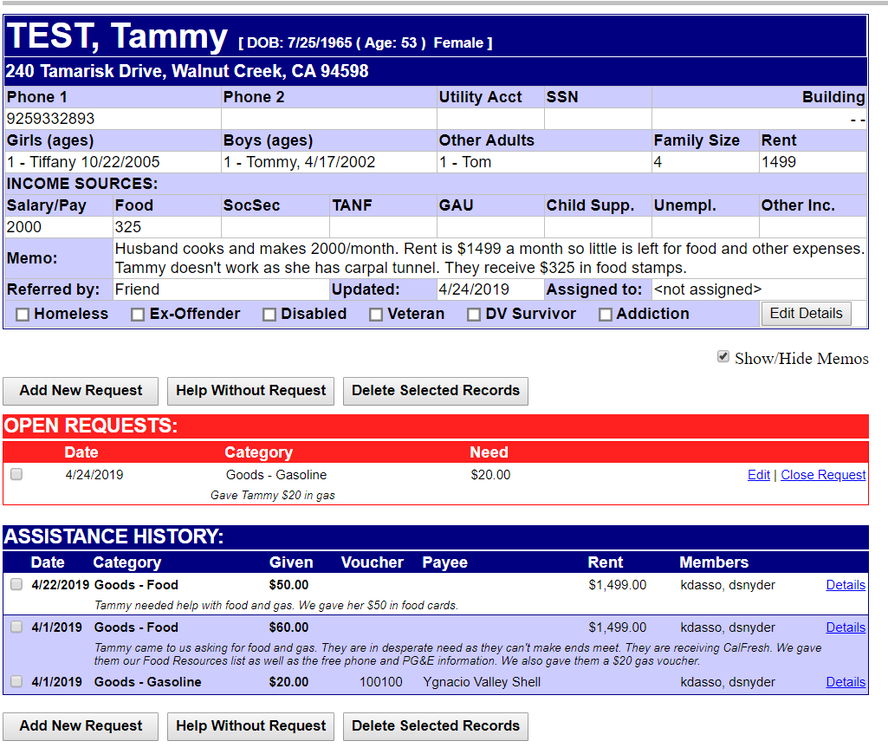

To close the record, click **CLOSE REQUEST** and **SAVE** and the aid will be recorded properly.

**Member Roster Report:**

Under the Reports section, if you click on the link for the Member Roster, you will see all members and associate members along with their contact information. Only administrators have the ability to update or delete files.

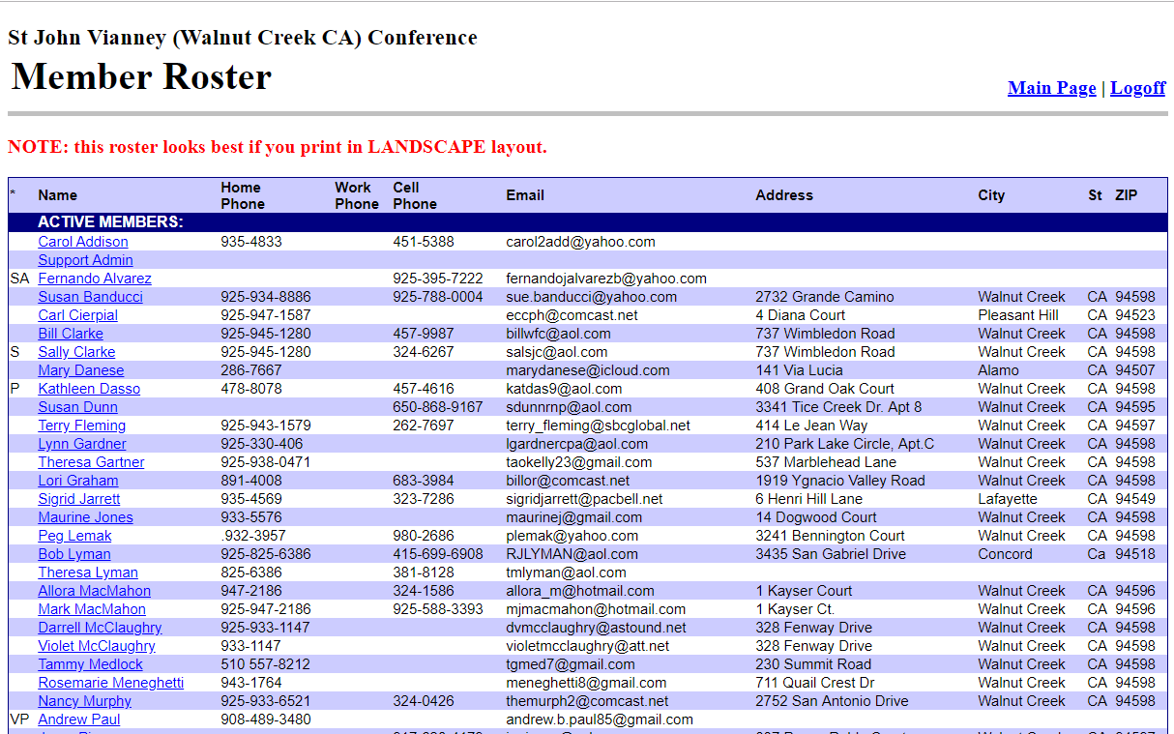

**Document Library:**

These are just a few of the many valuable resources that are accessible in this library:

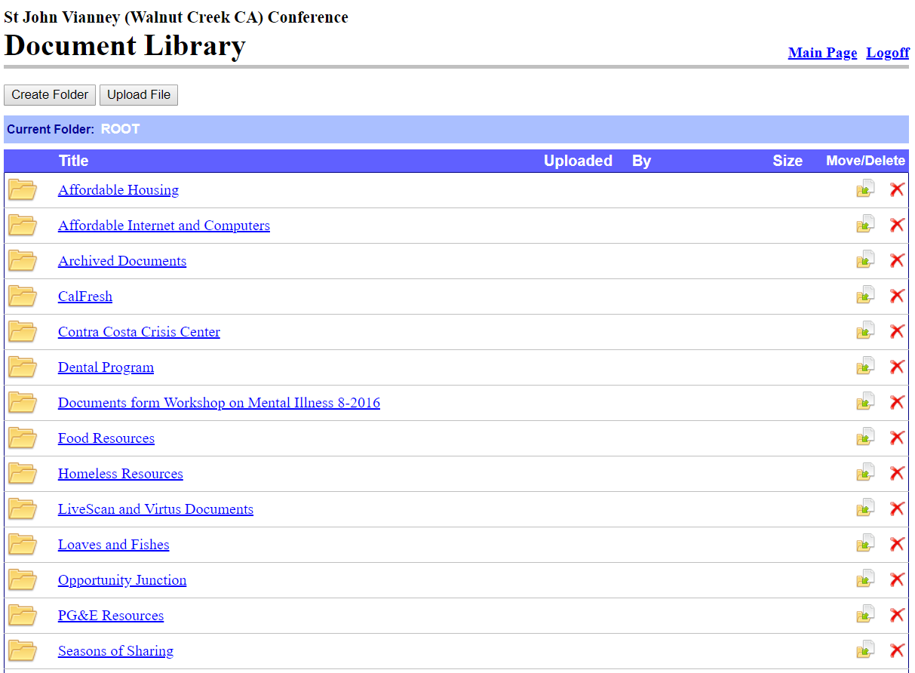

**Logoff:**

There are several different logoff links in the database. Two of them are located on the Main Menu, one at the top right-hand corner and one at the bottom of the screen. Additionally, each screen has a logoff link at the top right-hand corner of the screen.

You will want to logoff when you are done with your use of the data base.

Keep in mind, that the logoff process is a two-part process. You will first click on **Logoff**  and then the data base will prompt you with the following:

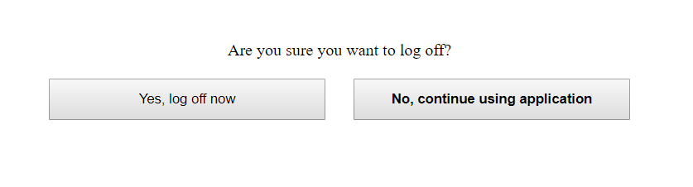

You will need to click the box to the left to completely logoff.

**Final Notes:**

* Timeliness of Recording – we ask that whenever possible that you record any aid given to neighbors within **48 hours** of an office or home visit. This way, our reporting will be up-to-date.
* Deleting Files – if you need help deleting a file, please contact Kathy Dasso, Doris Snyder or Andrew Paul.